**WHY IS MTSS NEEDED?**

Not all children learn in the same way and at the same rate. MTSS is a process to support students to achieve academic success.

**HOW IS MTSS DIFFERENT FROM SPECIAL EDUCATION?**

Some students may not qualify for special education services, but still need interventions in order to reach their full potential. MTSS is a process that supports all children in reaching their full potential.

**FAQ’S**

An intervention is anything a school does, above and beyond what all students receive within Tier 1 (Core Instruction) that helps a student succeed in school.

*How will we respond when some of our students do not learn?*

*How will we enrich and extend the learning for students who are already proficient?*

*(DuFour et al., 2010).*

In order to ensure fidelity and sustainability of MTSS implementation, all educators should receive initial and ongoing professional development so that they have the knowledge and skills necessary to deliver effective core instruction and make data-based decisions about student progress in mastering concepts.

**Intervention**

**Multi-Tiered System of Supports (MTSS):**

An evidence-based model of schooling that uses data-based decision making to integrate academic and behavioral instruction and intervention.

**Tier 1 (Core Instruction):** Effective core instruction with differentiation for all students.

**Tier 2 (Targeted Interventions):** Intervention, including enrichment and extension, for small groups of students with similar needs.

**Tier 3 (Intensive Interventions):** Intervention, including enrichment and extension that personalize the learning for students with highly specific needs.

**Definitions**

 **THE MTSS MODEL**

***CONSTITUTION ELEMENTARY SCHOOL***

**What is the MTSS process?** The Multi-Tier System of Supports (MTSS) is a process to provide instruction and support to promote the academic success of all students. While it can be used for all subjects, Constitution Elementary is currently utilizing the process in reading and mathematics, as well as behavioral success.

An effective MTSS process will have 3 key components. The first is core instruction (Tier 1), from the general education classroom teacher. The second component is analyzing student data on a regular basis, which is used to help determine the response to intervention (Tier 2). The third component is research based supplemental instruction (Tier 3). This is given in addition to the student’s regular classroom and Tier 2.

It is imperative that the MTSS system accounts for the intervention needs of all students. The diamond-shaped model emphasizes the need for targeted and intensive intervention for students that have needs that require additional instructional support beyond what differentiation in the classroom can provide. Access to supports on either side of the diamond

It is imperative that the MTSS system accounts for the intervention needs of all students. The diamond-shaped model emphasizes the need for targeted and intensive intervention for students that have needs that require additional instructional support beyond what differentiation in the classroom can provide. Access to supports on either side of the diamond is based upon a student’s needs, not a student’s classification as gifted, SpEd, or any other label.

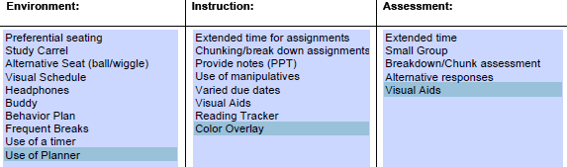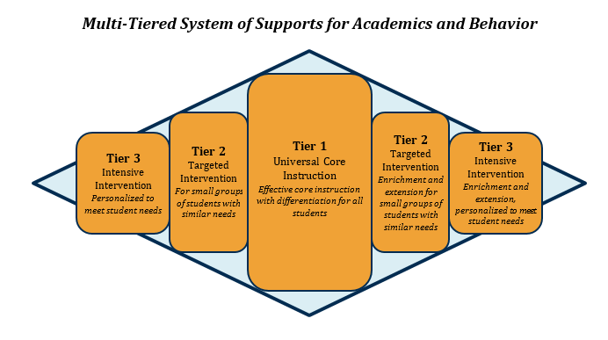

**Interventions to support students in TIER III – Must be utilized prior to Referral**

Continue in TIER III

Parent Contact 2x per month

Referral Form completed

Psychologist Review

Minimal Growth

GROWTH

**CRITERIA REMEDIATION**

**CRITERIA ENRICHMENT**

PASS

Retake Assessment

**CRITERIA REMEDIATION**

**CRITERIA**

Continue in TIER II

Below 70% on 75% of retakes move to TIER III

Return to TIER I instruction

Below 70%

**CRITERIA ENRICHMENT**

ENGAGE NEW YORK

READING STREET

SMALL GROUP PHONICS INSTRUCTION

100% OF STUDENTS WILL RECEIVE TIER ONE INSTRUCTION

SGI – PASI/PSI Leveled and taught by Classroom Teachers and Interventionist

**TIER 1**

SMALL GROUP INSTRUCTION BASED ON TIER 1 ASSESSMENTS

* 90% or higher on 75% of classroom assessments
* Above benchmark on DIBELS
* AZ Merit Highly Proficient
* Below 70% on classroom assessment
* Teacher referral
* Excessive absences



**TIER 2**

LEVELIZED SMALL GROUP INSTRUCTION FOCUSING ON GAP AREAS

** ACCOMODATIONS IN PLACE to support student

* AZ MERIT Highly Proficient
* Gifted Qualified – COGNAT
* Teacher Referral
* AZ MERIT Bottom 15%
* Number Worlds Intensive
* Reading Matrix Bottom 25%
* 70% or below on 75% or more of retake classroom assessments

 



**TIER 3**