CAP Parcours 2: 2019
3e année

Learning Outcome:
I revise and correct my texts, leaving traces of my reflective practice by following the revision and correction steps provided PAVOH (Punctuation, Agreement, Verb, Spelling and Homophones).
1rst PLC meeting  February 20th, 2019  Question #1:  What do students want to do, learn,  understand and be able to communicate? (in the French curriculum) | Reverse planning : Planning summative, formative and diagnostic assessments  Choosing criteria: grid construction  Summative assessment:  Review and correct a short story written by a student, which respects the following subject : The Animals Escape from the Zoo.  Formative assessment:  Review and correct a short story story written by a student, which respects the following subject : The Show  Diagnostic assessment:  Review and correct a short story story written by a student, which respects the following subject : The Mountain of Toys.  Expectations for the narrative:  Necessary elements to be found in written text:  -who, when, where and what  -initial situation (two lines) and story set-up  -trigger element, rising tension  -two adventures detailing the attempts to solve problem  -dialogue with hyphens  -resolution of conflict or problem  -final situation (two lines)  Reverse planning  -teach and show students how to use the the four-box frame writing strategy (see example)  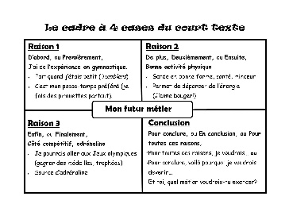  -illustrate your 4 boxes if needed  -must be able to separate the elements  box 1: initial situation (who, when, what, where);  box 2: trigger element;  box 3: event or adventure # 1 and event # 2;  box 4: final situation  -encourage creativity and motivation to allow students to develop the initial situation (draw a who, when, where and invent the what, develop an initial situation from a given image)  -use a revision and correction template  Success criteria for students:  - I respect the characteristics of the story.  - I write in full sentences.  - My text is easily read and shows fluidity.  - I'm creative.  - I leave traces of my revision and correction (PAVO).  For the next PLC:  Tasks to be done by the week of March 18th:  -Have students complete the diagnostic assessment: The Mountain of Toys using the testing sheet.  -Teach and display a template of the four-box frame writing strategy on the interactive white board.
2nd PLC meeting  March 27th  Question #2:  What do we do with students who have learned?  Question #3:  What are the best teaching and learning strategies? | Diagnostic assessment :  3A - 0/23  3B - 0/21  3C -0/20  3D - 7/21  Total 7/85  8% of our students revise and correct their work with PAVOH  Correction standards:  Green: traces of revision, 4 colors of PAVOH  Yellow: some traces of revision, 2-3 correction colors  Red: little or no traces of revision, or erroneous traces and little or no correction  Smart Goal :  3A - 13/23  3B -12/21  3C -12/20  3D - 19/21  Total 56/85  69% of our students will revise and correct their work with PAVOH  Findings:  - repetition of the little words (and, too)  -writing not fluid  -limited vocabulary  -sentence limits not respected  -content of narrative writing shows creativity and respect of topic  Strategies:  Use of images and inferences.  Modeling of strategies  Revising and group correction  Use of subject vocabulary words (who, when, where ...)  Activating previous knowledge  Visualization and creating a mental picture  Use of word walls  Bump it up wall  Co-creation of criteria grid  Explicit teaching of PAVOH: Noun and verb agreement and punctuation, spelling.  Tracking chart  Strategies to teach and explore for Monday, April 4th  1. Austin’s Butterfly (Mindset) - https://vimeo.com/38247060  2. Order of teaching strategies  a. The elements of the sentence (uppercase for 1rst word, sentence subject, predicate, clauses, punctuation)  b. The types of sentences (.,!,?)  c. Variation of lengths of sentences  d. Variation of vocabulary  i. synonyms, antonyms  ii. word walls  iii. create conceptual diagrams with words  3. Fragment Sylvain’s grid model (length and type of sentences)  i. direct feedback 1 to 1 (questioning / mini-lesson with the student)  4. Co-construction of criteria with the students, following diagnosis  i. Show students good examples and counterexamples to show them the  criteria for success  5. Take student examples and rework them in class group  6. Peer feedback  Common formative  • each brings his own revised text, evaluated with Sylvain's grid  Things to complete for next PLC:  Reflect on formative / summative evaluations
3rd PLC meeting  April 4th  Question # 4  How will we know it it works? | Strategies for storytelling:  -peer pairing  -model descriptive feedback  1. establish criteria with students  2. use the four-box frame  Students at risk for not succeeding :  3A: Adam, Michaella, Olivia, Brandon, Tillie  3B: Danielle, Gabriel, Elias, Stella, Amayah  3C: Alexandre, Roxanne, Dawens  3D: James et Emma  Suggestion: decompartmentalization to 2 classes  Findings and difficulties:  • lack of time to teach and practice  • too many criteria to see in short amount of time  • necessity to go back and teach the basic sentence for students who are not up to par  • first lesson in co-constructing criteria did not have the desired outcome  Formative 1 -corrected  Need to calibrate and compare results.  Winning strategies:  1. Activity: Compare two texts with the objective of highlight the criteria that illustrates a captivating text.  https://docs.google.com/document/d/1Uz4RYF3kLW14ojjk879ilMHqqniPesT1405hsywgkNo/edit  2. Activity: Determine the criteria for success for text revision.  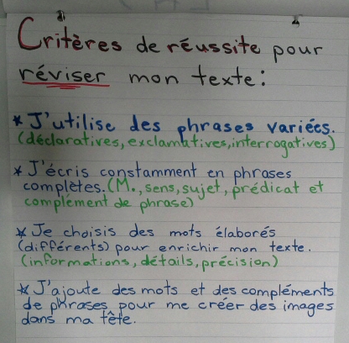  3. Activity: Enriching sentences.  https://docs.google.com/document/d/1bBFEfptnUSQAx3tkIwCh6CjHhserWd0xlYyoSb_GbbY/edit  4. Activity: Revising a sentence.  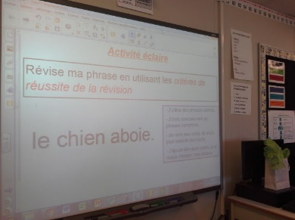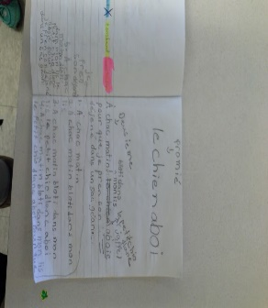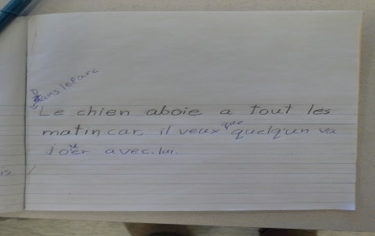  • Use lined paper to create models and number them. Students will therefore be able to easily refer to them when they revise their own work. This also allows the teacher to clearly see students work.  • Break up the work into steps to focus on, one success criterion at a time  • Keep all work neatly organised by stapling each rough draft together  • Do a group class review to show how work is to be done. Explain that rough draft are exactly that : rough.  • When students use the Chromebooks: Ask them to create a copy of their work each time and to number it (# 1, # 2, etc.) which will allow the student and the teacher to see the progress made.  Next steps:  -Reflexive task activity  - keeping computerised tracks  a. The elements of the sentence (uppercase for 1rst word, sentence subject, predicate, clauses, punctuation)  b. The types of sentences (.,!,?)  c. Variation of lengths of sentences  d. Variation of vocabulary  i. synonyms, antonyms  ii. word walls  iii. create conceptual diagrams with words  e. Language manipulations  f. Relationship words  To be done in class :  -practice strategies  -administer a short Code 20 text from the Testing (EQAO) and have the students review it
4th PLC meeting  April 18th  Question 3  What do we do with students who have not learned? | Winning strategies:  1- Activity 1: I enrich two sentences.  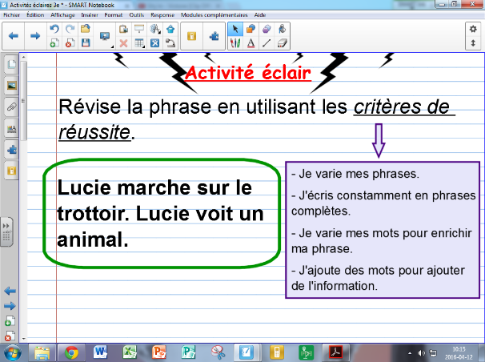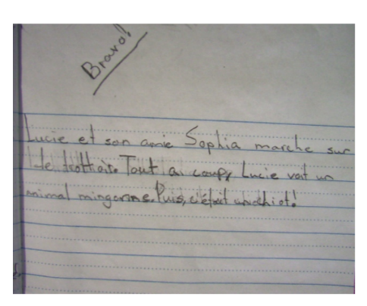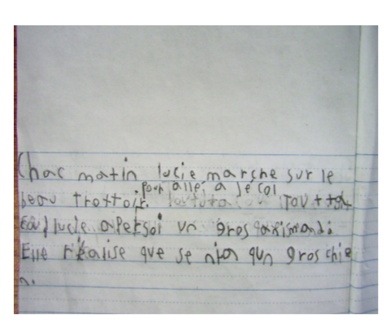  2- Activity 2: Revision of a code 20 in dyads  https://docs.google.com/a/ecolecatholique.ca/document/d/16TK0dzrhOLF5vJzmEwaCLAGOlyUUtaBsgzLVUqPOta0/edit?usp=sharing  Step 1: I edit the text with a partner, leaving traces of my reflexive approach.  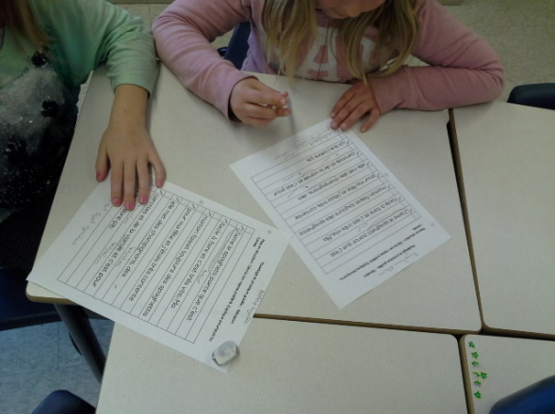  Step 2: With my work partner, I review another team’s copy and I give constructive and precise comments.  Step 3: I share my comments with the other team.  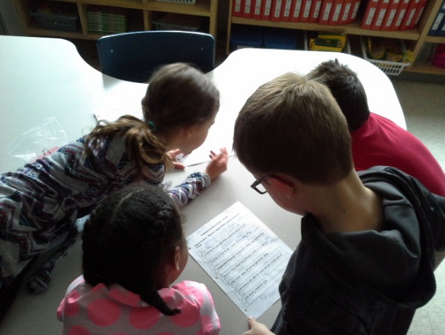  • checklist: success criteria to revise your text.  Strategies for the next PLC :  • Spelling strategy approached - Julie B. with time limit (1. write 2. group activity 3. 15 minutes)  • Writing stations  • Draw your sentence - Roger – add to sentences to make them great by using mental imagery  • Pyramid game (one student sees the words and the other student must guess the word the student is describing)  • Formative: Brutus narrative (revision / correction)  • Summative: (planning / writing)  • Summative: The Animals Escape from the Zoo (planning, writing, editing, correction)  • Publication ⇒ in June
5th PLC meeting  2nd of May  Question 3  What do we do with students who have not learned? | Formative assessment : Brutus narrative text  Results for tracking chart  ⅔ - 0/10 , J-3/10, V-7/10  3A - 0/19 , J-10/, V-9/19  3B -3/18, J-6/18 , V- 9/18  3C -0/18, J-8/17, V-9/17  3D - R-3/19, J-9/19, V-7/19  Total 41/83  49% of students revise and correct their texts using PAVOH  We also calibrated the students work in order to ensure valid results.  Winning strategies:  1- Dictation - approximate spelling  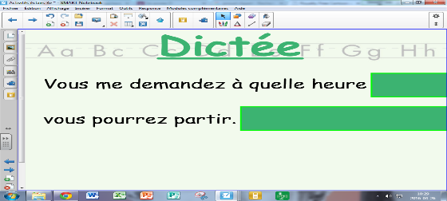  2- Hand activity (direct feedback - in a dyad)  https://drive.google.com/a/ecolecatholique.ca/file/d/0B1rNpnf-eHgbbnlqLTZQcEhtZE0/view?usp=sharing  - See video at 50 sec., 3:20, 4:00  William’s testimony (3D) - Importance of Revision  https://drive.google.com/a/ecolecatholique.ca/file/d/0B1rNpnf-eHgbZW5rOHkyTDdhR1k/view?usp=sharing  3-Read the work with the student  -give direct and accurate feedback  4-Reading one instruction at a time  5-Using post-its  - the students must find the criteria for success in his own text and affix a  post-it to prove it  6-Worksheet with numbered steps  7-Constructive criticism by pairs  8-Modeling with counterexamples - errors to make students realize the missing elements  9-Reading a text with and without punctuation  10-Scoring system - Number of Challenges  Teacher reflective practice:  The elements of the basic sentence are not yet acquired. Why?  FSL? student learning styles? motivation?
6th PLC meeting  May 16th  Question 3  What do we do with students who have not learned? | Next meeting  -Work and correction of Brutus narrative  Findings:  - Teaching how to properly correct mistakes in their texts: grammar, punctuation, homophones, conjugation  -students have difficulty finding the verb in the sentence  -activity analysis (Sylvain) successful practice. This activity gives meaning to all words  - Preparation for EQAO testing slowed the progress of lessons  -the new grammar - taught at the beginning of the school year to have a good foundation  - encourage students to frame difficult words / not certain + uses referential (5 words)  2nd Formative assessment  Tracking chart :  3A -V /19, J /19, R /19  3B -V /18, J /18, R/18  3C -V 7/17, J10/17  3D-V 6/19, J 12/19, R 1/19  ⅔- V 8/10, 2/10  Total =  87% of students revise and correct their work using PAVOH  next step:  • administer summative task: The Animals Escape from the Zoo
June 9th | Summative: The Animals Escape from the Zoo (planning, writing, editing, editing and editing)  Results at the end of the PLC course:  ⅔ - V: 9/10, J: 1  3A - V: 18/19 , J:1  3B - V: 8/18 , J10,  3C - V: 8/17, J: 8/17  3D - V: 13/19 J: 6/19 R: 0/19  Total: 56/83 67% Green  What not to forget for next time :  -start year by teach students how to correct their work, in order create a good understanding of how to create great work.  -lack of time  -make sure to not teach « how to correct grammar and spelling » at the same time as « how to revise and enrich narrative texts », to ensure students understand the difference.

