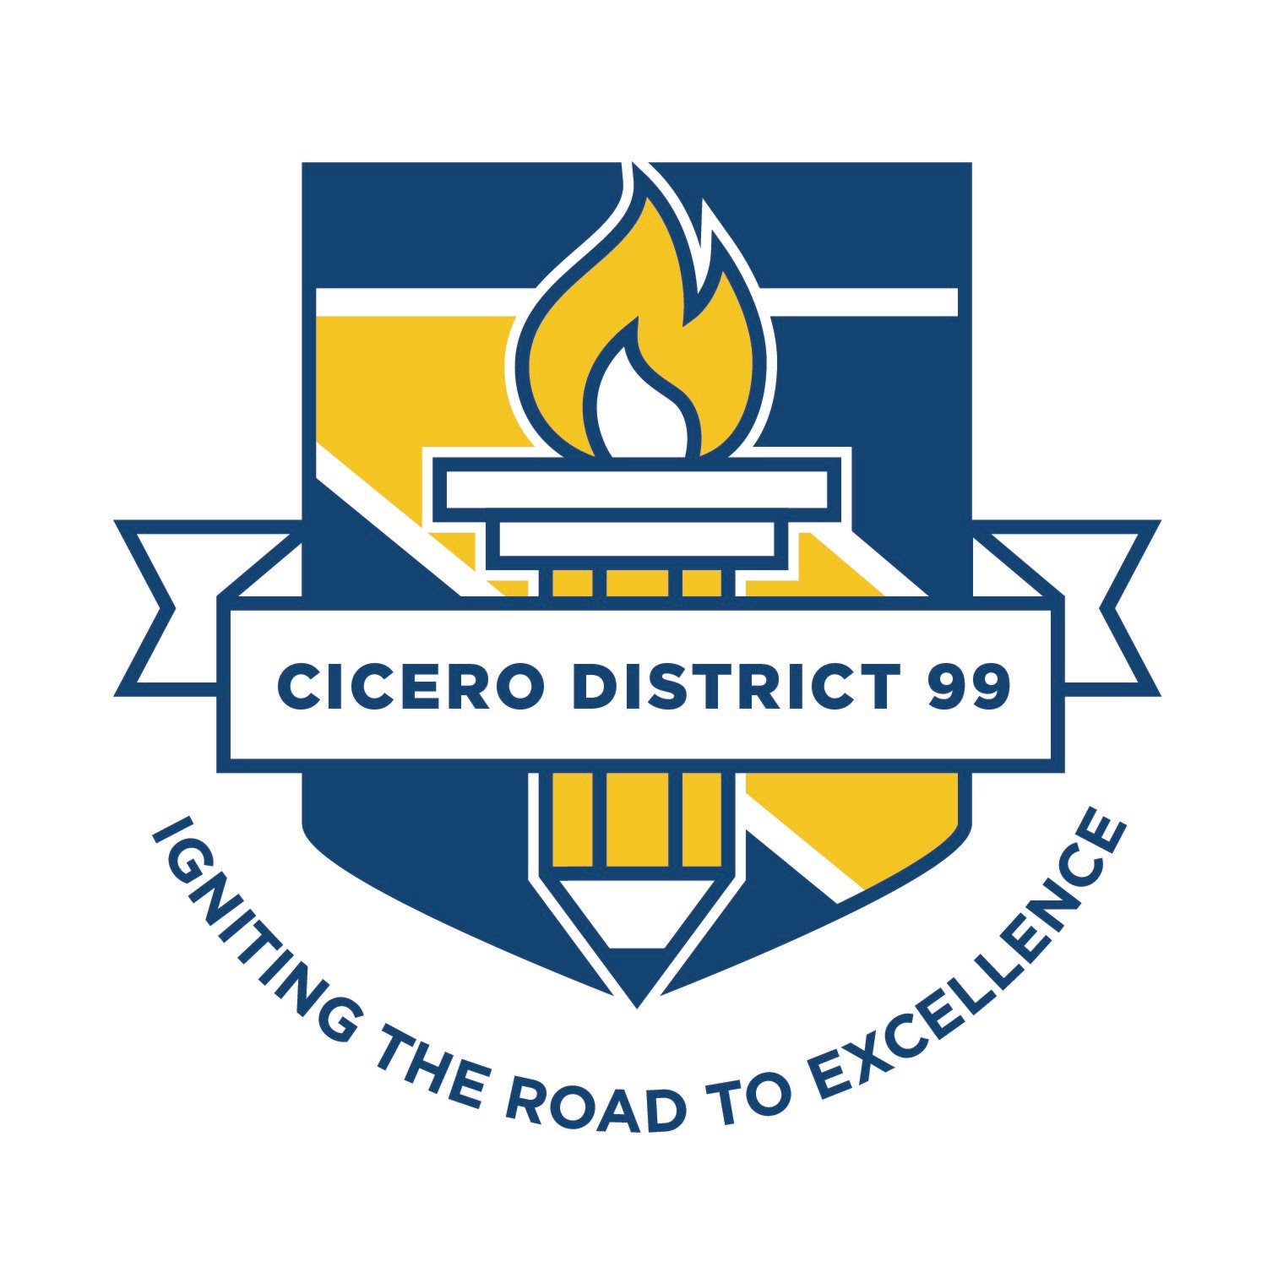
School Name:____Burnham School________________

Strategy | Action | Timeline | Responsibility | Status Updates
Creating a culture focused on results
 | Development of Mission, Vision, Values, Goals, and Commitments Document with stakeholders | August 2019 | School Leadership Team | Complete  Updated Annually
 | Train staff leaders to use templates (Agenda and cycle template) | September 2019 | Principal at SLT Meeting | Complete
 | Each team will utilize the PLC process for ongoing review of student classroom performance  - K-5 - Unit by Unit in reading and math  - 6 - Unit by Unit in departmentalized content area and and either writing or SS based on team  - Specials - Interdisciplinary Literacy | Cycle templates reviewed based on at-a-glance pacing schedule | Principal and Assistant Principal | Ongoing
 | Develop, Schedule, and provide professional development (PLC training during wednesday meetings and on ½ days based on Critical Issues, feedback from the SLT, and FLW results) using global PD | September 2018 | Principal  Instructional Coach  Director of PLCs | Ongoing
 | Develop Instructional Coaching Questionnaire. Instructional provide specific coaching and support around teacher/PLC team needs in the areas of reading and Math | September 2018 | Principal  Instructional Coach | Ongoing
 | Refine PBS plan to improve the school climate and learning environment to support increased student achievement, social-emotional skills, and positive behavior. | November 2018 | PBS Committee | Ongoing
Hiring and retaining high quality staff
 | Work with HR to develop a consistent process to recruit and hire staff who possess and can apply PLC practices. | April 2019 | Principal
 | Develop Building level “On-Boarding Process” to support District Mentoring Program to train, equip, and prepare new staff to be successful PLC team members | August 2019 | Principal  Mentor Coordinator
 | Identify, recruit and train qualified mentors who exhibit the traits we want to see in our staff. | August 2019 | Principal  Mentor Coordinator
 | Develop and sustain vertical articulation between grade levels to create shared responsibilities for student learning | August  May | School Leadership Team | August Complete
Providing teams with targeted support
 | Provide training to teach faculty how to turn data into actionable information. | October 2018 | Principal  Assistant Principal | Complete
 | Provide each teacher with current and previous year MAP Data | August  October  January  May | Principal  AP  Jamie Funkhouser | Ongoing
 | Ensure that an array of data (MAP, ECRA, CFA) on student performance is available in a format that teachers find understandable and that invites interpretation. | October 2018 | Principal  Assistant Principal | Complete
 | Train and support teachers using Mastery Connect for formative and summative assessment in math | September 26, 2018 | Technology Department | Complete
 | Develop a plan to implement formative and summative assessment system using Mastery Connect across all grade levels and curriculum areas to enable staff to address individual student needs | August 2019 | Principal Curriculum Directors
 | Identify Tiers (EWS-Watch list) for Multi-Tiered System of Support to accelerate academic and social-emotional/behavioral intervention based upon student needs. | August 2018  Meet every Thursday | Principal  MTSS Director  PBS Team | Ongoing
 | Provide training and support for teachers to ensure consistent evidence-based interventions are utilized building wide. | May 2019 | Director of MTSS  Intervention Coach
Building the capacity of team leaders and PLC Teams
 | Team Leaders provided specific training to facility collaborative teams | May 2019 | Director of PLCs | Ongoing
 | Establish building wide PLC expectations and accountability system (attend PLC Meetings, review folders, meet with SLT, and provide feedback and support . | August 2018 | Principal | Ongoing
 | Align the building expectations with district PLC expectations.  - Guaranteed and Viable Curriculum  - Measuring Impact  - Providing Targeted Support | June 2018 | Principal | Ongoing
 | Evaluate the effectiveness of the PLC model through the use of PLC observational protocols (surveys, walkthroughs and and team evaluations) | August  December  May | School Leadership Team | Ongoing
 | Team completes critical issues form and is provided targeted PD by Principal based on team needs. | September 2018  April 2018 | School Leadership Team | September Complete
Defining problems of practice and improving instruction
 | Ensure all teams use PLC Cycle template for Math & Literacy to analyze & assess data results and plan for interventions/enrichment | September 2018 | Admin and Coaches | Ongoing
 | Provide a structured professional development to train staff how to use the NWEA learning continuum to impact learning | August 2019 | Principal  Jamie Funkhouser | Complete
 | Utilize NWEA Map assessment data and information at the building and classroom levels to inform intervention/enrichment programs and guide learning | August to May | Grade Level PLC Teams | Ongoing
Measuring impact and celebrating success
 | Review of PLC implementation progress throughout the building | January 18, 2019  May 17, 2019 | School Leadership Team
 | Review School Math Performance SMART Goal | May 2019 | School Leadership Team
 | Review School Reading Performance SMART Goal | May 2019 | School Leadership Team
 | Principal uses data generated by NWEA MAP to demonstrate the effectiveness of curriculum and instruction in the PLC | 3x per year based on assessment calendar | Principal
 | PLC teams and team members celebrate achievement and are the work of PLC teams is recognized at monthly meetings. | Monthly building meeting | Principal

