Brazosport ISD A-Rated for College, Career, and Military Readiness

While the state of Texas is rating all Texas school districts as “Not Rated: Declared State of Disaster” for the 2019-2020 school year, we believe it remains important to keep our community informed about the performance of our students. Brazosport ISD would have been A-rated for the second year in a row for College, Career, and Military Readiness (CCMR).

CCMR - Ratings | 2018 | 2019 | 2020
District | 77-C | 91-A | 92-A
Brazoswood | 90-A | 93-A | 95-A
Brazosport | 70-C | 91-A | 91-A
Brazos Success | 75-C | 90-A | 91-A

College, Career, and Military Readiness is a term used to describe a combination of student success measures that include:
- Earning dual credit college hours
- Performance on college entrance exams (SAT, ACT, and TSI)
- Performance on Advanced Placement (AP) Exams
- Earning an industry-based certification
- Enlistment in the Armed Services
- Earning an Associate’s Degree in high school

“This is an exciting accomplishment for the students of Brazosport ISD and reflects the district’s commitment to ensuring that BISD graduates are ready for their next steps after graduation,” said Brazosport ISD Superintendent Danny Massey. “It clearly demonstrates the great learning opportunities our students have in a district that continues to strive to set the standard for educational excellence.”
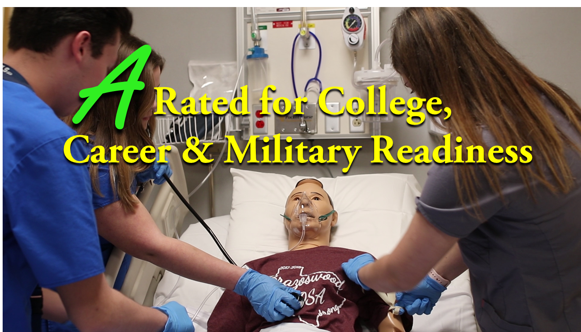

(photo in 2020-2021/graphics/Ratings by State)

