Bonaire Primary School Kindergarten
Playbook
Instructional Components, Environments, and Exemplars

Initially created January 2021
Kindergarten
Instructional Components:
- Heggerty
- Writing
- Reading Mini Lesson
- Guided Reading & Centers
- Phonics
- Math
- Bobcat Buildup
- Shared Reading
- Interactive Reading
- Science/Social Studies

- Heggerty
Teacher: Leading the lesson from the front of the class
Para: Walking around the room and observing students. Reinforcing/redirecting students as needed.
Students: Standing at their desks focused, participating and using hand motions as led by the teacher.

- Writing
Teacher: From the front of the class, the teacher models the lesson (using the minilesson framework) that students are expected to use in their writing that day.
Para: Walking around the room to ensure that all students are focused and listening to the lesson. Reinforcing/redirecting students as needed.
Students: At desks focused and participating in the lesson.
Students try the skill taught in their pieces independently while the teacher and para are conferencing.
Students share what they tried/teacher summarizes what was worked on.

- Reading Minilesson
Teacher: From the front of the room by chart/interactive board, leads and models skill to be learned using the minilesson framework, books, and charts.
Para: Walking around the room to ensure that all students are focused and listening to the lesson. Reinforcing/redirecting students as needed.
Students: At desks focused and participating on the lesson that is being taught.
Students try the skill taught during their private and partner reading time while the teacher pulls a guided reading group or conferences with students. Para conferences with students.

- Guided Reading, Centers & Independent Reading
Teacher: Pulls guided reading groups
- Teacher has preplanned book with goals.
- Students are seated with the book.
- Teacher reviews previous skills and introduces the text.
- Students read text while the teacher monitors.
- Small group discusses the text.
- Teacher gives teaching point based on student needs.
- Phonics/Word Work that ties in with the text
Para: Observes and manages the classroom, works with students, and/or works with a small group while students are working at centers.
Students: Work independently on literacy-based activities, read privately and read with a partner.

- Phonics
Teacher: Leads an interactive whole group lesson at the front of the classroom with manipulatives and pocket chart as needed.
Para: Assists with whole group lesson. Observes and monitors students reinforcing/redirecting students as needed.
Students: At desks focused and participating on the lesson that is being taught.
Students practice skills that are taught during an Apply Time and/or during Literacy Centers.

- Math

- Calendar - Interactive daily lesson to discuss the month/months of the year, day/days of the week, yesterday, today & tomorrow, number of days we’ve been in school (ten frames, counting)
  - Teacher: At front of room by the calendar leading interactive, whole group lesson.
  - Para: Walking around the room and observing students. Reinforcing/redirecting students as needed.
  - Students: At desks focused and participating in discussion.

- County Number Talks - 3 to 4 problems a day using mental math, show, tell and explain.
  - Teacher: At front of room by the interactive board leading interactive, whole group talk.
  - Para: Walking around the room and observing students. Reinforcing/redirecting students as needed.
  - Students: At desks focused and participating in discussion.

- Minilesson – Whole group lesson based on a standards-based teaching point using manipulatives, charts.
  - Teacher: Leads an interactive whole group lesson at the front of the classroom with manipulatives and charts as needed using I do, we do, you do (gradual release).
  - Para: Assists with whole group lesson. Observes and monitors students reinforcing/redirecting students as needed.
  - Students: At desks focused and participating on the lesson that is being taught. Students will practice skills that are taught during Math Centers.

- Math Centers – Practice current skills and maintain previously taught skills. Five centers, 1 new skill and 4 review skills.
  - Teacher: Working with small groups based on student needs to fill gaps or extend.
  - Para: Observes and manages the classroom, works with students, and/or works with a small group.
  - Students: Work independently or in small groups on math-based skills.

- Bobcat Buildup
Teacher: Meets with a group
Para: Observes and manages the classroom, works with students, and/or works with a small group.
Students: Work in differentiated groups for reading and/or math. When students are not working with the teacher, they are working independently or with a partner/small group on something that supports their needs.

- Shared Reading
Teacher: At the front of the room using the interactive board or the big book for the lesson.
- Teach lesson based on goals selected.
- Introduce the text.
- Model the text.
- Reread together.
- Discuss text.
- Make the Teaching Point/Revisit text.
- Reread on multiple days as needed.
Para: Walking around the room to ensure that all students are focused and listening to the lesson. Reinforcing/redirecting students as needed.
Students: At desks focused and participating in the lesson.

- Interactive Read Aloud
Teacher: At the front of the room using the interactive board and/or the book for the lesson.
- Teach lesson based on goals selected.
- Introduce the text.
- Read the text stopping to have conversations about it.
- Discuss text with students based on goals.
Para: Walking around the room to ensure that all students are focused and listening to the lesson. Reinforcing/redirecting students as needed.
Students: At desks focused and participating in the lesson.

- Science/Social Studies
Teacher: Introduces or reviews a concept using a read aloud, video clip, or artifact.
Para: Walking around the room to ensure that all students are focused and listening to the lesson. Reinforcing/redirecting students as needed.
Students: At desks focused and participating in the lesson. Complete an independent activity relating to the concept.

Kindergarten Classroom Exemplars and Environment

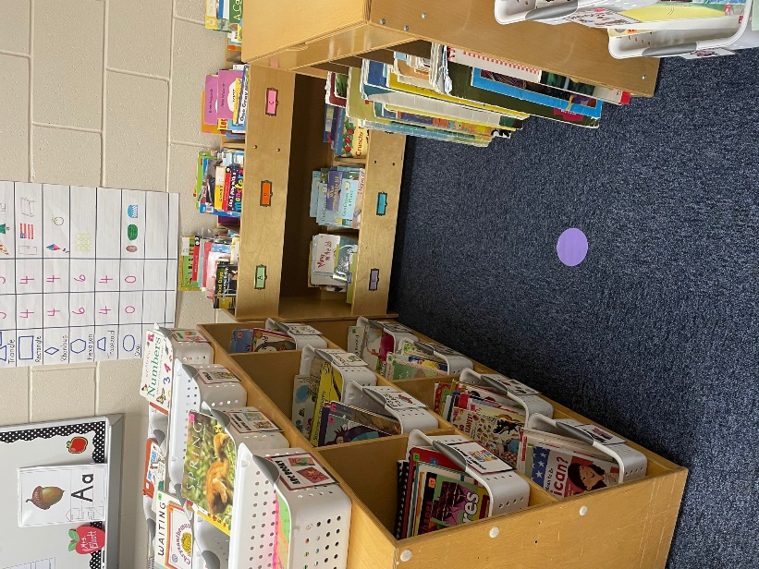
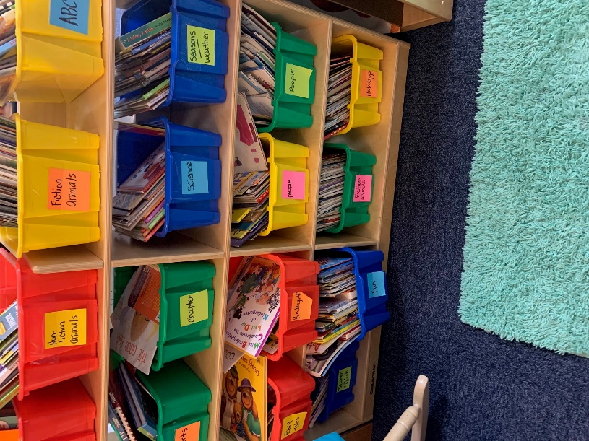
Classroom libraries:
with genre books

with genre books, leveled books, and big books

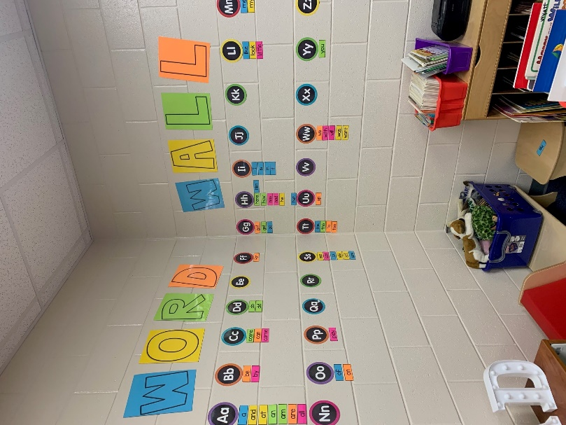
Word Walls
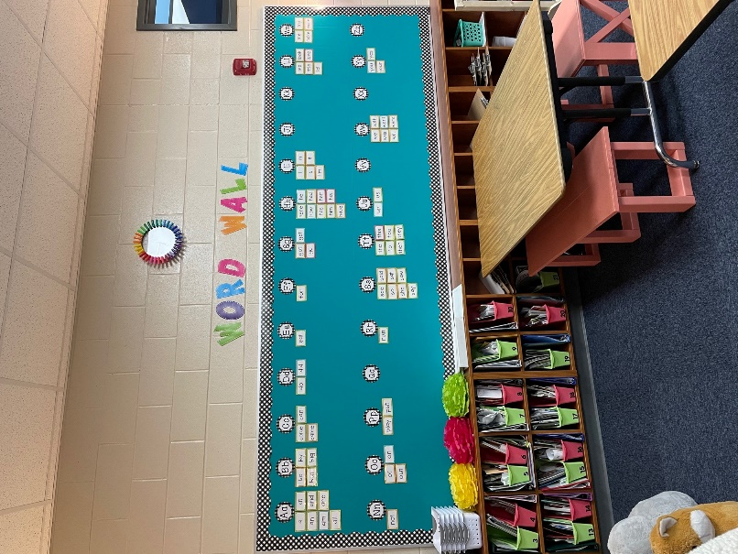

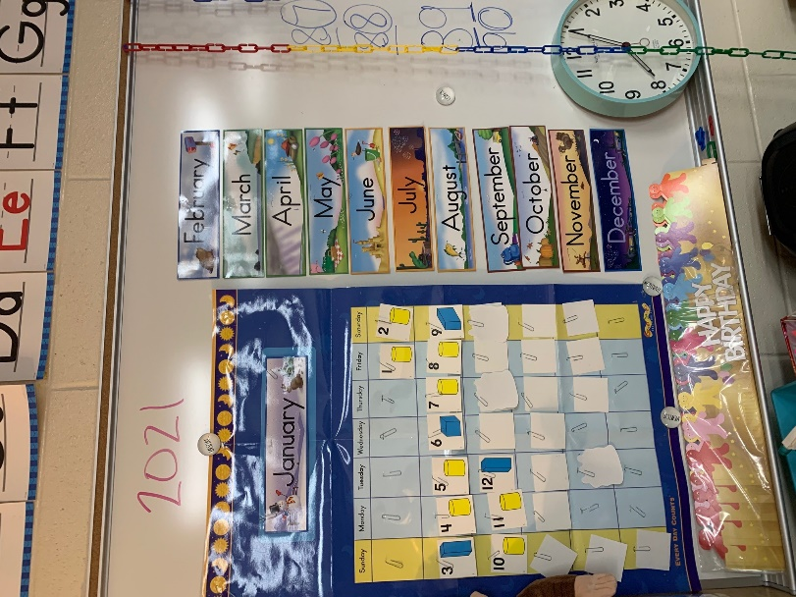
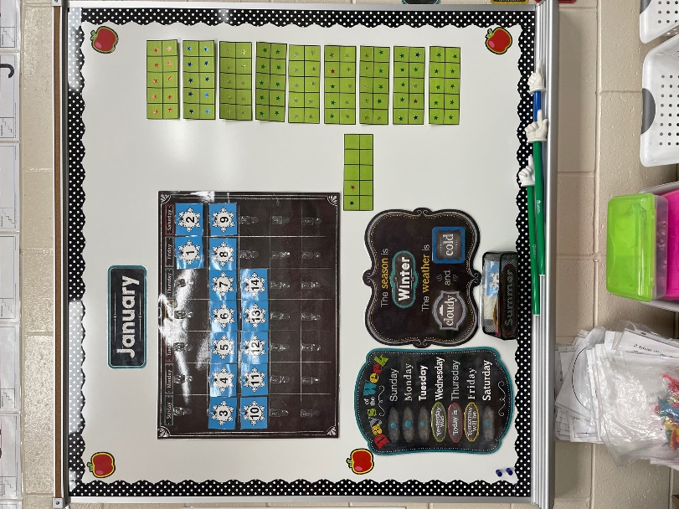

Calendars

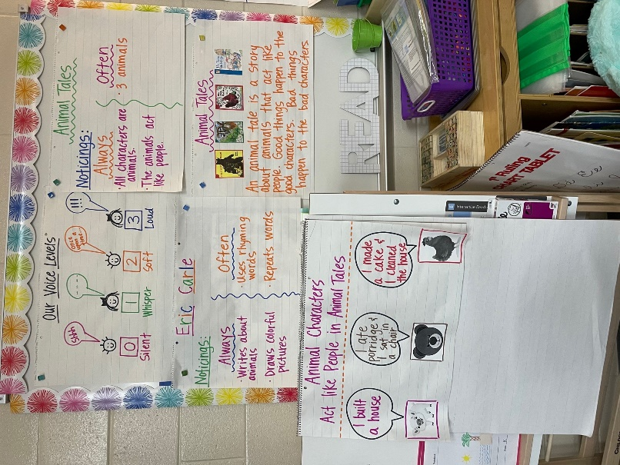

Reading Mini Lesson Charts
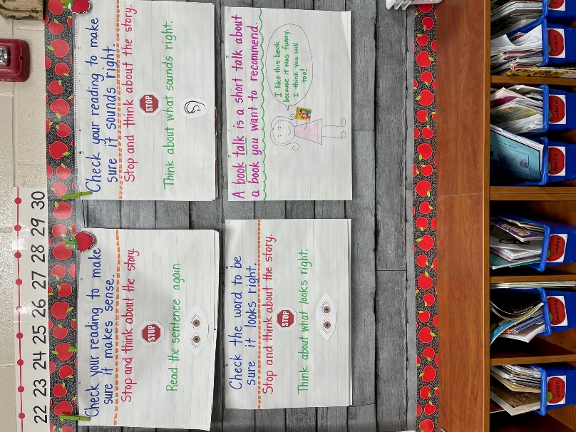

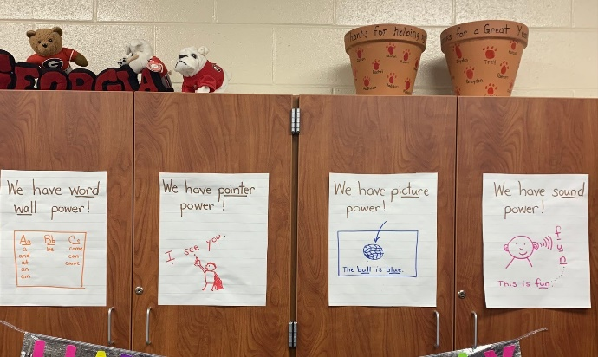
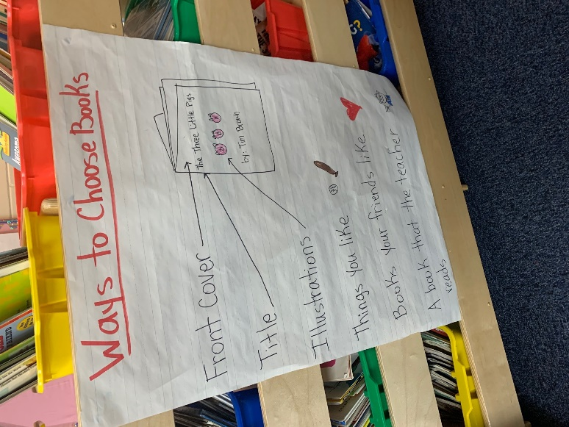
Reading Mini Lesson Charts

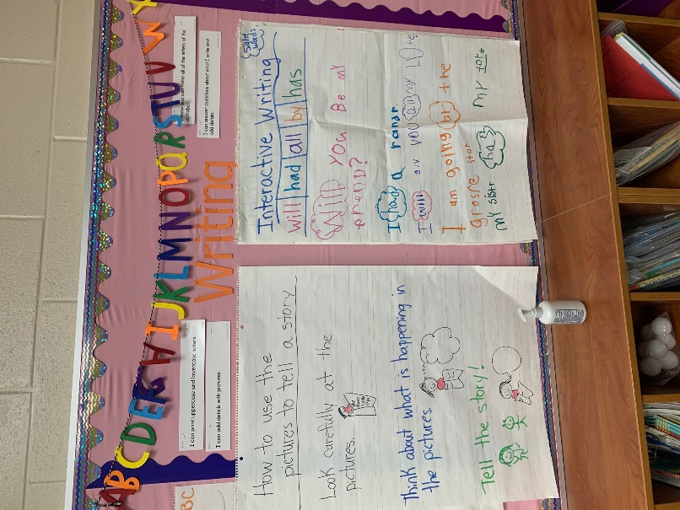
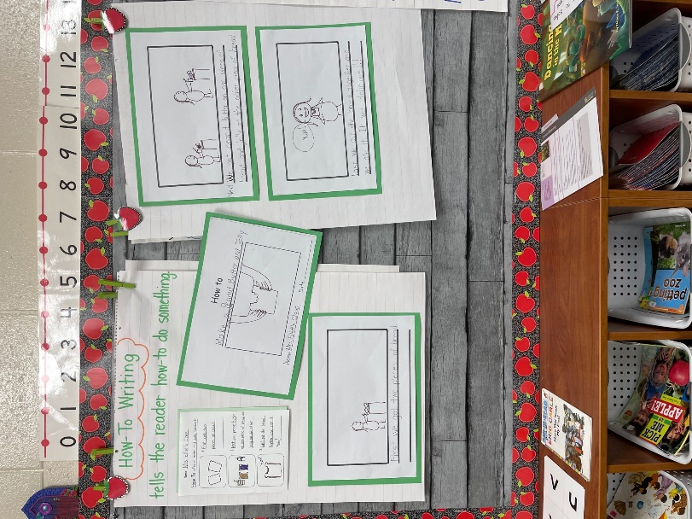
Writing Charts

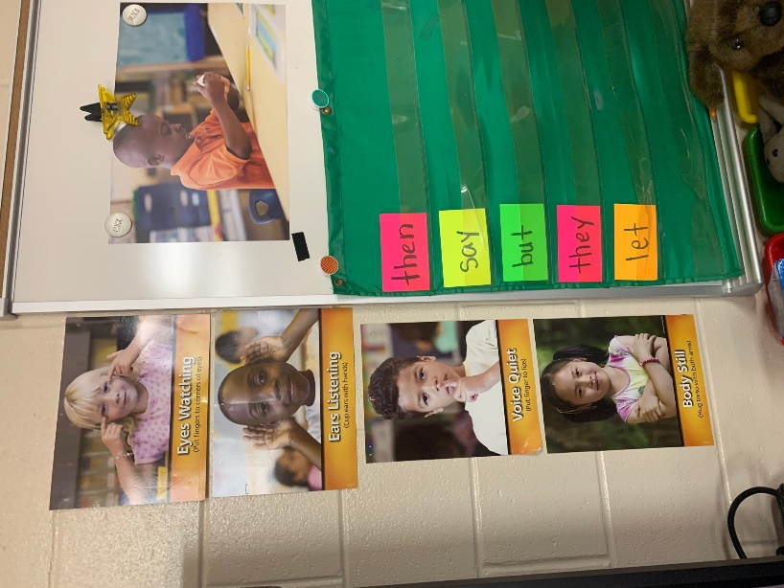
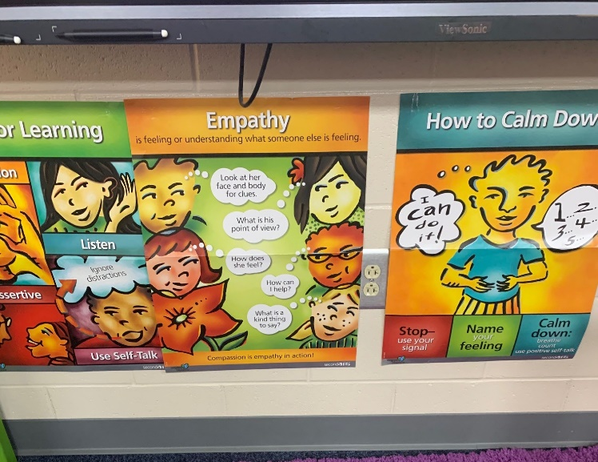
Second Step Charts

Pocket Chart for Phonics
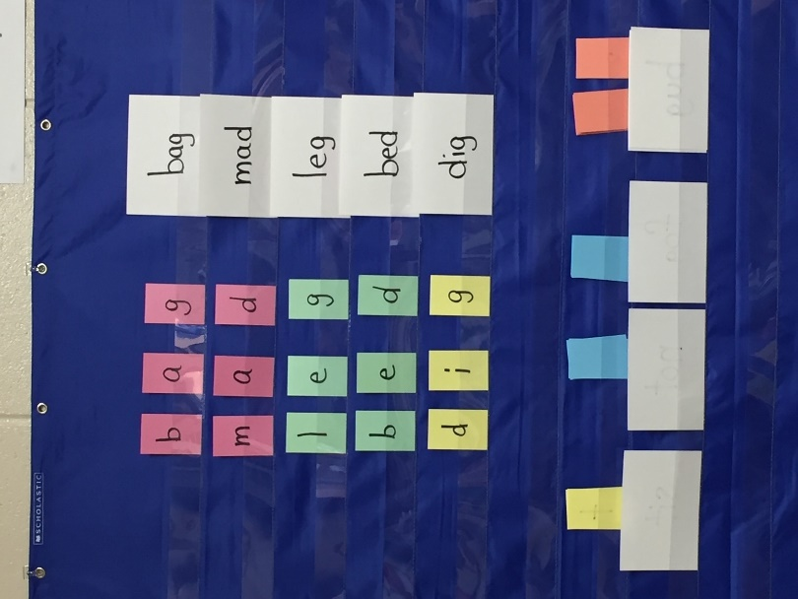

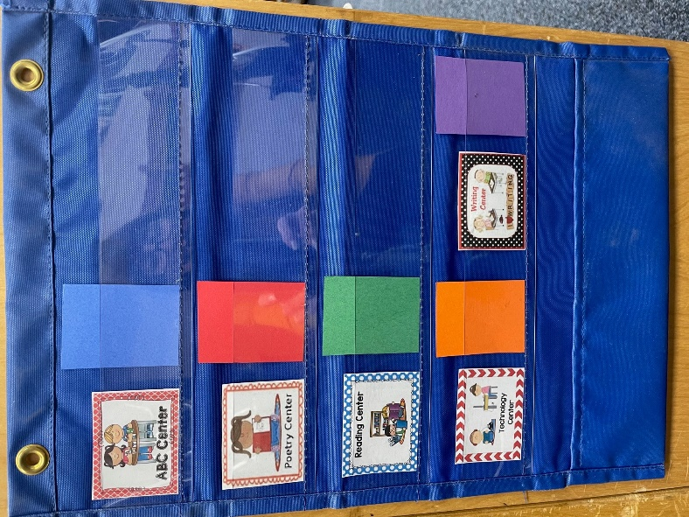
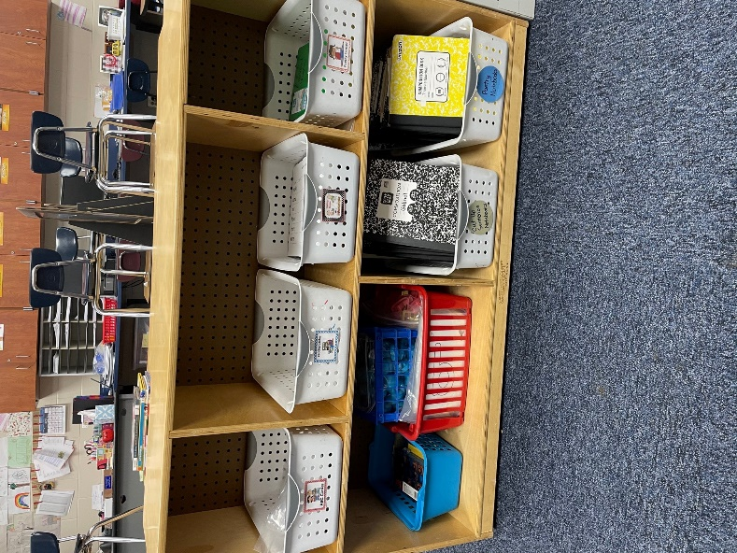
Centers:
Baskets with materials
Center Rotation Chart

