Bonaire Primary School 2nd Grade Playbook

Instructional Components, Environments, and Exemplars

Initially created January 2021
2nd Grade
Instructional Components:
- Heggerty
- Writing
- Reading Mini Lesson
- Guided Reading & Centers
- Phonics
- Math
- Bobcat Buildup
- Shared Reading
- Interactive Reading
- Science/Social Studies

Social Studies
- Teacher introduces or reviews a concept
- Read aloud or video clip or study artifact
- Class discussion centered around concept
- Sometimes students respond in journal or complete an independent activity related to the concept
Science (we flip flop week to week between science and social studies)
- Teacher introduces or reviews a phenomenon
- Read aloud or video clip or study artifact
- Class discussion centered around concept
- Sometimes students respond in journal or complete an independent activity related to the concept
Phonics
- Teach- Teacher review previous concept then introduces new concept. (Inquiry based, demonstration or modeling,
- Apply-(try it whole group then students practice independently)
- Share-Come together and review the concept. Students share something they learned.
- Optional Assess (Observe daily to see if the skill needs to be addressed another day)
Grammar/Conventions-embedded in phonics
- Teacher reviews or introduces concept (song, video clip, looking at a shared text)
- Whole group: I do, we do, you do (gradual release)
- Independent Practice
Shared Reading
Teacher puts a shared text on the board or document camera
Day1: Teacher reads to students
Day 2: Teacher reads with children (choral read, echo read)
Day 3: Reread and use a focused skill from the lesson card
Day 4 and 5 Choral or echo read poem

Guided Reading- done during independent reading time and during bobcat buildup
- Teacher reviews previous skill then introduces the text
- Students read the text while teacher monitors
- Small group discusses the text
- Teacher gives a teaching point based on student needs
- Phonics/Word work that ties in with text
- Writing about Reading tied to the text once a week. Students complete in the group or independently.
Bobcat Buildup
- Students are regrouped at the grade level based on Essential Skills/Standards. Groups will last approximately one month.
- Each teacher has a group of students based on similar need.
- Whole group instruction based on that group level need.
- Groups are reassessed at two weeks.
- Teachers are actively engaged with students throughout the activity.
IRA
- Introduce the text
- Read the text
- Turn and talks, think alouds
- Discuss the text (meaning, author’s purpose, inferring, central message, and/or theme)
- If time allows, revisit and/or respond to text with writing
RML
- Teacher introduces teaching point or previously taught skills first or last
- Model for students using books and/or chart, we do, you do
- Introduce or restate teaching point, students go off to apply skill
- Independent Reading time: Students practice skill taught from RML and read independently to build stamina or work on phonics or writing about reading activities, while the teacher pulls Guided Reading Groups and/or conference with students.
Writing Mini Lesson
- Teacher models what students are expected to try today in their writing using model piece, mentor piece (student’s piece), charts and/ or mentor texts
- Students try the skill taught in their pieces independently while the teacher conferences
- Teacher allows students to share and/or turn and talk about the skill they tried today
Heggerty
- Follow the prompts in the book (students use hand motions)
Math-
- One word problem a day-review with students (morning work/brain check)
- County number talks- 3 to 4 problems a day using mental math, show, tell, explain
- Mini lesson-standards based teaching point using oral, written, chart, and/or manipulatives, I do, we do, you do
- Independent Practice-teacher monitors students working at their desk on practice sheet, workbook, manipulatives, or centers
- Small groups- (If necessary based on student need) students are working on independent practice while teacher pulls 3-5 students to fill gaps or extend, fact fluency, coolmath4kids, xtramath, freckle, that quiz
- Closing- today we learned… or turn and share a strategy you used today and/or turn and talks and/or check work with a partner

2nd Grade Classroom Exemplars and Environment

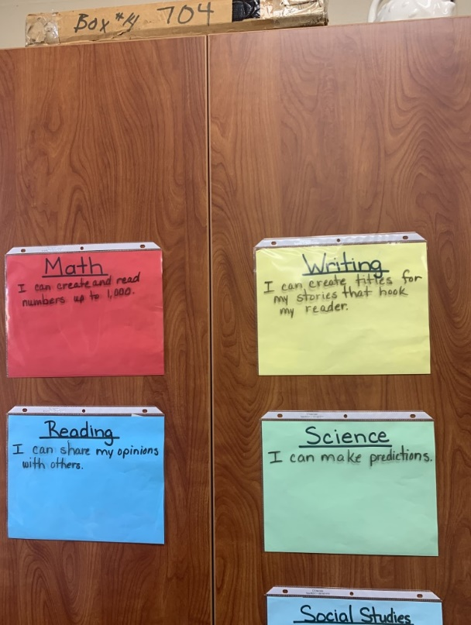
I can statements posted.

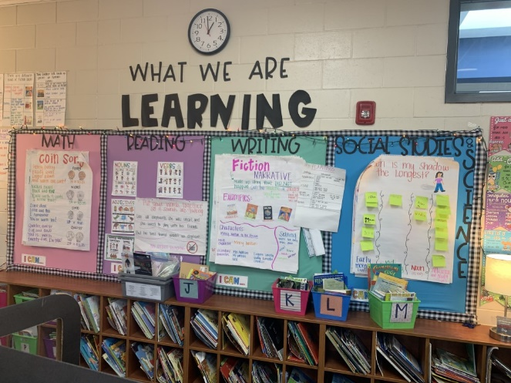

Charts for the day or week posted in an organized way
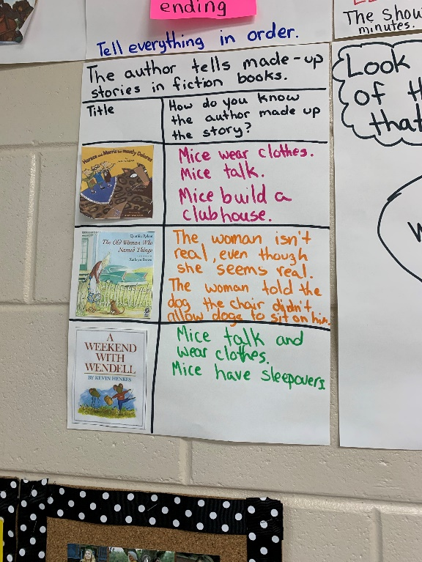
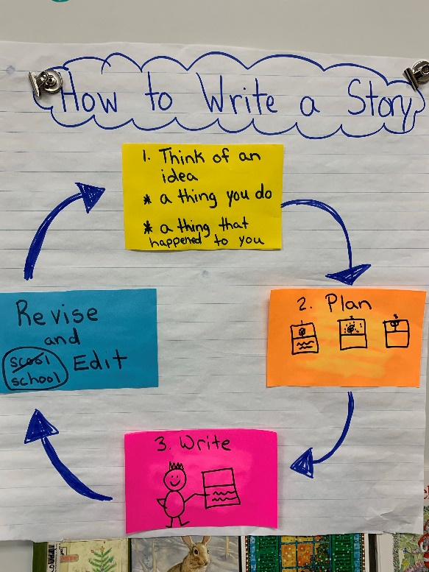

Charts with picture support.
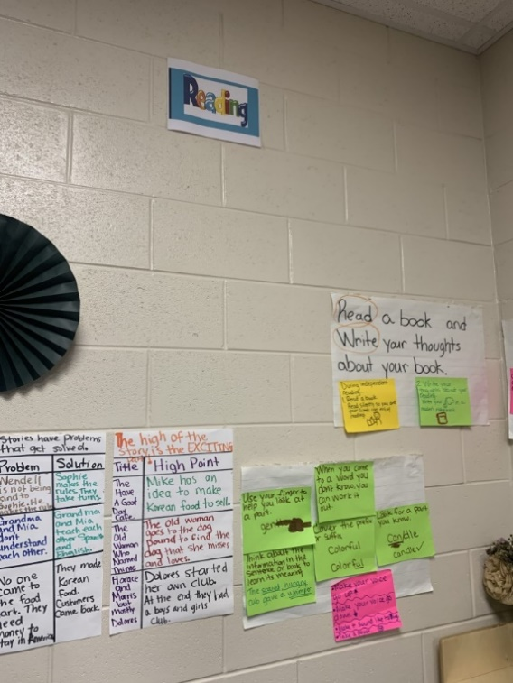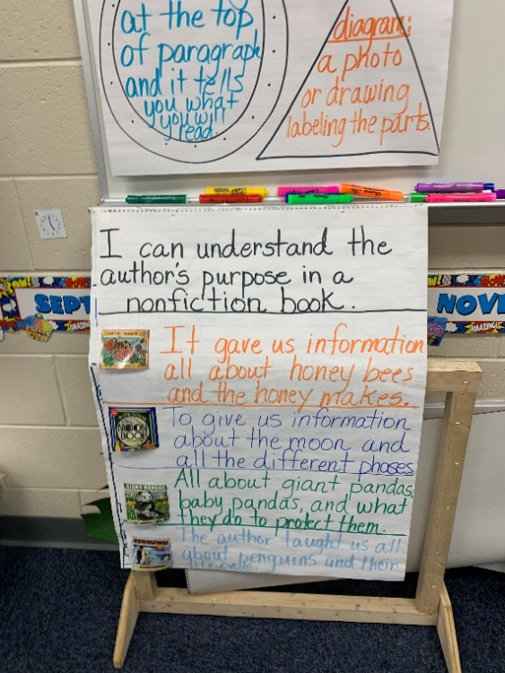
Charts in an organized way... a wall for each subject
Remember to use the F&P charts

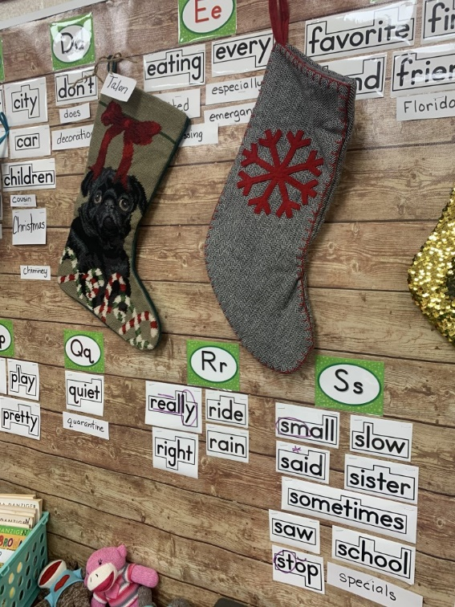
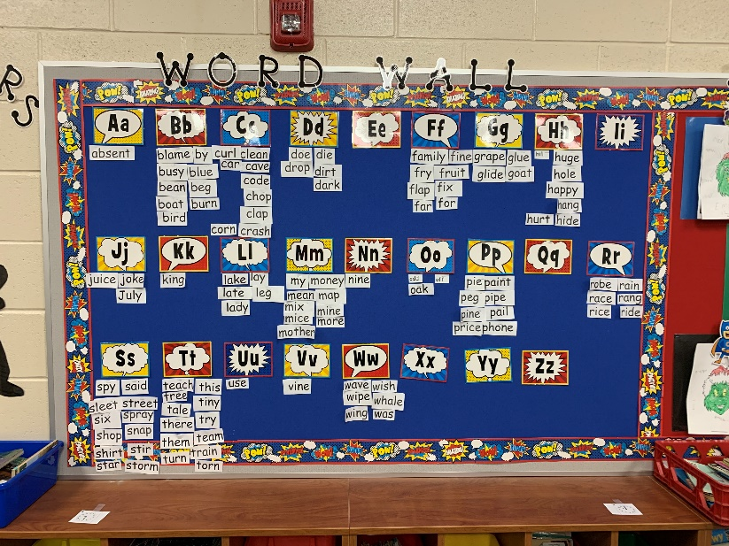
Adding to the word wall, not just sight words

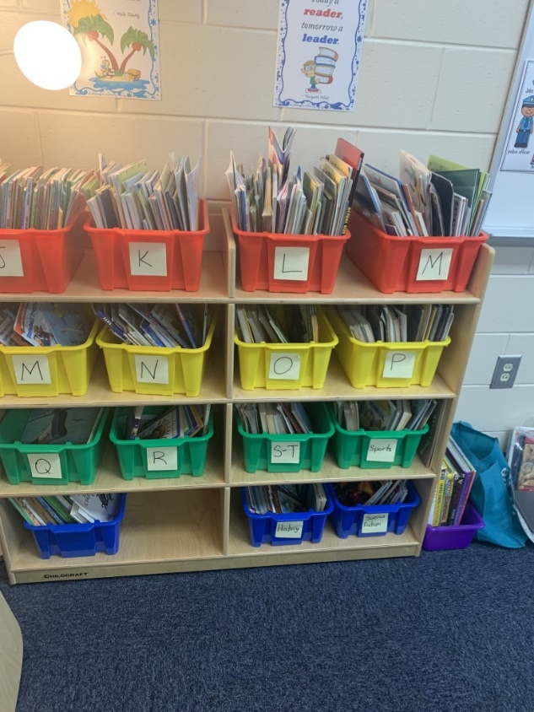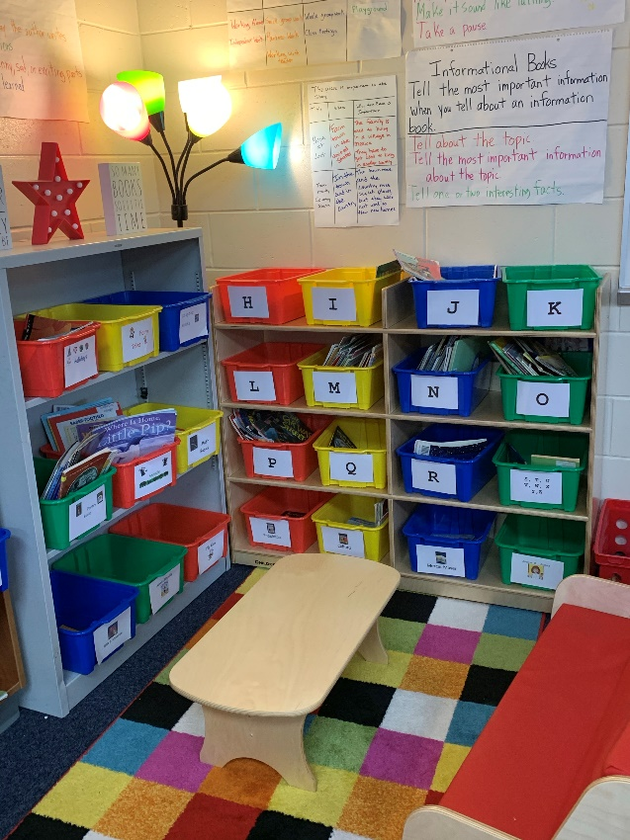
Leveled books and genre books in classroom libraries.

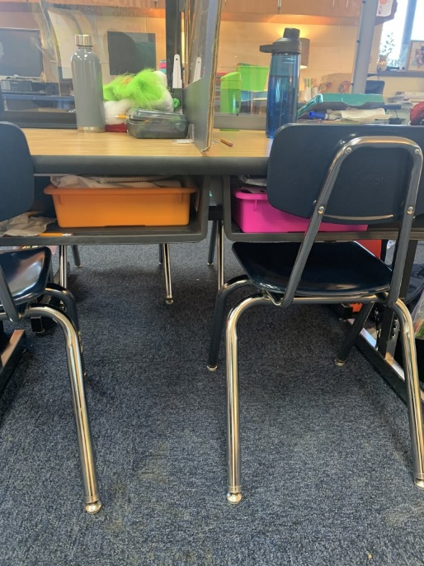

Organized math materials, easy for students to get their materials to bring to a small group
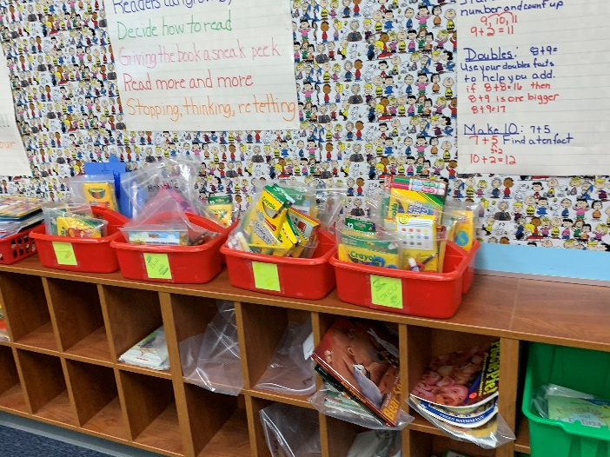

Having an area for small groups

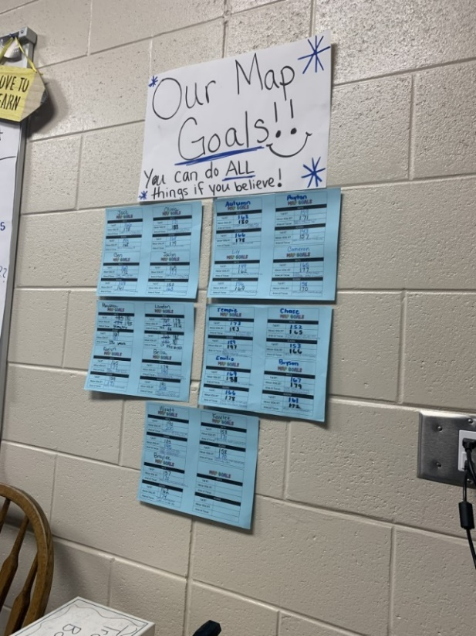
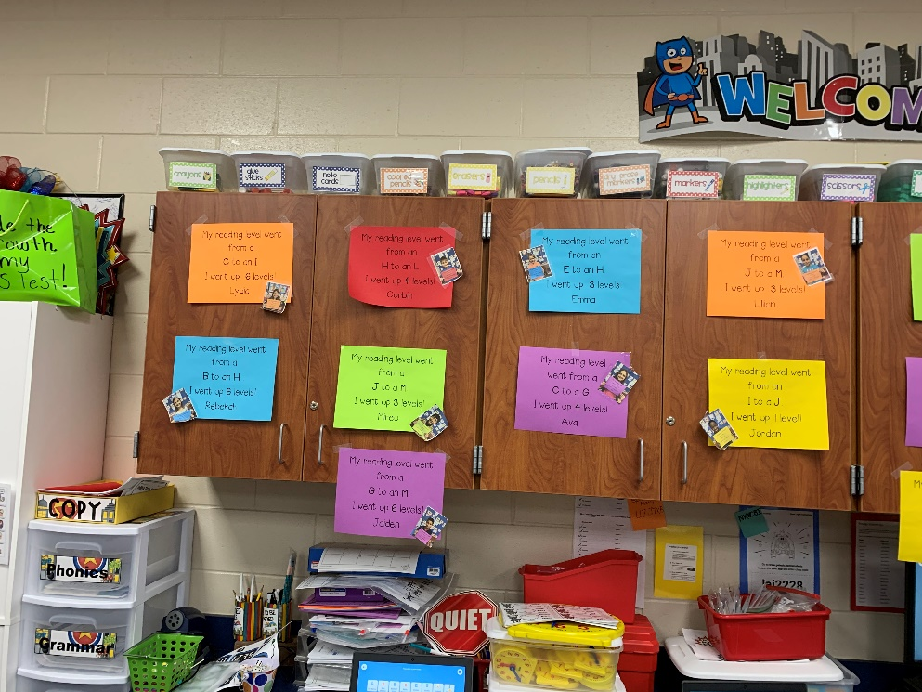

Goals visible to students (can be in their notebooks for math and reading)

