Bonaire Primary School 1st Grade Playbook

Instructional Components, Environments, and Exemplars

Initially created January 2021
1st Grade
Instructional Components:
- Heggerty
- Writing
- Reading Mini Lesson
- Guided Reading & Centers
- Phonics
- Math
- Bobcat Buildup
- Shared Reading
- Interactive Reading
- Science/Social Studies

Bobcat Buildup
Students are regrouped at the grade level based on Essential Skills/Standards.
Groups will last approximately one month.
Each teacher has a group of students based on similar need.
Whole group instruction based on that group level need.
Groups are reassessed at two weeks.
Teachers are actively engaged with students throughout the activity.

Reading Mini Lesson and Independent work:
Teacher will lead the lesson
Teacher will model the lesson
Students will practice
Teach point will be reviewed again
Students will read independently along with center rotations
Students will also have a time to read with a partner or book club
During independent reading the teacher will conference with students and pull small groups
Reading will end with a closing or share time
Anchor charts are available for student viewing

IRA:
Students are seated and able to view the book
Teacher has already tagged book with a goal
Teacher stops to comment or ask questions
Students respond/turn and talk
Teachers monitor students’ responses
When book is finished teacher will ask questions and discuss the book

SR:
Teacher is reading aloud
Students are looking at the book
Students are engaged
Teacher stops to comment or ask questions
Students respond/turn and talk
Teachers monitor students responses
When book is finished teacher will ask questions and discuss the book

Guided Reading:
Teacher has pre-planned book with goals
Students are seated with book
Follow format for F & P lessons: Intro text, Students whisper read while teacher listens in and addresses misconceptions, Discuss book with teaching point, author’s message, word work, write about guided reading once a week, summarize teaching point

Writing:
Teacher models/demonstrates the skill or strategy for the mini lesson that day or students are engaged in an interactive writing lesson.
Students try the skill through active engagement/have a try
During independent practice the teacher will be conferencing, pulling small groups with the students, and strategy groups.
At the end of the lesson, students will have a time to share what they have learned

Heggerty:
Teacher is leading the lesson in front of the class
Students are following along and doing the hand motions for each part

Phonics:
Teacher models/demonstrates the skill or strategy for the mini lesson that day
Students try the skill through active engagement/have a try
At the end of the lesson, students will have a time to share what they have learned

Math:
Teacher will teach skill and model/demonstrate
Students will have a chance to practice the skill
Students will work Independently while the teacher pulls small groups based on data
Students will work in their math center/station after completing their independent work
Manipulatives are accessible for student use
Number Talks/Fluency work
Charts are accessible for student viewing

Science:
Read alouds/Big Books
Video clips to support understanding
Materials are accessible for student use
Independent work/Notebooks

Social Studies:
Read alouds/Big Books
Video clips to support understanding
Materials are accessible for student use
Independent work/Notebooks
Georgia Studies Weekly is used to support

1st Grade Classroom Exemplars and Environment

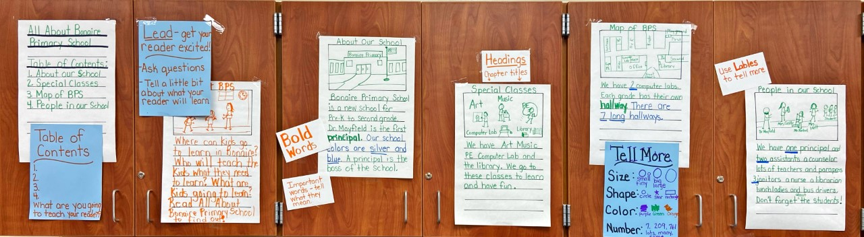
Writing Exemplar Piece Displayed for student’s to refer to…
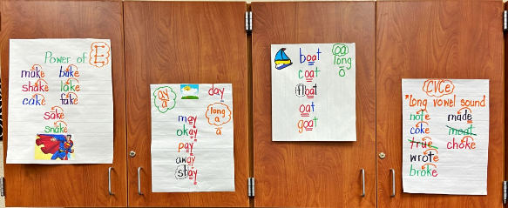
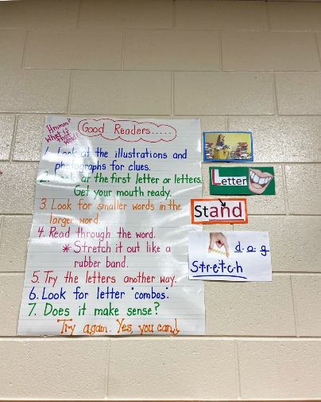

Charts are displayed around the room for students to refer to as needed

Classroom Libraries are set up with leveled books and books divided by genre or author
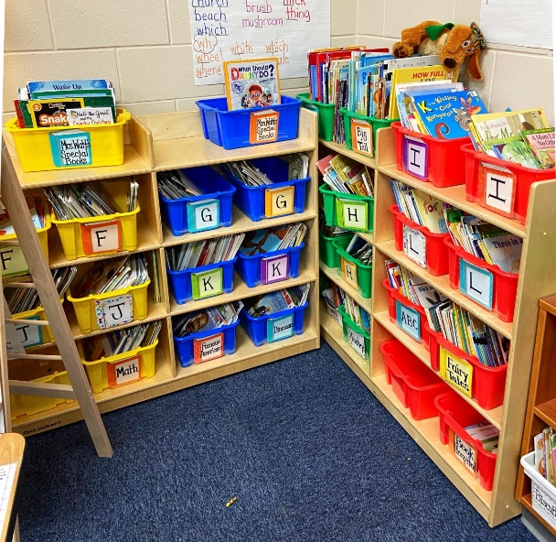
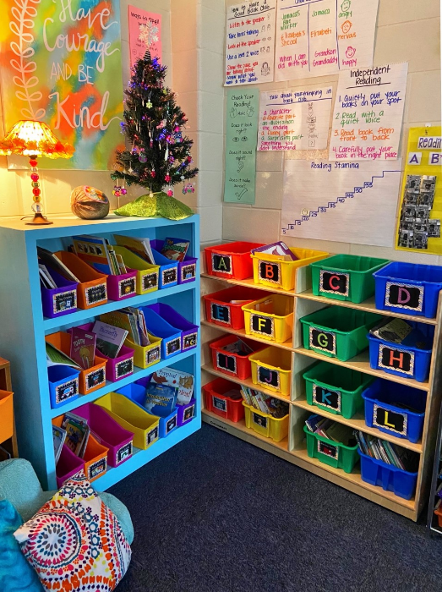

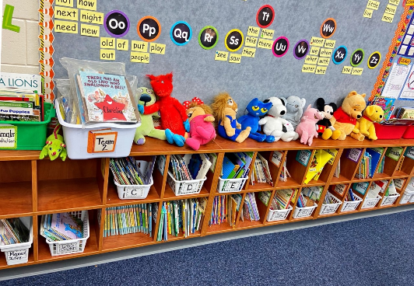
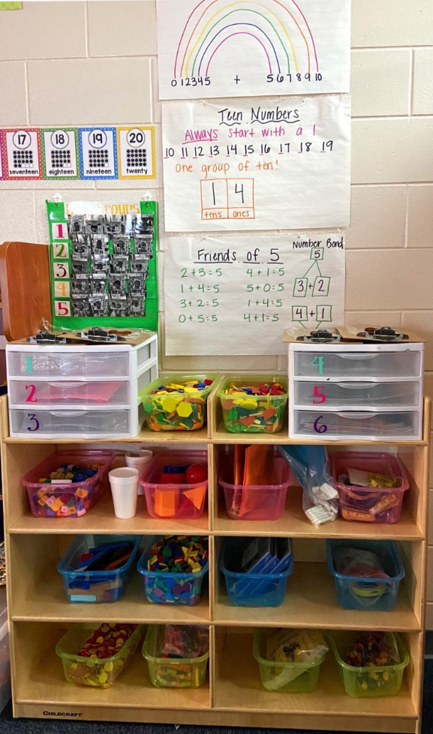

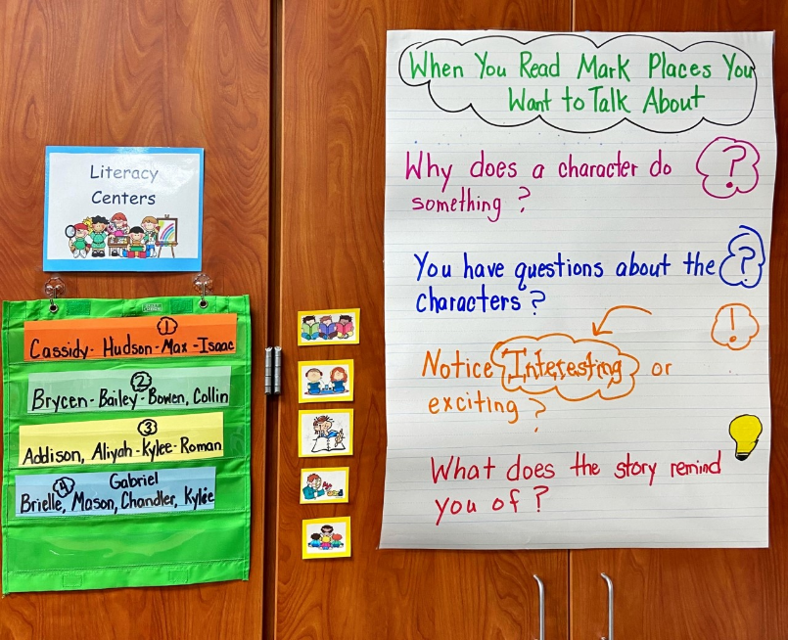

Literacy centers are clearly displayed for students to utilize.

Math Centers and manipulatives are set up for the students to access easily.

