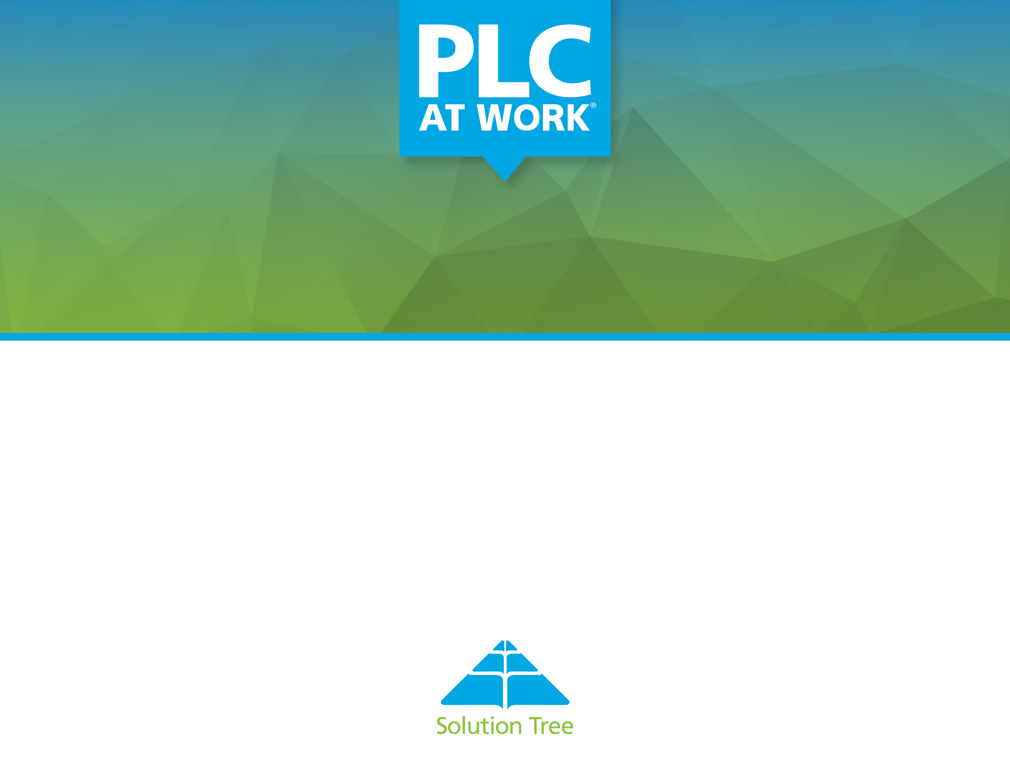

Schoolwide SMART Goals

Bayyari Elementary
Springdale School District
Date: September 2022

Reflection Discussion
Coach Directed Discussion Questions | Help me to understand your current reality.  - Student achievement in state assessments shows significant growth in all areas.  - Staff is committed to the PLC process and values their team collaboration time.  - We have a lot of new staff that we need to ensure to continue to build their knowledge and understanding of the PLC process and RTI.  What do you see as your school’s greatest strengths?  - The staff has moved from buy-in to a commitment to the PLC process.  - Positive relationships with all students continue to grow and teams of teachers take responsibility of all their students.  What do you see as possible roadblocks to the success of this project?  - So much area to grow in Tier 1 and kids having large gaps in their instruction.  - We have a lot of brand new teachers that have to learn essential standards, the PLC process, classroom management skills and effective teaching strategies.  What have been your greatest successes over the past 3 – 5 years?  - ACT Aspire spring 2022 shows significant growth in all areas.  - Beginning to communicate accountability and expectations for high level of learning for all students.  - Receiving the Solution Tree PLC at Work grant to set the school in a new direction for school improvement.  - We now understand what “all students” learning at high levels means.  Here is what I have seen as evidence of your current reality and potential building blocks for your PLC work?  - Work products such as guaranteed viable curriculum timelines,  - ACT Aspire data spring 2022

Suggested Solution Tree Resources
NA

Process Goal from PLC at Work® Continuums
As a schoolwide collaborative team, we will deepen our knowledge and implementation of common formative and summative team assessments to improve student achievement and our school wide system of interventions.

The primary evidence will be through: movement from Developing to Sustaining on the PLC assessment continuum, work products with Angie Freese, common formative and unit summative team assessments, data spreadsheets and protocols that show results, student work products, alignment of rigor and DOK level that is required by the standard.

Indicator of  PLC at Work | What steps or activities must be initiated  to create this condition  in your school? | Who will be responsible for initiating or sustaining these steps or activities? | What is a realistic timeline for each step or phase of the activity? | What will you use to assess the effectiveness of your initiative?
Monitoring Each Student’s Learning | - All staff engaged in professional development with our content coach, Angie Freese.  - Collaborative teams developing multiple common formative team assessments aligned with the learning targets within each essential standard.  - Collaborative teams developing unit summative assessments tied to each essential standard.  - Collaborative teams utilizing effective data organizers and data protocols to ensure we are taking action with the results.  - Collaborative teams improving their knowledge and implementation of aligning assessment questions with the level of rigor and DOK required by the standard. | - All collaborative teams.  are responsible for initiating these steps, with support and monitoring implementation by the guiding coalition. | - Scheduled visits with Angie Freese are on the school calendar.  - Beginning September and roughly every 2-3 weeks throughout the school year.  - Beginning September and identified on each team’s instructional timeline showing when they are administering a unit summative assessment.  - Beginning September and used every 2-3 weeks with every common formative and unit summative assessment.  - This will take place during coaching visits with Angie Freese. | - Movement on the PLC assessment continuum from Developing to Sustaining by the end of the 2022-23 school year.  - Student work products.  - Work products developed with Angie Freese.  - Examples of team formative and summative assessments.  - Team data spreadsheets and data protocols.  - Each team’s student achievement results on each team developed assessment.

Suggested Solution Tree Resources to Support Goal
PD with Angie Freese
Global PD
Solution Tee books or other suggested resources from Angie Freese

Achievement Goal based on School Data
As a schoolwide collaborative team, we will improve in mathematics from (Grades 3-5: 45% to a minimum of 50% ready or exceeding based upon the May 2023 ACT Aspire), and (Grades K-5: 38% proficient to minimum of 45% proficient based upon the May 2023 MAP assessment.

Indicator of  PLC at Work | What steps or activities must be initiated  to create this condition  in your school? | Who will be responsible for initiating or sustaining these steps or activities? | What is a realistic timeline for each step or phase of the activity? | What will you use to assess the effectiveness of your initiative?
Using School Improvement Goals to Drive Team Goals | Each collaborative team will develop one SMART goal tied to the schoolwide goal in math.  Ensure each collaborative team has a minimum of 80 minutes each week to work toward attainment of the team goal.  Each collaborative team will review essential standards in math.  Each collaborative team will continue developing CFAs tied to their Essential Standards and Learning Targets. | Principal, AP, Math Instructional Facilitator, along with site Leadership Team.  Every collaborative team is responsible for carrying out the team goal and action steps. | Team SMART goals set in October, and progress monitoring checkpoints indicated on each team SMART Goal form.  Progress monitoring of school wide goal in January and May 2023. | September, January, and May summative MAP assessment data.  Grade level team formative assessment data.

Suggested Solution Tree Resources to Support Goal
- Coaching from Samantha Neff and David Jones
- Assessment coaching from Angie Freese
- Global PD

Achievement Goal based on School Data
.As a schoolwide collaborative team, we will improve in reading from (Grades 3-5: 24% ready or exceeding to a minimum of 30% ready or exceeding based upon the May 2022 ACT Aspire), and (Grades K-5: 32% proficient to minimum of 40% proficient based upon the May 2023 MAP assessment).

Schoolwide goal set by the RTI team:
As a schoolwide collaborative team, we will reduce the percentage of K-5 tier 3 students in reading from 163 students (34%) to 122 students (25%) by May 2023. This goal is based upon the 2022 fall MAP reading assessment and the students who scored in the 21% or below.

As a schoolwide collaborative team, we will improve in Language Arts (Language Usage) from (Grades 3-5: 62% ready or exceeding to a minimum of 70% ready or exceeding based upon the May 2023 ACT Aspire), and (Grades 2-5: 40% proficient to minimum of 45% proficient based upon the May 2023 MAP assessment.

Indicator of  PLC at Work | What steps or activities must be initiated  to create this condition  in your school? | Who will be responsible for initiating or sustaining these steps or activities? | What is a realistic timeline for each step or phase of the activity? | What will you use to assess the effectiveness of your initiative?
Using School Improvement Goals to Drive Team Goals | Each collaborative team will develop one SMART goal tied to the RLA school wide goal.  Each collaborative team will set short term goals tied to every CFA in RLA throughout the school year.  Ensure each collaborative team has a minimum of 80 minutes each week to work toward attainment of the team goal.  Review Essential Standards and an Instructional Timeline in RLA.  Collaborative teams will revise and improve common formative assessments in RLA to monitor progress in attaining the team SMART goal. | Principal, AP, Literacy Instructional Facilitator, along with site Leadership Team.  Every collaborative team is responsible for carrying out the team goal and action steps. | Team SMART goals set in September, and progress monitoring checkpoints will be indicated on each team SMART Goal form.  Progress monitoring of school wide goals in January and May 2023.  Essential Standards in RLA will be revised, if needed, by October 30, 2022.  Timelines for administering and analyzing common formative team assessments will be noted on each team’s Essential Standards Instructional Timeline | September, January, and May summative MAP assessment data.  Grade level team formative and summative assessment data.

Suggested Solution Tree Resources to Support Goal
- Learning by Doing
- Global PD
- Coaching support from David Jones, Angie Freese and Jaquie Heller

Stretch Goal
By June 2023, Bayarri students will increase the percentage of students proficient in READING by a minimum of 15% based upon the 2023 end of year MAP and ACT Aspire summative assessments.

Current Reality: We are 8% points away from meeting our stretch goal on the READING portion of the ACT Aspire based upon the 2022 ACT Aspire assessment.

By June 2023, Bayarri Elementary School will be recognized as a model PLC school.

Indicator of  PLC at Work | What steps or activities must be initiated  to create this condition  in your school? | Who will be responsible for initiating or sustaining these steps or activities? | What is a realistic timeline for each step or phase of the activity? | What will you use to assess the effectiveness of your initiative?
Using School Improvement Goals to Drive Team Goals | Attain each collaborative team goal and school wide goal in RLA from year to year. We will analyze the summative MAP and ACT Aspire data to determine progress and make adjustments to attain this stretch goal.  Begin progress monitoring and develop action plans for all Tier 3 students with the new 2021-22 schoolwide intervention team.  Develop an improved Tier 2 and Tier 3 intervention schedule, and ensure intervention is driven by student’s needs at the target level.  Develop and improve teacher efficacy in believing in themselves and our students to achieve at a higher level. | Principal, AP, Literacy Instructional Facilitator, along with site Leadership Team.  Every collaborative team is responsible for carrying out the team goal and action steps. | Goal completion is June 2023.  Annual school wide goals to monitor progress in achieving the stretch goal will be evaluated in June 2021, June 2022, and June 2023.  The timelines for SMART goal progress monitoring checkpoints will be indicated on each team’s SMART goal form developed in September 2020, 2021, and 2022 | End of year MAP summative assessment data in 2021, 2022, and 2023.  End of year ACT Aspire data in 2021, 2022, and 2023.  The attitudes, behavior, and communication during staff and team collaboration will improve to support efficacy and high levels of learning for all students.

Suggested Solution Tree Resources to Support Goal
- Taking Action
- Learning by Doing
- Global PD
- Support from David Jones

Coach Directed Next Steps
What has been accomplished since last we met (not applicable in first meeting)?
Click or tap here to enter text.

What are the next steps?
This is an annual goal setting document, therefore, the next steps (action steps) are outlined in the Year 3 PLC Action Plan

What homework needs to be assigned?
Related to this document and goal setting, all collaborative teams will write a SMART goal tied to the two schoolwide goals. Teams will write short-term goals on and off throughout the school year tied to their essential standards.

