MISSION STATEMENT, VISION STATEMENT, CORE BELIEFS
& COLLECTIVE COMMITMENTS
Fort Smith School District Mission Statement
The mission of the Fort Smith Public Schools is to ensure academic
and personal success for each student today and in the future.

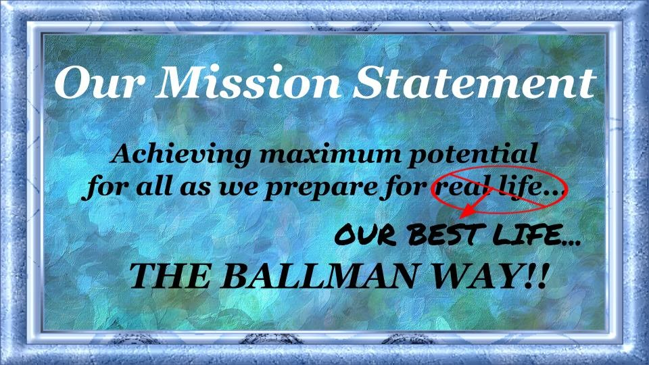

Ballman Elementary Vision Statement
We are an innovative school aiming to prepare our students for a rapidly changing world by equipping them with critical thinking skills, global perspective, and respect for core values of honesty, loyalty, and compassion. Development of these skills is the cornerstone of education.
Students will work toward their maximum potential today to be prepared for tomorrow.

Ballman Elementary Core Beliefs
(Behavior)
- Engaged students have fewer behavior problems
- Set procedures and be consistent
- Create positive relationships for positive behavior
- Active, relevant learning contributes to positive behavior
- Positive incentives will improve behavior
(Learning for Students)
- All students can learn and make progress
- Active involvement creates productive learners
- Provide a safe environment for active learning
- Build positive teacher/child relationships
- Children learn from each other
(Instruction)
- Assessment drives instruction
- Differentiated instruction is necessary to meet all student needs
- Students deserve to be challenged-Set high expectations
- Essential questions and instruction must be meaningful
- The pace of instruction is determined by the pace of learning
(Learning for Adults)
- Adults are life-long learners
- Learn from our mistakes and experiences
- We learn from each other
- We choose our own paths
- If you think you can, you can. If you think you can’t, you can’t.

Collective Commitments
for Staff:

- I will provide a positive, supportive school culture where everyone feels emotionally, physically, and intellectually safe.
- I will promote and celebrate student successes.
- I will meet individual needs by monitoring and using evidence of student learning gathered from formative assessments to improve my instruction and will have the information completed in time for weekly meetings.
- I will teach the essential skills (both academic and behavior) of our agreed-upon curriculum, unit by unit, and keep them updated on the BIC Site.
- I will enhance student engagement by fostering students’ intellectual curiosity.
- I will be a POSITIVE, contributing member of our collaborative team.
- I will work effectively with my colleagues to achieve our SMART goals and will record the results inside the unit plans.
- I will keep parents informed of the progress of their children.

Collective Commitments
for Parents:

- Support learning by having my child at school on time each day and not checking out early unless it is an emergency.
- Spend at least 30 minutes each day discussing with my child what he/she has learned at school, make sure homework is completed each day, and limit the time my child watches TV, spends time on video games, or on the computer.
- Encourage my child to treat others the way he/she wants to be treated.
- Love, discipline, and teach my child honesty, morals, and responsibility by setting good examples for him/her to follow.
- Communicate and work with my child’s teacher on a regular basis and attend all parent/teacher conferences.
- Participate in my child’s education by volunteering and serving on advisory committees whenever possible.
- Keep contact information updated in the office.
- Follow procedures for parent drop-off and pick-up.

Collective Commitments
for Students:

- Attend school regularly and be on time with homework, supplies and books.
- Work hard to do my best in class and complete all work assignments.
- Respect people and property.
- Show a positive attitude toward self, others, school and parents.
- Use only kind and respectful words and actions to avoid any mean behavior.
- Read at least 30 minutes every day outside of school time.
- Give notices and information to my parents received from my school on a daily basis.
- Will show school spirit by participating in activities during the school day.

