3RD GRADE | Grade  To Grade  15 to 16 | Grade to  Grade  16 to 17
WHOLE | + 18% | +5%
M P | - 3% | -8%
P P | - 15% | +3%
P | + 8% | +7%
H P | + 9% | -2%
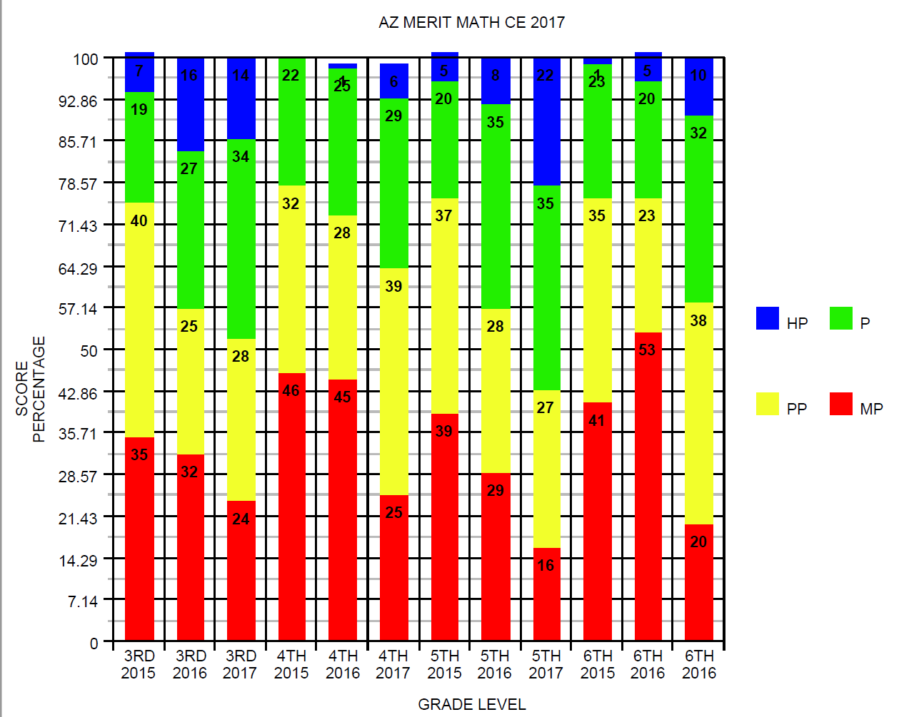

6th GRADE | Grade to Grade  15 to 16 | Cohort  15 to 16 | Grade  to Grade  16 to 17 | Cohort  16 to 17
WHOLE | + 1% | + 1% | +17% | -1%
M P | + 12% | + 14% | -33% | -9%
P P | - 12% | - 14% | +15% | +10%
P | - 3% | - | +12% | -3%
H P | + 4% |  | +5% | +2%

4th GRADE | Grade to Grade  15 to 16 | Cohort  15 to 16 | Grade  to Grade  16 to 17 | Cohort  16 to 17
WHOLE | + 5% | + 2% | +9 | -8
M P | - 1% | + 10% | -20 | -7
P P | - 4% | - 12 | +11 | +14
P | + 3% | - 6% | +4 | +2
H P | + 1% | - 6% | +5 | -10
Grade to Grade  15 to 16 | Grade to Grade  15 to 16 | Cohort  15 to 16 | Grade  to Grade  16 to 17 | Cohort  16 to 17
WHOLE | + 19% | + 21% | +14% | +31%
M P | - 10% | - 17% | -13% | -29%
P P | - 9% | - 4% | -1% | -1%
P | + 15% | + 13% | ---- | +10%
H P | + 3% | + 8% | +14% | +21%

Third Grade | # of Students | % Proficient
EL | 16 | 13%
C | 28 | 59%
N | 29 | 55%
S | 27 | 48%

Grade Level | # of Students | % Proficient | Increase in Proficiency Level | Met Target Growth | High Growth | Average Growth | Low Growth
4th EL | 12/11 | 33% | 55% | 64% | 64% | 13% | 13%
4th | 83/78 | 36% | 18% | 35% | 31% | 32% | 37%
5th EL | 8/4 | 38% | 38% | 50% | 100% | 0 | 0
5th | 55/54 | 60% | 59% | 61% | 70% | 22% | 7%
6th | 71/67 | 42% | 24% | 54% | 54% | 36% | 10%

Highest
Second
Third

s

