3RD GRADE | Grade to Grade | Grade to Grade
WHOLE | + 5% | -1%
M P | - 4% | +3%
P P |  | -2%
P | + 5% | +3%
H P | +1% | -4%
4th  GRADE | Grade to Grade  15 to 16 | Cohort  15 to 16 | Grade  to Grade  16 to 17 | Cohort  16 to 17
WHOLE | + 9% | + 4% | +9% | +7%
M P | - 15% | - 14% | -- | -14%
P P | + 6% | + 9 | -9% | +6%
P | + 7% | +7% | +5% | +8%
H P | -2% | - 2% | +4% | -1%
5th  GRADE | Grade to Grade  15 to 16 | Cohort  15 to 16 | Grade  to Grade  16 to 17 | Cohort  16 to 17
WHOLE | + 24% | + 18% | +8% | +18%
M P | - 11% | - 22% | -12% | -16%
P P | - 12% | + 5% | +4% | -1%
P | + 21% | + 16% | +6% | +14%
H P | + 2% | + 2% | +2% | +4%
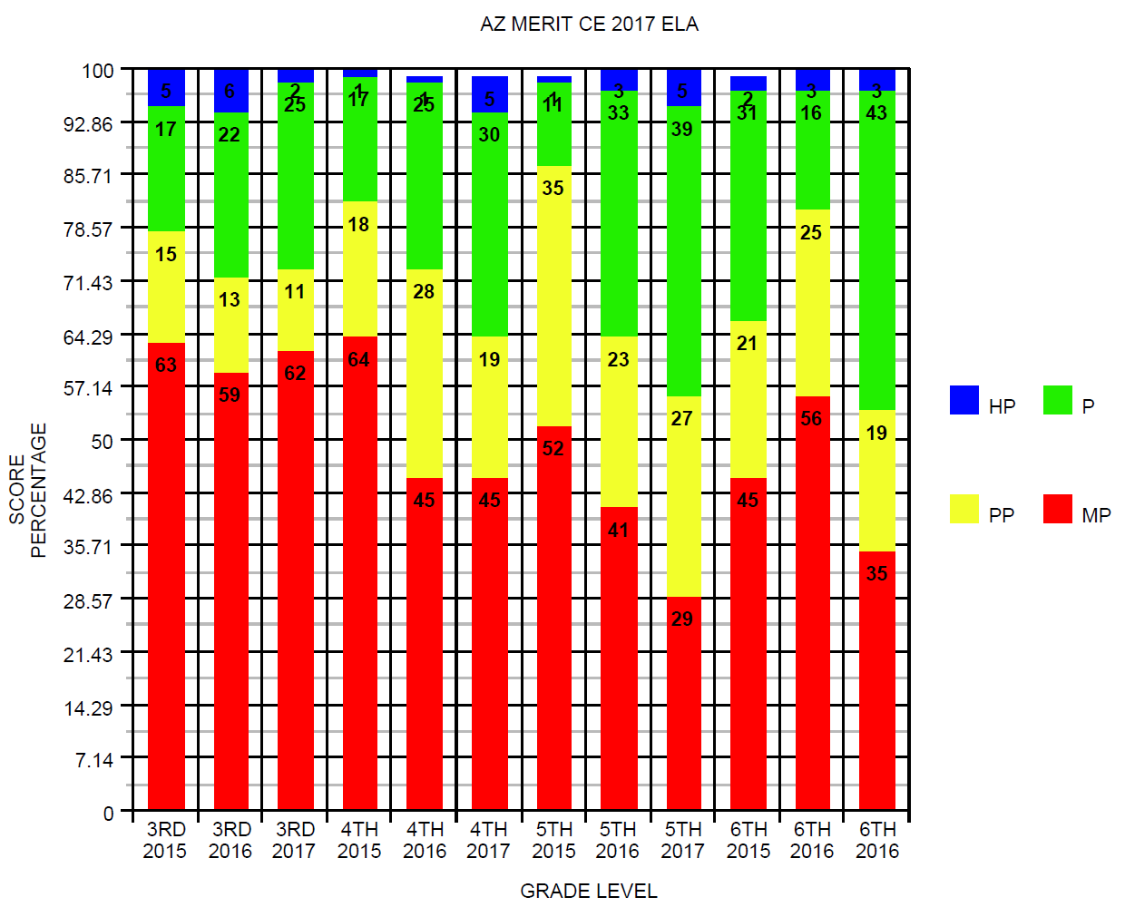

6th  GRADE | Grade to Grade  15 to 16 | Cohort  15 to 16 | Grade  to Grade  16 to 17 | Cohort  16 to 17
WHOLE | - 15% | + 7% | +27% | +10%
M P | + 11% | + 4% | -21% | -6%
P P | + 4% | - 10% | -6% | -4%
P | - 15% | + 5% | +27% | +10%
H P | + 1% | - 2% | -- | --

Third Grade | # of Students | % Proficient
EL | 16 | 0%
C | 28 | 50%
N | 29 | 25%
S | 26 | 26%

Grade Level | # of Students | % Proficient | Increase in Proficiency Level | Met Target Growth | High Growth | Average Growth | Low Growth
4th EL | 12/11 | 8% | 18% | 18% | 36% | 36% | 27%
4th | 81/73 | 40% | 29% | 44% | 29% | 37% | 34%
5th EL | 9/4 | 11% | 22% | 75% | 100% | 0 | 0
5th | 53/52 | 49% | 30% | 50% | 48% | 33% | 19%
6th | 68/63 | 46% | 21% | 59% | 57% | 22% | 21%

HIghest
Second
Third

