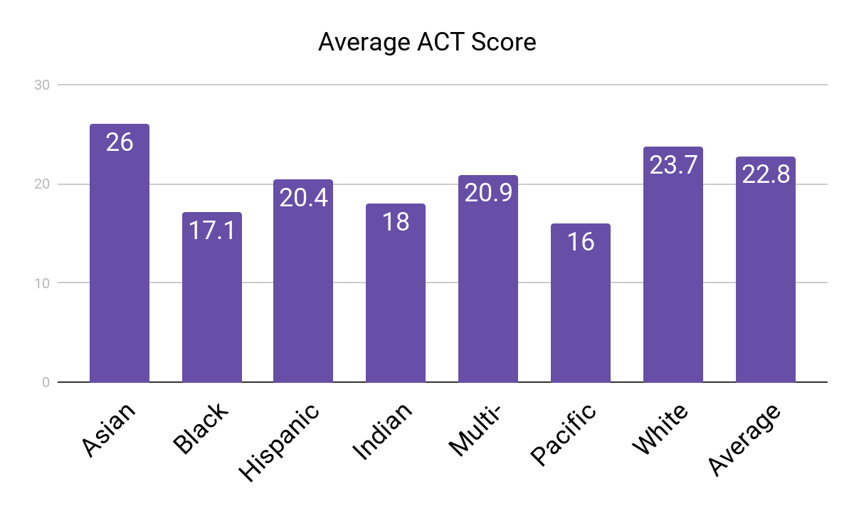
The above bar chart is the average ACT composite score for our students who took the ACT during the 16-17 school year. The two largest populations of our building are our White students who make up 66.3% of our population and our Black students who make up 16.6% of our population. Our two smallest populations are our Indian and Pacific Islander populations which each represent .4% of our population.

This chart provides reasons for celebration and concern. Our overall average is two points higher than the state average (20.4) however, our Black population average is three points lower than the state average and six points lower than their White counterparts. The difference between our White and Black scores is the mark in which we will gauge our progress in making Hickman a place where all students can learn. We have set our goal to increase the average ACT score for our Black students from 17 to 19 by 2021. To accomplish this goal we have aligned our school improvement plan with the work of our share leadership teams which are focused on reducing the number of referrals received by our Black students, reducing the number of failing grades by improving tier 1 instruction, and increasing enrollment into AP/Honors courses for our students of color.

