Have we grown since becoming a
Professional Learning Community?

In 2005 (prior to beginning our PLC journey), the following data was noted in the school report card by the state of New York in regard to CR Weeks Elementary School:
Both the Grade 4 ELA Assessment and Grade 4 Math Assessment results (the only assessments administered at the time at the elementary level) were considered "below average" compared to similar schools.
Today, the Windsor Central School District (pink dot) outperforms the majority of similar schools in the state (grey dots) as noted by the 2019 released assessment performance charts below:

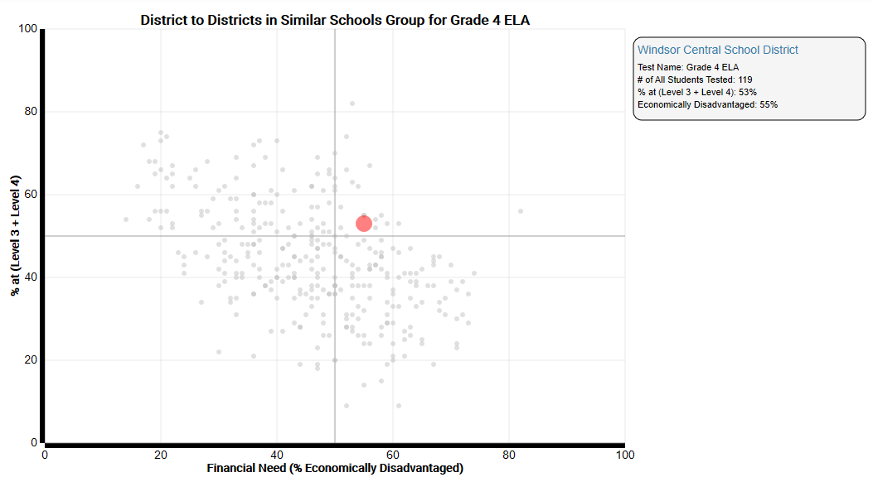
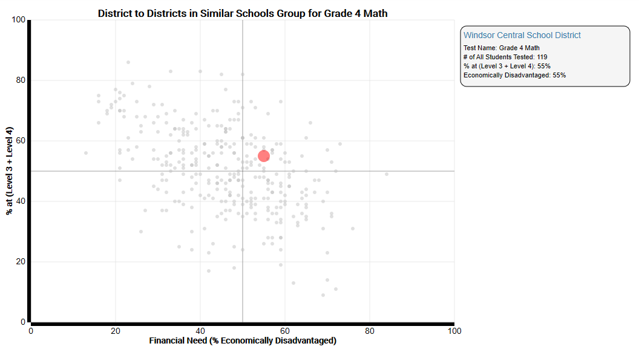
In 2017, the staff of C.R. Weeks Elementary School proudly opened their doors to a districtwide special education inclusive classroom. We wanted to ensure that our most striving learners stayed in our own community, rather than be sent to locations off site.
A majority of these students take the state assessments (despite it being challenging for many.) While we do not like to use this as an excuse, with full grade level class sizes in the building of approximately 40 students, 3-6 students per grade level who score below proficiency level do make a significant difference in overall proficiency levels for the school.
Below is a chart showing overall building proficiency. We pride ourselves in the fact that with the inclusion of these striving learners, the proficiency rates (from 2017 to 2019) actually are improving or are remaining somewhat steady. We will continue to do all that we can as a professional staff to continue to support our students and raise these levels.
Overall Proficiency | 2017 | 2018 | 2019
ELA | 39% | 42% | 41%
MATH | 63% | 60% | 58%

Overall proficiency of non-economically disadvantaged students is as follows:
Overall Proficiency | 2018 | 2019
ELA
Grade 3 | 55% | 70%
Grade 4 | 87% | 45%
Grade 5 | 45% | 53%
Math
Grade 3 | 62% | 70%
Grade 4 | 75% | 67%
Grade 5 | 69% | 73%

As evidenced in our application, while these percentages may not always reflect true numerical increases, it is critical to note that small numbers of students can drastically change overall percentiles. We are incredibly proud of the 2019 Recognition School Award from the NYS Department of Education where our inclusive environment and focus on continuous improvement were celebrated.

