HOW TO GET THE MOST OUT OF WATCHING YOUR VIDEO
Getting Ready
Watching yourself on video is one of the most powerful strategies you can use to improve. However, it can be a challenge. It takes a little time to get used to seeing yourself on screen, so be prepared for a bit of a shock. After a little time, you will become more comfortable with the process.
- Find a place to watch where you won’t be distracted.
- Review the “Watch Yourself” and/or “Watch Your Student” forms to remind yourself of things to keep in mind while watching.
- Set aside a block of time so you can watch the video uninterrupted.
- Make sure you’ve got a pen and paper ready to take notes.
Watching the Video
- Plan to watch the entire video at one sitting.
- Take notes on anything that catches your attention.
- Be certain to write the time from the video beside any note you make so that you can return to it should you wish to.
- People have a tendency to be too hard on themselves, so be sure to also watch for things you like.
- After watching the video, review your notes and circle items you will discuss further with your coach. Take time to respond to the reflection questions as well.
- Sit back, relax and enjoy the experience.

- How do you feel the structure of the lesson played out?

- How do you feel like the level of engagement flowed throughout the lesson?

- How do you feel the routines and procedures flowed throughout the lesson?

- What did you notice about the interactions between you and the students?

- What do you think went well that you would want to share with your team?

- Did you notice any part of the lesson that you would want to redo, and what would you do differently?

WATCH YOURSELF
After watching the video of today’s class, please rate how close your instruction is to your ideal in the following areas:
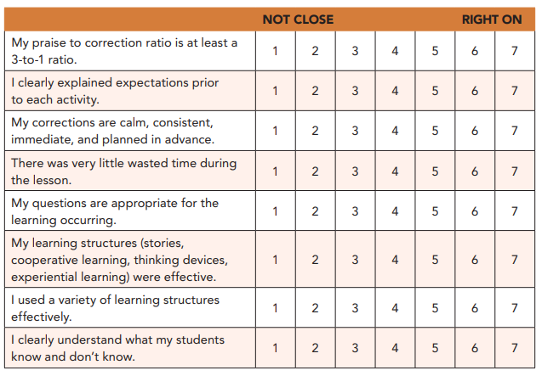

WATCH YOUR STUDENTS
After watching the video of today’s class, please rate how close the behavior of your students is to your goal for an ideal class in the following areas:
