MURDOCK ELEMENTARY

CONTENT MASTERY
Content Mastery addresses whether students are achieving at the level necessary to be prepared for the next grade, college, or career. This component includes achievement scores in English language arts, mathematics, science, and social studies on Georgia Milestones and Georgia Alternate Assessment 2.0.
2023 ELA Content Mastery
State Average | 62.12
District Average | 73.07
Murdock Elementary | 100.0
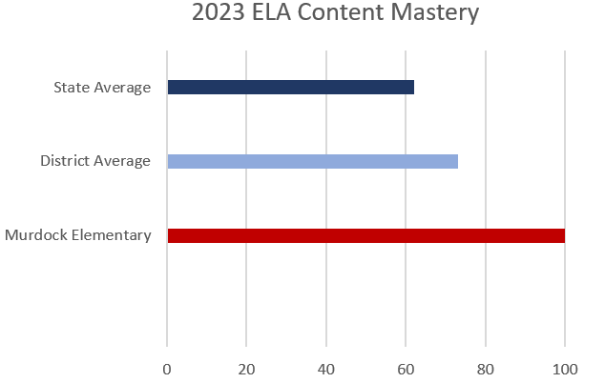

2023 ELA Content Mastery
State Average | 68.80
District Average | 76.11
Murdock Elementary | 100.0
