Fayette R-III APR

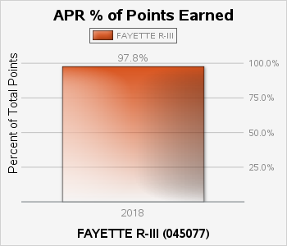

What is it?
APR Points Earned is the overall score for each of the MSIP 5 Performance Standards - Academic Achievement, Subgroup Achievement, High School Readiness, College and Career Readiness, Attendance Rate and Graduation Rate.

How is it calculated?
The Comprehensive Guide to the Missouri School Improvement Program outlines the calculation in detail: https://dese.mo.gov/sites/default/files/MSIP_5_2017_Comprehensive_Guide_0.pdf

How is it used?
The APR Points Earned is used to determine the accreditation level of a school district.

Why is it important?
The APR Points Earned is used to determine the accreditation level of a school district.

The graph represents districts held accountable for a subset of all APR standards.

