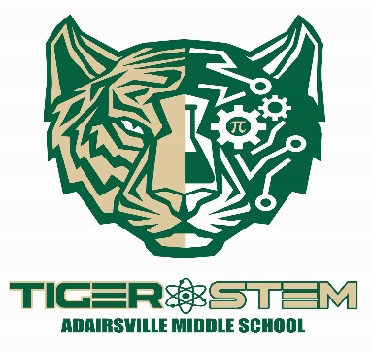
PLC Artifacts
(In the order of appearance)

PLC Story
Mission, Vision, & Collective Commitments
AMS PLC Timeline
BCSS Playbook
AMS SIT Team
AMS RTI Pyramid
BCSS A-Team Process
A-Team Application
R.E.A.L Criteria
Ladder of Complexity
Guaranteed and Viable Curriculum

PLC Practices
TA Cycle Unit Plan
Teaching Assessing Cycle
Collaborative Schedule
Focus Time
P.B.I.S Matrix
P.B.I.S Student Menu
Adairsville Middle School State STEM Certification

Achievement Data
AMS Student Achievement Data
Discipline Data
AMS Tier 2
AMS Tier 3

Awards/Recognitions
AMS Awards and Recognitions
State STEM Certified School
School Climate Ratings

Supplemental Artifacts
BCSS References and Resources

