American Literature End-of-Course Exam – Georgia Milestones
Year | 2017-2018 | 2018-2019 | 2019-2020  S1 ONLY* | 2020-2021 | 2021-2022 | 2022-2023
Proficient+  (80-100) | 33.0% | 34.2% | 32.9% | 30.8% | 24.0% | 18.7%
Developing +  (68-100) | 76.3% | 78.3% | 71.9% | 68.6% | 74.0% | 63.3%
 | No Collaborative Teams | No Collaborative Teams- Began Guiding Coalition in Spring | Collaborative Teams began; focus only on essential standards, CFAs, and prevention | Collaborative Teams; added focus on CSA and Tier 2 | Continued collaborative teams with focus on Tier 1 and Tier 2 | Continued collaborative teams with focus on Tier 1 and Tier 2
*2019-2020 – Winter Milestone data only. No Milestone administration during the Spring of 2020.
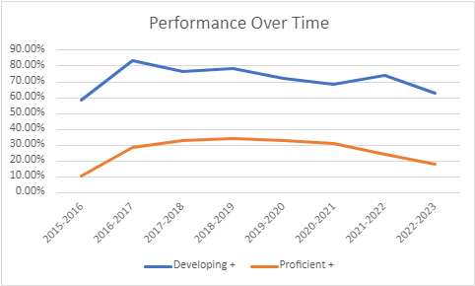

Our American Literature team consists of four ELA teachers. Our ELA team was completely new beginning in 2021-2022. This change in our department has impacted our ability to move students to proficiency. We are working to improve vertical alignment to ensure that students are better prepared for the Milestone exam in 11th grade.

American Literature End-of-Course Exam - Exceptional Education Trends
Achievement Level | 2019-2020  S1 Data Only* |  | 2020-2021 |  | 2021-2022 |  | 2022-2023
 | Total | 82 | Total | 197 | Total | 212 | Total | 166
 | Ex Ed Total | 4 | Ex Ed Total | 12 | Ex Ed Total | 21 | Ex Ed Total | 22
 | Number | Percentage | Number | Percentage | Number | Percentage | Number | Percentage
Beginning (0-67) | 1 | 25% | 10 | 67.67% | 11 | 52.4% | 15 | 68.18%
Developing (68-79) | 2 | 50% | 2 | 33.33% | 10 | 47.6% | 7 | 31.82%
Proficient (80-91) | 1 | 25% | 0 | 0% | 0 | 0% | 0 | 0
Distinguished (92-100) | 0 | 0% | 0 | 0% | 0 | 0% | 0 | 0
*2019-2020 only consists of exceptional education students taking the exam in the Winter of 2019. These students were all served on a consult basis. The students served through inclusion would have tested in the Spring of 2020.

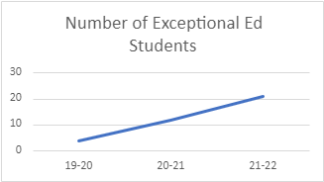
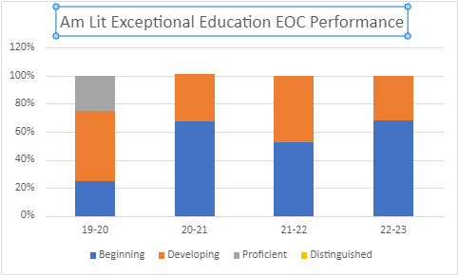
15
7
11
10
10
2
1
2
1
The number of exceptional education students at the BCCCA has increased rapidly since 2020. Prior to 2020, the only exceptional education students allowed to attend the Academy were those who experienced high levels of academic success on a consult-only model. Whereas, passing the test does not represent proficiency in Georgia, we are seeing many more students requiring more supportive models pass their EOC at the BCCCA. In addition, our inclusion Exceptional Education students are outscoring the district on the American Lit EOC (See table below).
Am Lit | Developing+
DHS 1 | 12.00%
DHS 2 | 9.09%
DHS 3 | 31.58%
BCCCA | 31.82%
*DHS – District High School

American Literature End-of-Course Exam – ELL Trends
Achievement Level | 2019-2020  S1 Data Only |  | 2020-2021 |  | 2021-2022 |  | 2022-2023
 | Total | 82 | Total | 179 | Total | 212 | Total | 166
 | ELL Total | 0 | ELL Total | 2 | ELL Total | 3 | ELL Total | 2
 | Number | Percentage | Number | Percentage | Number | Percentage | Number | Percentage
Beginning (0-67) | 0 | 0% | 2 | 100% | 3 | 100% | w | 100%
Developing (68-79) | 0 | 0% | 0 | 0% | 0 | 0% | 0 | 0%
Proficient (80-91) | 0 | 0% | 0 | 0% | 0 | 0% | 0 | 0%
Distinguished (92-100) | 0 | 0% | 0 | 0% | 0 | 0% | 0 | 0%

The English Language Learner (ELL) population at the Academy is very small. We do not have an push-in model ESOL teacher on staff to serve these students. However, beginning in the Spring of 2021, all academic teachers began training directly geared toward supporting ELLs. This is an area we know we need to improve.
American Literature End-of-Course Exam – Economically Disadvantaged Trends
Achievement Level | 2019-2020  S1 Data Only* |  | 2020-2021 |  | 2021-2022 |  | 2022-2023
 | Total | 82 | Total | 179 | Total | 212 | Total | 166
 | ED Total | 52 | ED Total | 62 | ED Total | 64 | ED Total | 51
 | Number | Percentage | Number | Percentage | Number | Percentage | Number | Percentage
Beginning (0-67) | 18 | 34.62% | 28 | 45.16% | 17 | 26.6% | 21 | 41%
Developing (68-79) | 18 | 34.62% | 25 | 40.32% | 33 | 51.6% | 24 | 47%
Proficient (80-91) | 16 | 30.77% | 9 | 14.52% | 14 | 21.9% | 6 | 12%
Distinguished (92-100) | 0 | 0.00% | 0 | 0% | 0 | 0% | 0 | 0%

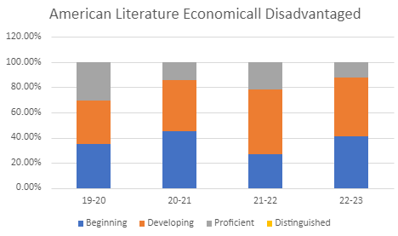

66
14
9
16
25
24
33
18
28
21
17
18

The Academy attracts many economically disadvantaged students because they are able to obtain career credentials and technical certificates while in high school. While students are here at the Academy earning credentials, they must also take an ELA course. Between 2019-2020 and 2021-2022, we saw economically disadvantaged students moving out of the beginning learner level and into developing and higher. Whereas there was an increase in beginning learners in 2022-2023, we have used our data and research to establish a plan for next year to improve performance.

