NAPLAN: Education chief warns students not improving
Date: August 5, 2015

Alexandra Smith, Henrietta Cook
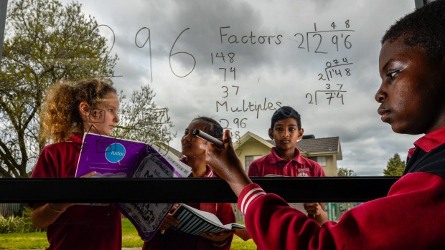
Year 6 students Holly, Nobel, Andrew and Joshua from Harrisfield Primary School in Noble Park. The school has performed well in NAPLAN. Photo: Penny Stephens
The literacy and numeracy skills of Australian students have stagnated since the controversial NAPLAN tests were introduced in 2008.
New NAPLAN data reveals that primary school students have made minimal improvements but high school students have slipped, particularly in writing tasks.
Education experts are warning that teaching needs to change if the performance of Australian students is to significantly rise.
The head of the Australian Curriculum, Assessment and Reporting Authority, Robert Randall, said this year's NAPLAN results showed "that at a national level we are seeing little change in student achievement in these important areas of learning".
Advertisement
"This data does not show the extent of improvement we would like to see," Mr Randall, who oversees NAPLAN, said.
"I'd like to be reporting better results; they are not bad results, but I'd like to see some improvement."
The results show that since 2008, reading, grammar and writing skills have improved for year 3 students and spelling and numeracy have improved for year 5.
But the writing skills of year 7 and 9 students have dropped, and all other results have been stable.
Mr Randall said the National Assessment Program: Literacy and Numeracy – which tests children in years 3, 5, 7 and 9 – was "not in itself a means of improving the quality of education". But he said it provided data for "objective discussion about what is working and what is not".
University of Melbourne emeritus professor Patrick Griffin said he was not surprised NAPLAN results had flat-lined.
Professor Griffin, an expert in assessments in schools, said NAPLAN would be more useful if it helped teachers improve and target their teaching.
"If you want to change student performance you actually have to change teaching," he said.
"Unless NAPLAN, or any other testing strategy, looks to give teachers advice on how to make the change, then that change doesn't happen. And NAPLAN doesn't provide teachers with that."
The results show that NSW, Victoria and the ACT had the highest average NAPLAN scores this year, but the only states with significant improvement were Queensland and Western Australia.
Year 3 students recorded improvements in their writing task this year after ACARA was forced to introduce different questions for primary school students. Last year's persuasive writing question was criticised for being too confusing and many students scored zero.
Victorian Education Minister James Merlino said while Victoria continued to be a leading jurisdiction, there had not been "significant or consistent growth in learning outcomes" across all year levels and domains. This reinforced the importance of new initiatives to lift the achievement of all Victorian students, he said.
Harrisfield Primary School in Noble Park appears to be bucking the trend and was identified as a "high-gain school" by ACARA earlier this year after recording significant improvements in year 3 and 5 numeracy.
They are now waiting to receive the 2015 NAPLAN individual student reports, which will be delivered to Victorian schools from August 17, around two weeks earlier than last year.
Principal Meredith Iaconese attributes the school's success to its structured and targeted approach to learning. The primary school operates a bit like a high school, with students moving from teacher to teacher for different subjects.
Students from up to three year levels are organised into fluid groups based on their ability.
"We are able to target the deficiencies, and also extend those who are competent."
Read more: http://www.theage.com.au/victoria/naplan-education-chief-warns-students-not-improving-20150804-girev3.html#ixzz3jLQpKrT1
Follow us: @theage on Twitter | theageAustralia on Facebook

