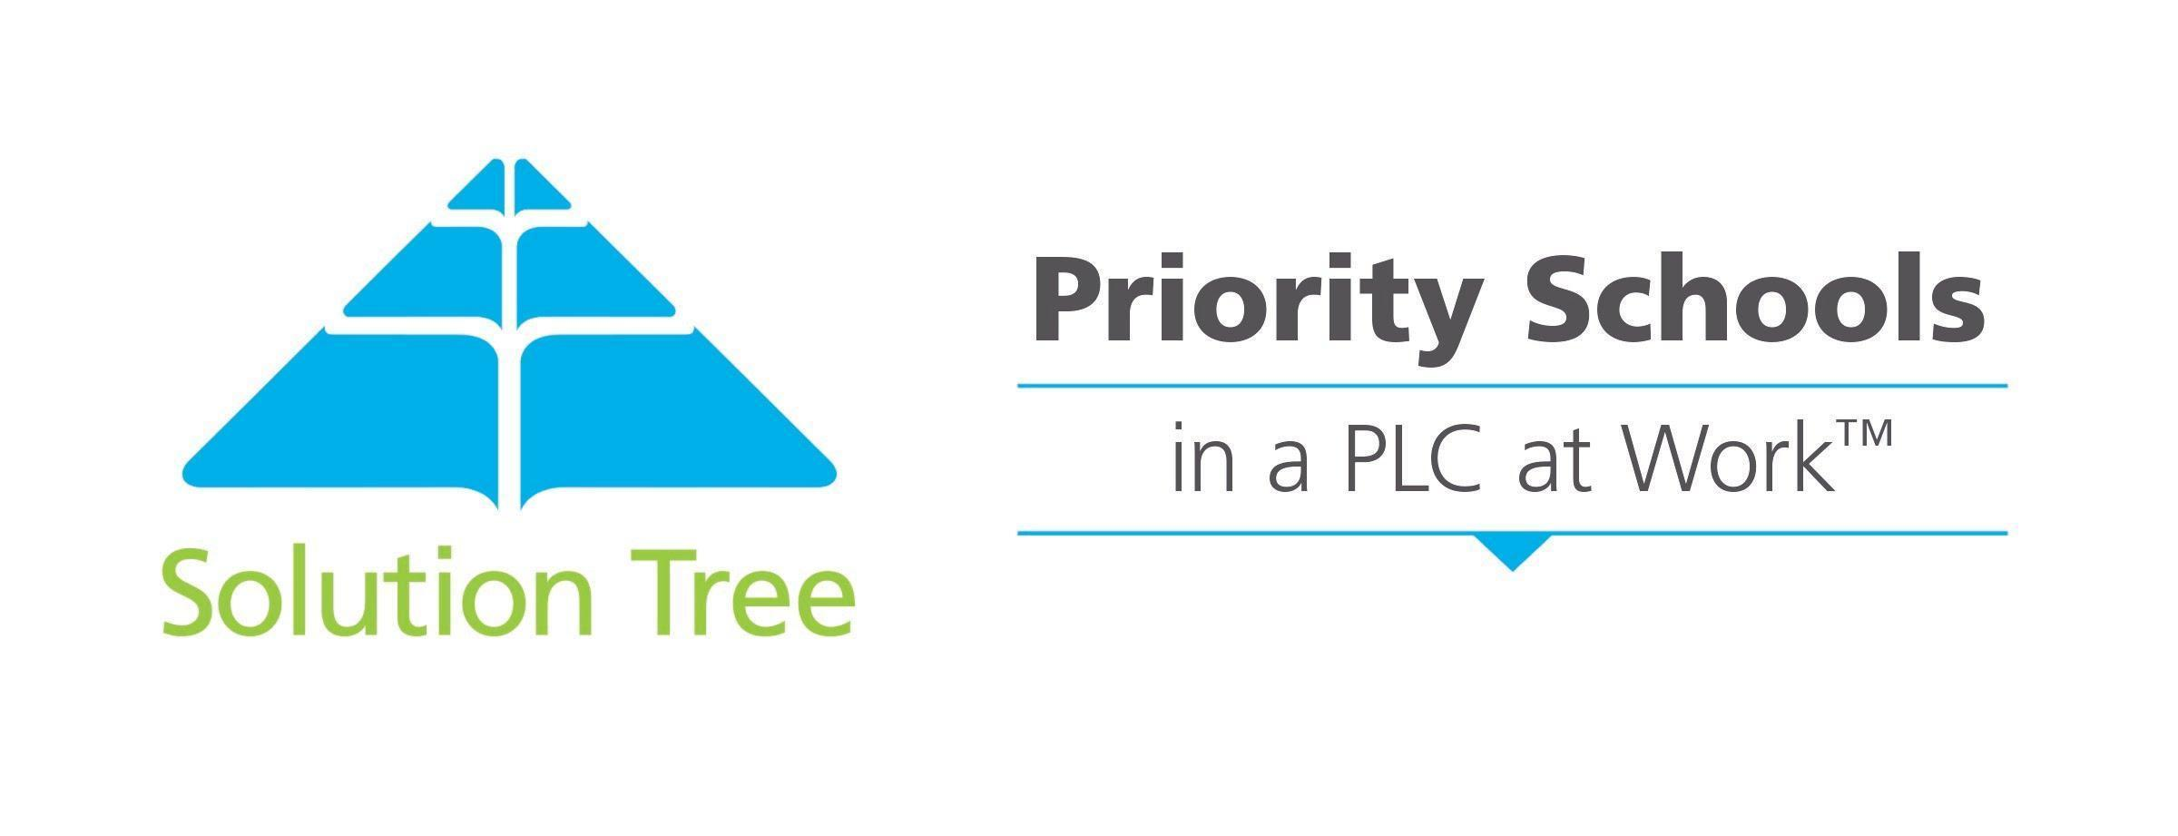

2022-2023

Collaborative Team Self-Assessment

School: Washington Middle School

Team: Reading 6

Date: Feb. 15, 2023

Solution Tree Coach: Amy

School Improvement for All Rating Categories

Level 0 – We haven’t discussed this yet
We are not yet engaged in this action, nor have we discussed how to begin implementing it in a way that will produce student learning results.

Level 1 – We are just beginning to talk about this
We have only just now learned we need to do this action or have initiated some work related to the action without a clear vision or idea how to proceed. This is not yet being implemented.

Level 2 – We are attempting to do this
We have started this action though at times teams are told to do it without understanding why the work is critical to improve student learning. Some staff will resist the work.

Level 3 – We are intentionally practicing this with room to grow
We are clear about the action and intentionally working to implement it, though there may still be needs for significant revision in the process. Teachers understand the importance of the action and many not yet have efficient and effective strategies for its full implementation.

Level 4 – We are embracing this as part of our routines and culture
We implement the action routinely, regularly monitor results, and adjust team practices and actions as needed when analyzing student learning of standards on a unit by unit basis.

Implementation of an ongoing process in which educators work collaboratively in recurring cycles (unit by unit) of collective inquiry and action research to achieve better results for the students they serve. Collaboration is the engine that drives the school improvement process. Teams focus on answering four critical questions that guide the process and ensure everyone is engaged in the right work.

Professional Learning Communities
In a Professional Learning Community, teachers and adult stakeholders focus on three big ideas:
- A Focus on Learning
- A Collaborative Culture and Collective Responsibility
- Results Orientation

It is recommended that collaborative teams meet a minimum of 60 minutes per week to address these three big ideas and the four critical questions that follow. Teams also need to have foundational pieces in place that include functional norms, purposeful agendas, and SMART goals.
Level 1  Beginning | Level 2  Attempting | Level 3  Practicing | Level 4  Embracing
Collaborative teams discussed norms but may not have a written record. Norms do not address the behavioral issues on the team impacting an effective focus on student learning. | Collaborative teams have written norms though they are more general to meeting behaviors without specifics to the work of the collaborative team (e.g., come on time, be prepared, etc) | Collaborative teams have written norms to be referenced and used. Norms include desired teacher behaviors to include norms for accountability and consensus. | Every teacher on each collaborative team operates using team norms to include norms for accountability and consensus. Team members hold one another accountable to the norms as needed.
Collaborative teams sometimes use agendas or stray from agendas created and lack a consistent way to store artifacts created. | Collaborative teams use agendas for most meetings and/or save work in binders for future use. | Collaborative teams use agendas and record team work in electronic folders for team access. | Collaborative teams create agendas before meetings, routinely use protocols, and save team work and data in electronic folders for team access.
Collaborative teams have a SMART goal with or without action steps and seldom refer to the goal. | Collaborative teams have a SMART goal with limited to no action plan and reference it when directed to. | Collaborative teams have SMART goals with action steps that drive their work and are used for celebration. | Collaborative teams have SMART goals with action steps that drive their work and are used for celebration. Teams routinely monitor their progress and make adjustments as needed.

Overall Rating

Level 3 – We are intentionally practicing this with room to grow
We are clear about the action and intentionally working to implement it, though there may still be needs for significant revision in the process. Teachers understand the importance of the action and many not yet have efficient and effective strategies for its full implementation.

Evidence and Justification

PLC notes, each team member takes on the leadership role in different areas, creating and revising assessments and unit plans collaboratively, Coordinating lessons, sharing resources.

What is it we want our students to know and be able to do?
A guaranteed and viable curriculum (1) gives students access to the same essential learning regardless of who is teaching the class and (2) can be taught in the time allotted. Teachers must work collaboratively to determine the guaranteed and viable curriculum for each course and grade level. The essential learnings are derived from the state standards and broken down into learning targets.

Level 1  Beginning | Level 2  Attempting | Level 3  Practicing | Level 4  Embracing
Collaborative teams do not reference a common pacing guide and may use curriculum suggestions and topics as a general progression of learning. | Collaborative teams use a district pacing guide and may give common assessments on different, but close, dates. | Collaborative teams create and follow a clear scope and sequence which identifies standards students will learn in a given calendar window with clear common assessment dates. | Collaborative teams reference unit plans and a common scope and sequence to ensure students will learn all of the essential standards for the year before the start of each unit. They make adjustments as needed.
Collaborative teams discuss the topics students will learn without necessarily referencing standards or proficiency. | Collaborative teams discuss standards students are going to learn. | Collaborative teams unwrap standards in a unit to develop a shared understanding of what students must know and be able to do. | Collaborative teams unwrap standards and record their work in unit plans with examples to clarify what students must do to be proficient with standards.
Collaborative teams do not create student learning targets or use different student learning targets across the team. | Collaborative teams use book objectives and student learning targets and change them daily. | Collaborative teams generate student learning targets to use throughout a unit with students. | Collaborative teams create student learning targets and use them with students for reflection and goal setting.

Overall Rating

Level 3 – We are intentionally practicing this with room to grow
We are clear about the action and intentionally working to implement it, though there may still be needs for significant revision in the process. Teachers understand the importance of the action and many not yet have efficient and effective strategies for its full implementation.

Evidence and Justification

Broke down the essential standards / targets, collaboratively created units around identified targets, communicate as a team to ensure the pacing is coordinated, update resources as necessary, incorporate Benchmark curriculum.

How will we know if each student has learned it?
The teachers collaboratively create common formative and summative assessments to help students acquire agreed upon knowledge and skills. Formative assessments for learning are part of an ongoing process to monitor each student’s progress on a continuous basis, to inform the teachers of the effectiveness of their practices, and to provide scaffolding to students. SMART goals are established to monitor the progress made.

Level 1  Beginning | Level 2  Attempting | Level 3  Practicing | Level 4  Embracing
Teams create the common assessment near the end of the unit and it may or may not match the standards to assess. Proficiency and common scoring agreements may or may not be determined. | Teams create the common assessment at the start of the unit and most items are aligned to the standards and targets. Scoring agreements and proficiency may or may not be determined. | Teams create common assessments before the unit begins. Items are clearly aligned to the learning targets and standards and student proficiency is determined through common scoring agreements. | Teams create common assessments before the unit begins, align items, and emphasize priority standards. The assessment has enough items to determine proficiency and includes common scoring agreements.
Teams quickly glance at data, use averages, or analyze data for a few teachers who gave the assessment on a given day. | Teams wait to look at data until all team members have given the assessment and then move on (this means some students have the data immediately and others wait a long time). | Teams analyze data from the common assessment given on the same day and teachers determine next instructional steps. | Teams analyze data from common assessments given on the same day to determine next instructional steps and students analyze and reflect on their data to make learning goals.

Overall Rating

Level 3 – We are intentionally practicing this with room to grow
We are clear about the action and intentionally working to implement it, though there may still be needs for significant revision in the process. Teachers understand the importance of the action and many not yet have efficient and effective strategies for its full implementation.

Evidence and Justification

CFA’s which drives the RTI rosters, designated teacher to target students who have not mastered, unit assessments to determine mastery, work as a team to agree on assessment scoring.

How will we respond when some students do not learn it?
A multi-tiered system of interventions in a school wide plan ensures that every student in every course or grade level will receive additional time and support for learning as soon as they experience difficulty in acquiring essential knowledge and skills. The intervention occurs during the school day and students are required to devote the extra time and secure the skills. This is a collective school wide responsibility.

Level 1  Beginning | Level 2  Attempting | Level 3  Practicing | Level 4  Embracing
Teachers acknowledge some students need interventions that they identify with common assessment data but move on to the next lesson regardless. | Teachers make an individual plan to address interventions as necessary based on classroom data or from a common assessment. | The collaborative team creates interventions based on data from common assessments. | The collaborative team creates and determines the effectiveness of team interventions based on data from common assessments.
Some students needing intervention receive it during a lesson through differentiation. | Students needing intervention have varied experiences based on individual teacher classroom implementation. | Every student needing the intervention has access to it, whether the team decides to implement it during core instruction, during an alternate time in the school day, or before or after school. | Every student needing the intervention is required to devote extra time and support to learn during the school day.

Overall Rating

Level 3 – We are intentionally practicing this with room to grow
We are clear about the action and intentionally working to implement it, though there may still be needs for significant revision in the process. Teachers understand the importance of the action and many not yet have efficient and effective strategies for its full implementation.

Evidence and Justification

work as a team to determine which targets each teacher will cover in RTI for the students who did not master a specific area, restructure instruction as needed to ensure student mastery of specific targets,

How will we extend the learning for students who have demonstrated proficiency?
Extension opportunities are created for students who have reached proficiency with the guaranteed and viable curriculum. This group of students will engage in extensions of learning connected to the essentials.

Level 1  Beginning | Level 2  Attempting | Level 3  Practicing | Level 4  Embracing
Teachers acknowledge some students need extensions that they identify with common assessment data but move on to the next lesson regardless. | Teachers make an individual plan to address extensions as necessary based on classroom data or from a common assessment. | The collaborative team creates extensions based on data from common assessments. | The collaborative team creates and determines the effectiveness of team extensions based on data from common assessments.
Some students needing extension are routinely asked to help others during lessons. | Students needing extensions have varied experiences based on individual teacher classroom implementation. | Every student has access to extension activities based on non-priority standards. | Every student who demonstrates the need to extend learning has access to an extension to the unity and priority standards being currently taught.

Overall Rating

Level 2 – We are attempting to do this
We have started this action though at times teams are told to do it without understanding why the work is critical to improve student learning. Some staff will resist the work.

Evidence and Justification

students who have mastered the targeted skill will be allowed to select their own RTI.
Between Feb. and May, students will use data from common assessments to reflect and set learning goals based on the goal-setting sheet.

