ISBE Rankings
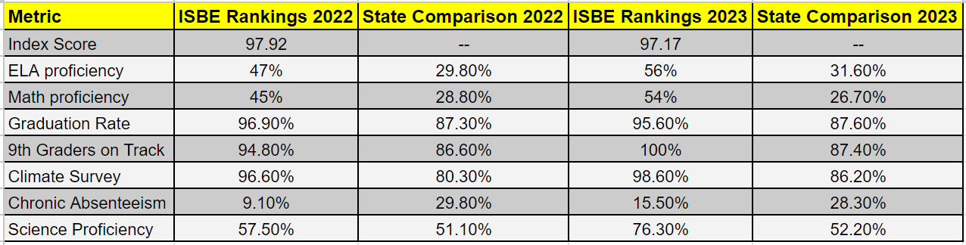
Narrative
Dear Dr. Twadell and the Model PLC Selection Committee:

Thank you for the time and effort to review our Model PLC application.
Since winning the DuFour Award in 2020, Westmont High School (Illinois) has continued to
operate as a model Professional Learning Community, and we have significant evidence to
show high levels of student learning growth and a genuine implementation of the three Big
Ideas.
Our passionate commitment to Ensuring Learning for All, sustaining an effective Collaborative
Culture and being driven by a Results Orientation is supported by the following evidence.

Summary Review of evidence to support retaining Model PLC status –
1) Earned the National Blue-Ribbon Award (for high achievement) in 2021. Westmont is
the most diverse, traditional high school with the highest poverty rate to win this
award in Illinois in over 25 years.
2) Earned the highest designation – Exemplary - every year from the Illinois State Board of
Education 2018 -2023). Furthermore, Westmont has the highest overall achievement
score of any Illinois high school since the inception of this designation system. The
scores for our students categorized as low income (95.71) are the best in Illinois.
Westmont also has the best achievement scores for Hispanic students (96.26) in the
state.
3) The University of Chicago developed the 5 Essentials Survey that is closely aligned with
PLC concepts and beliefs. It is administered to over 550 high schools in Illinois by the
Illinois State Board of Education. Westmont has the highest overall score on this survey
since it was first administered 7 years ago. Most recently, Westmont ranked number 1
of any Illinois high school on the 5 Essentials survey including the highest score for
Student to Teacher Trust (99 – highest score possible and best in state), and
collaborative teachers (99 – highest score possible and best in state).
4) The College Board awarded Westmont the status of Gold with Access on the 2023 A.P.
Honor Roll system. This is the highest designation that any traditional high school in
Illinois has earned. The Access designation recognizes our success with
underrepresented students. Our goal is to be the first, traditional high school to earn
Platinum status in 2024, once again demonstrating our commitment to continuous
improvement and a true PLC culture.
5) U.S. News and World Report (2023) ranked Westmont High School 24 out of over 600
high schools in Illinois and 14 out of all traditional high schools in Illinois. Westmont is
the most diverse, high poverty school ranked in the top 25 in Illinois. Furthermore, since

we first implemented PLC concepts in 2012-2013, Westmont is the most improved
traditional high school in this national ranking (in Illinois and the nation).
6) In the national ranking system GreatSchools.org, Westmont has a rating of 10 out of 10
and once again is the most diverse, traditional high school to earn this highest rating.
Our Equity rating of 9 out of 10 is also one of the best in the state and a clear indication
that our work with underrepresented students is recognized by outside agencies.
7) Westmont’s graduation rate continues to be among the best in Illinois, and since 2014
not one African-American or Latino student has dropped out of our high school. This
has continued since Westmont won the DuFour Award in 2020.
8) Since 2020, over 30 schools from every region of the country have visited Westmont to
learn about our PLC practices. The Illinois Principals Association has also asked members
of our Westmont team to help the most struggling schools in the state to implement
PLC concepts and practices.
9) Our state test scores (SAT in Illinois) remain 20 points or more higher than the state
average, and we are leaders in our economic sector according to the Illinois State Report
Card scatterplot. Of note, our math achievement for our low-income students is second
among all traditional high schools in Illinois. We are fully committed to continuous
improvement and collaboratively utilizing student performance information to drive
growth student by student by skill in all assessments including but not limited to the
state exam.
10) We have earned the highest rating possible from almost every outside agency that
issues designations or rankings, and in almost every one of these designations we are
the most diverse and highest poverty traditional high school to earn the highest rating
possible (A+ from Niche, 10 out of 10 from GreatSchools.org, Exemplary from the
I.S.B.E., Blue Ribbon from the National Education Department, highest scores in Illinois
from the University of Chicago 5 Essentials Survey, top 25 from U.S. and World Report,
Golden Apple from the Golden Apple Foundation, Gold Honor Roll with Access from the
College Board, and impressive graduation rates and test scores).

It was a great honor for Westmont to be selected as the DuFour Award winning school in 2020.
Since then, we have not rested on our laurels and are confident that we have become an even
stronger Professional Learning Community. There is no doubt that we believe we have retained
our status as a Model PLC, and we hope you agree.

Jack Baldermann – Superintendent – CUSD 201 / former principal Westmont High School
Dr. Kevin Weck – Principal – Westmont High School

Some additional clarification and spreadsheets demonstrating the highest achievement are
included.

In 2021, Westmont High School was selected for the national Blue-Ribbon Award by the United
States Department of Education. Westmont High School is the most diverse, traditional high
school with the highest percentage of students living in economic poverty to win this award in
Illinois in 25 years.
The Illinois State Board of Education created a designation and recognition system starting in
2018. Since the inception of this system, Westmont has earned the highest designation
(Exemplary) every year. In 2021, the I.S.B.E. did not issue new designations due to COVID
restrictions. In 2022, Westmont High School was named as Exemplary, and ranked number 2
out of 665 high schools in Illinois according to the I.S.B.E. criteria (97.79 score on 100-point
scale). In 2023, Westmont was once designated as Exemplary and once again ranked number 2
out of over 660 high schools in Illinois using the I.S.B.E. criteria (97.17 on a 100-point scale). We
are confident that since the state instituted this multi-criteria designation system, Westmont
has the overall highest achievement of any Illinois high school according to the I.S.B.E. criteria
and rankings (data and rankings attached to this application). As a school with over 35% of our
students living in economic poverty we are proud of this accomplishment, and it is a testament
to our successful implementation of PLC concepts and beliefs.
In addition to being among the very few schools to earn the Exemplary rating every year, in the
most recent rankings our students designated and our Hispanic students’ performance was
remarkable. Our scores for just our low-income students (95.71) and our Hispanic/Latino
students (96.26) were higher than the total score of 98% of Illinois high schools, and the highest
achievement scores for low-income students and Hispanic students in Illinois. (the spreadsheet
is attached).

The spreadsheet that shows performance on the University of Chicago’s 5 Essential Survey is
also included with this application.
The survey is closely aligned with Professional Learning Community practices and the 3 Big
Ideas. Collaborative Teachers is one of the 5 Essential categories.
Westmont High School’s scores are overall the best in Illinois including our scores for
Collaborative Teachers, student to teacher trust and academic engagement.

