1St paragraph Self Peer
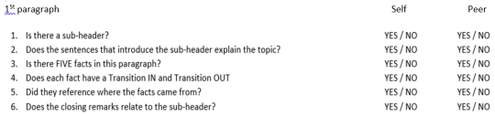
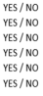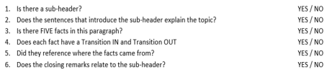2nd paragraph
Circle what the description you feel your writing accomplished. 