Name of Unit  Classify 2D Figures  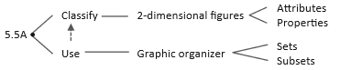 | SE’s  5.5 classify two-dimensional figures in a hierarchy of sets and subsets using graphic organizers based on their attributes and properties
Dates of Unit  Monday, December 9 – Tuesday, December 17 | Common Assessment Date  Wednesday, December 18th
Alignment Data  4.6D classify two‐dimensional figures based on the presence or absence of parallel or perpendicular lines or the presence or absence of angles of a specified size | 2019 STAAR Data  Current Student Performance on 4.6D 2019 STAAR  73.75%  Previous Student Performance on 5.5 2019 STAAR  68.61%
Model Questions that determine proficiency:

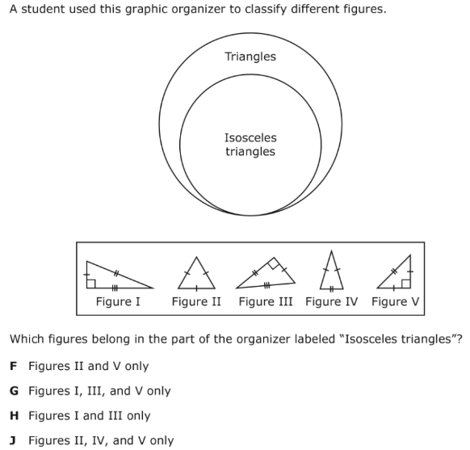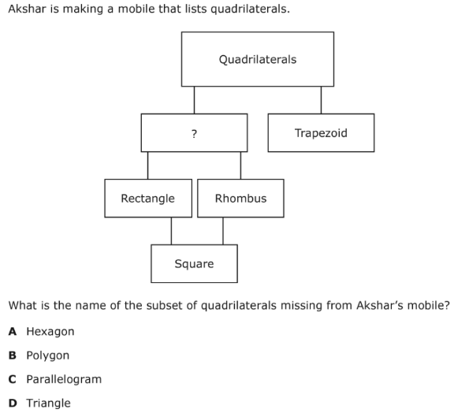

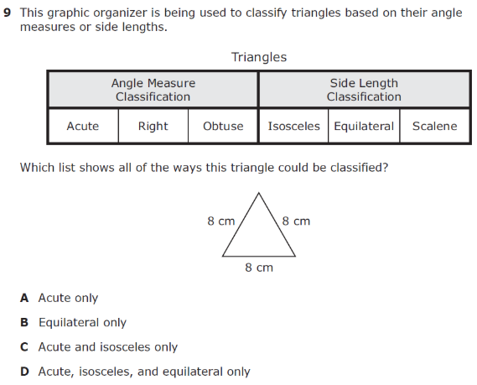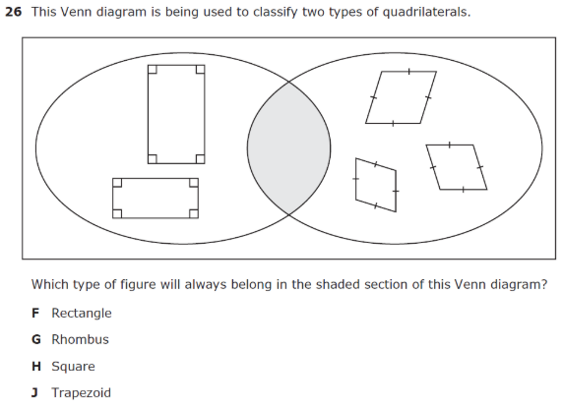

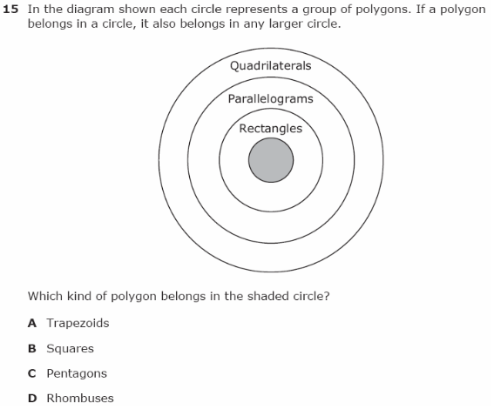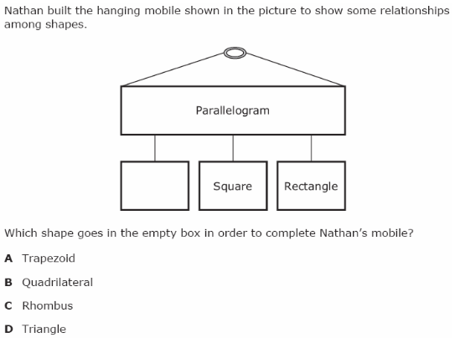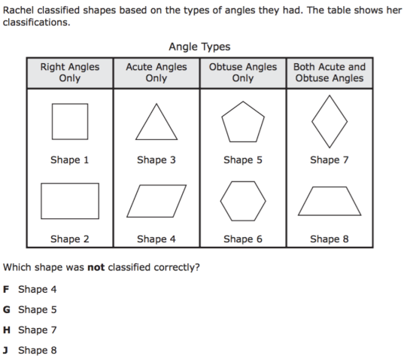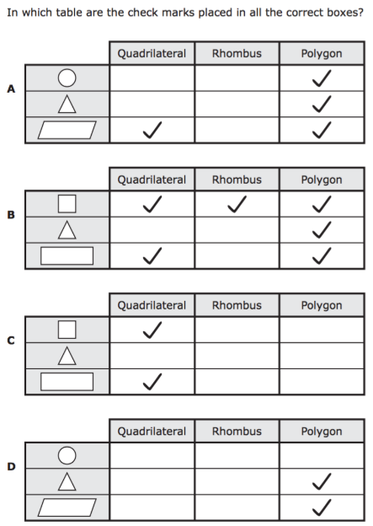
Distractor Factors
- Students may rely only on the look of a geometric figure to determine classification instead of comparing its attributes/properties.
- Students may not understand the inverse relationship between terms (i.e. all squares are rectangles but not all rectangles are squares).
Essential Questions
- What do we expect the students to know?

- What does mastery look like?

- What do we do for students who master these skills quickly?

- What do we do for unsuccessful students?

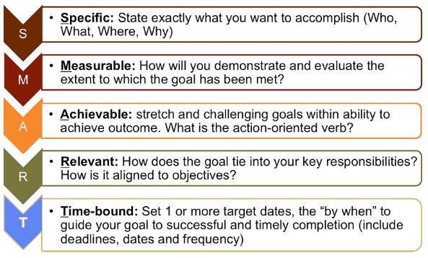
Smart Goal:
__% of students will be proficient at Classify 2D Figures with a score of at least __% on the next assessment to be given on _____________.

