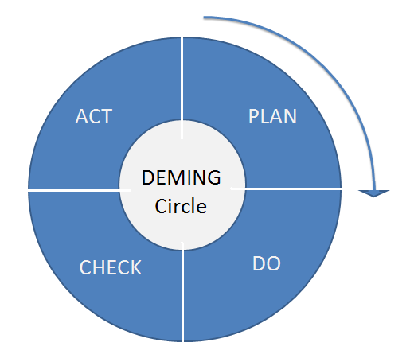
5th Grade Agenda

Mission:
Bragg Elementary School challenges students to be critical thinkers and respectful citizens in our school and community
Vision:
Bragg Elementary School promotes a respectful environment and provides real-world opportunities and tasks that challenge our students to become critical thinkers.

Team Members:  Danielle Jayroe (djayroe@wmsd.net)  Joline Mathis ( jmathis@wmsd.net)  Kendrick Barbee ( kbarbee@wmsd.net )  Sue Ellen Lucas selucas@wmsd.net | Norms:  - Be positive and solution-minded  - Work efficiently and follow the agenda  - Respect others  - No hogs, no logs
Celebrations
Joline: Had a good day Sunday.
Jayroe: Excited to end the year with some amazing kids!!
Kendrick: Blessed to still be here in the land of living!
Lucas: I love my students!

Shout- Out!!!!!
- Shout out to my 5th grade team. Y’all are the best!!
Discussion
- Add to newsletter (5th grade newsletter)
-Send out on remind and update website

- Mask Singer
- Email guess to Zachary
- Bradley Baby gift’ wednesday
- NWEA testing
- Grades due Friday, May 21
  - No changes can be made after these are turned in
Things this week:
Chromebook turn in during library
Monday:
Tuesday: math NWEA test
Wednesday: Dr. Baker / Bradley baby shower
Thursday:
Friday: concessions/ field day activities
More info
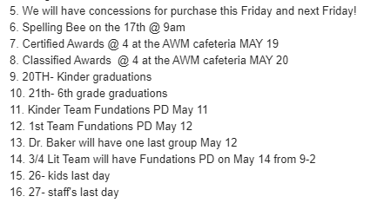

Coming up::
Wednesday 19th: teacher of the year announcement

Break into content teams

math agenda

