4th Grade PAW PLC March 22, 2021
Romanita Hinojosa | Reyna Reyes
Veronica Perales | Esmeralda Marroquin
Gabriela Tovar | Lizette Villareal
Laura Gorham

Online STAAR Resources | Overview SOTP Elementary Overview  SOTP Math tools Elementary SOTP Math Tools Video  District Specialist Training  Video (2 Hours) PDF of Slides with Embedded Links (most pictures on the slides will take you to a helpful resource and/or video) Jamboard with Planning and Teaching Consideration for Online Testing and Supports  Routine, Independent, and Effective Use of Online STAAR Testing RIE of Online Testing PDF Slides Jamboard  ***Teach, Model, Practice
MAP Data Growth Report  How do we ensure students are growing?  *Small Group Instruction  Analyzing Student Errors | 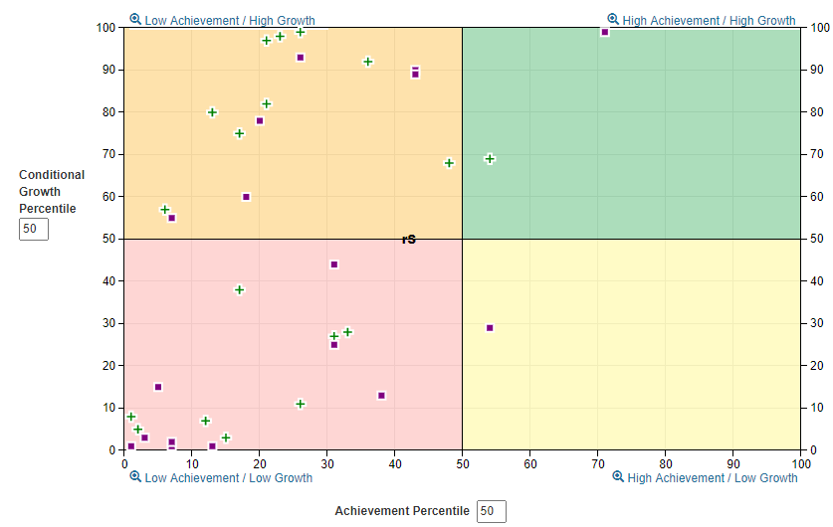
*Participation Log and Progress Monitoring Documentation
*PAW Grouping and Planning

