CAASPP- State Assessment Dashboard Data
English Language Arts
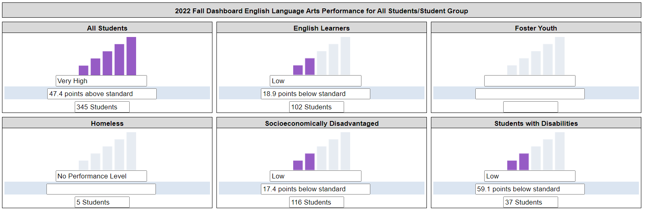
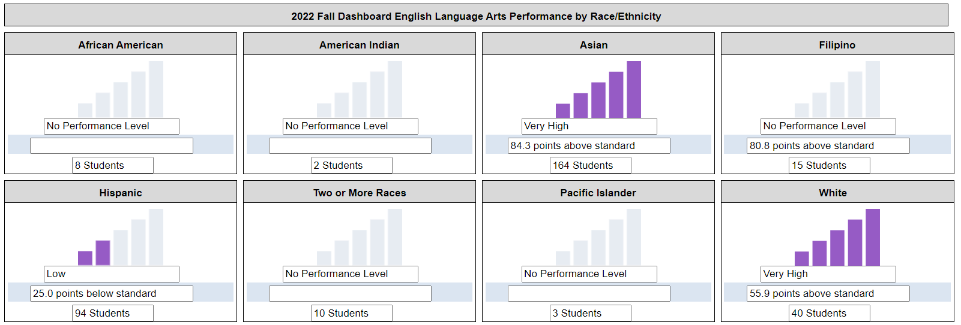
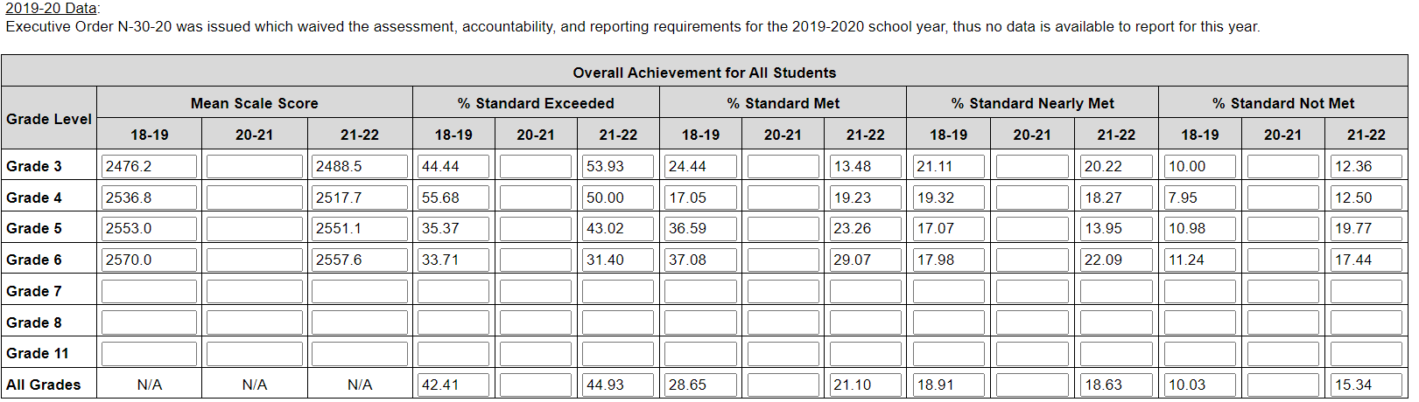

Math
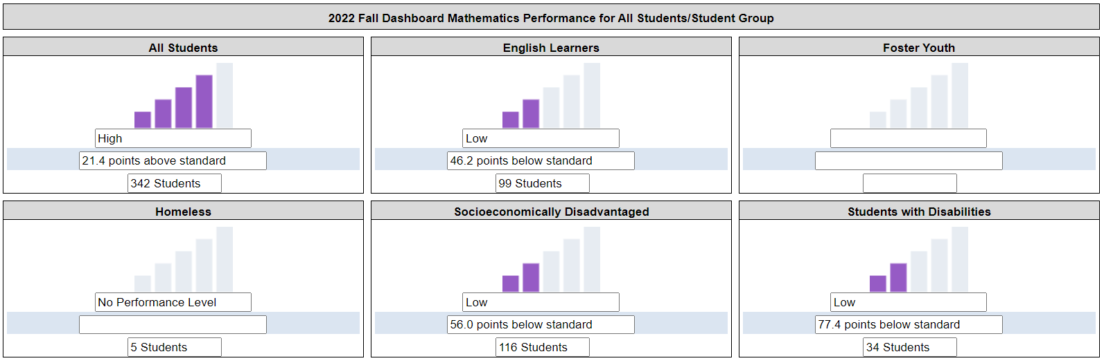
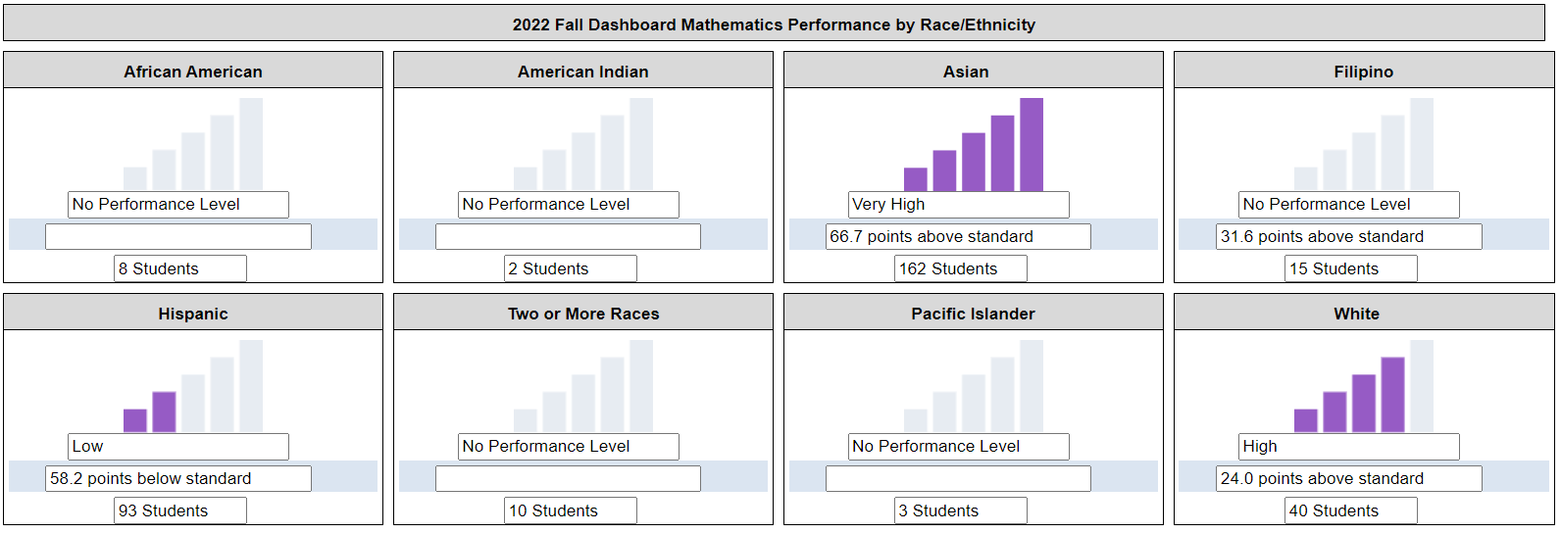
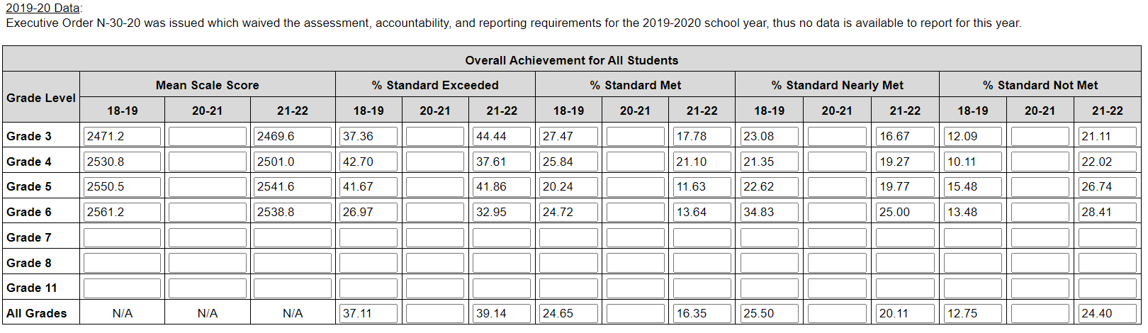

ELPAC- State English Learner Results
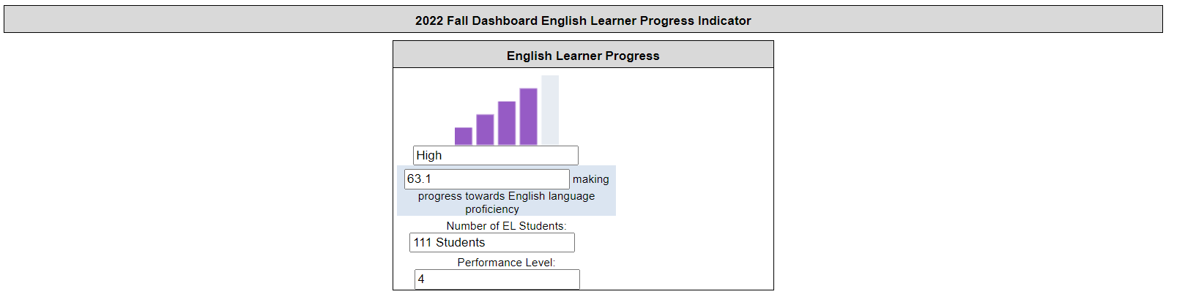

i-Ready Diagnostic Assessment Results 2022-2023
English Language Arts
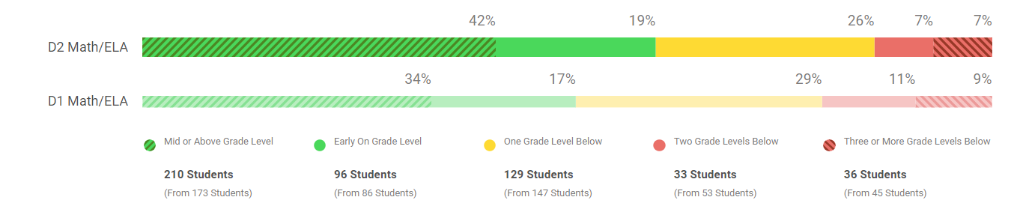
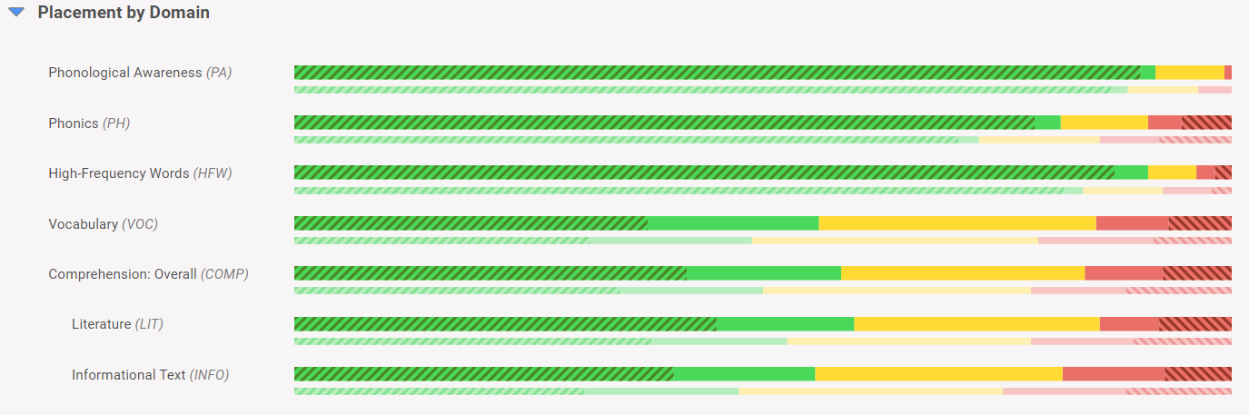

Math
