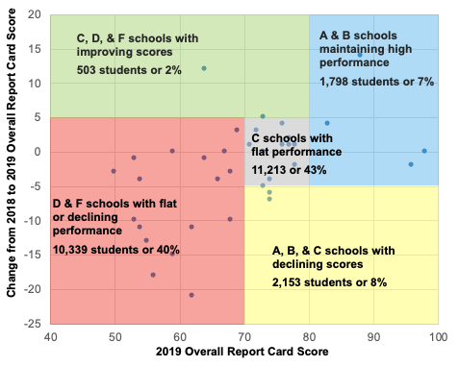
Lamar was the only elementary school in Midland ISD with a prior score of C, D or F that improved from 2018 to 2019. Lamar grew 12 percentage points.

