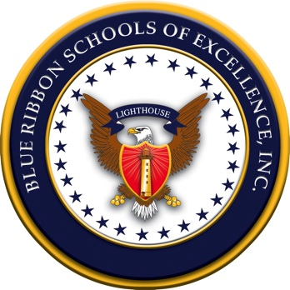

July 22, 2019

Mr. Adam Hampton
Principal
Owens Cross Roads Elementary School
161 Wilson Mann Road
Owens Cross Roads, AL 35763

Dear Mr. Hampton,

We are pleased that Owens Cross Roads School has been named a 2019 Blue Ribbon Lighthouse Renewal School! Based on the Blueprint for Excellence assessment process, your school has met the criteria for all nine categories. We are greatly honored to recognize such a deserving school working so diligently to fulfill the many learning needs of students. This is the school’s third time to earn the designation and the only one in the country so far this year.

This award will be presented during the Blue Ribbon Schools for Excellence National Conference in Florida at Disney's Yacht and Beach Club Convention Center at the Awards Luncheon on Sunday, December 15. We encourage you to bring a team of staff members to the conference and share your successes with other educators in a concurrent presentation session.

Designation as a Blue Ribbon Lighthouse School lasts for five years, at which time the school will be eligible for revalidation. Blue Ribbon Lighthouse Schools commit to sharing expertise and exemplary practices with other schools on a local, regional, and national level as well as providing mentoring and networking to schools seeking guidance and assistance in school improvement initiatives.

We will be highlighting your school and teachers on our website: www.blueribbonschools.com, as well as including best practices from your school in our Interactive Library of Best Practices database. Through these initiatives, we will be able to share information from America's best schools with other schools around the country. It is our belief that there is always room for improvement in fulfilling the ever-changing needs of our children. If we share our knowledge, we can all be better together!

Congratulations and please accept our sincere appreciation for everything that you do to create positive learning environments for all children. We thank you for the opportunity to recognize the accomplishments at Owens Cross Roads School and we look forward to celebrating your successes.

Best regards,

Judith Warden Fields. Ed.D
CEO, Blue Ribbon Schools of Excellence

CC: Acting Superintendent of Schools, Dr. Mark Minskey

