Kindergarten Reading & Writing Data
2019-2020
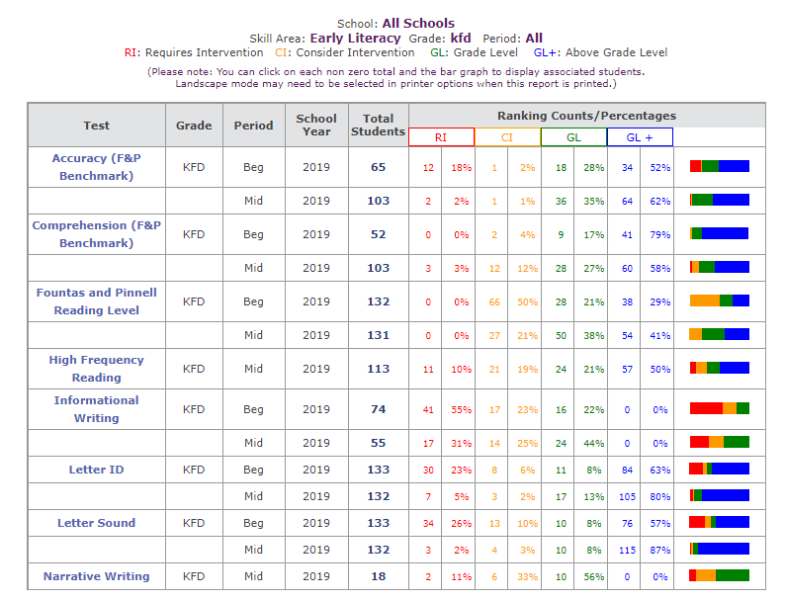

1st Grade Reading & Writing Data
2019-2020

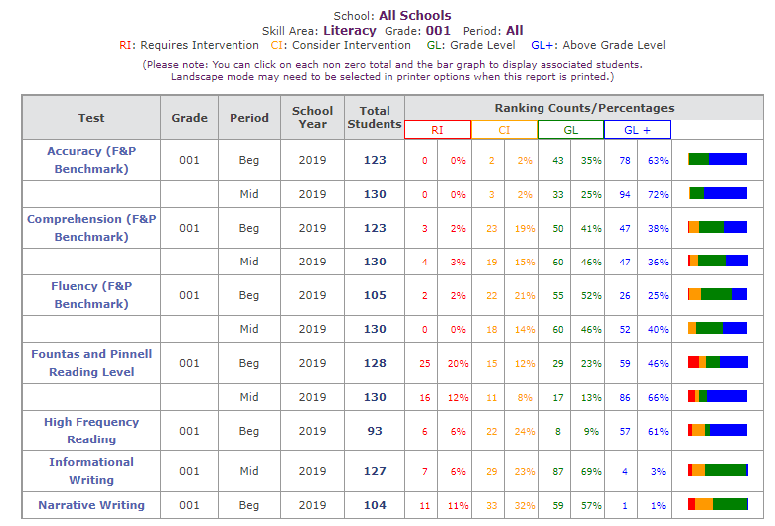

2nd Grade Reading & Writing Data
2019-2020
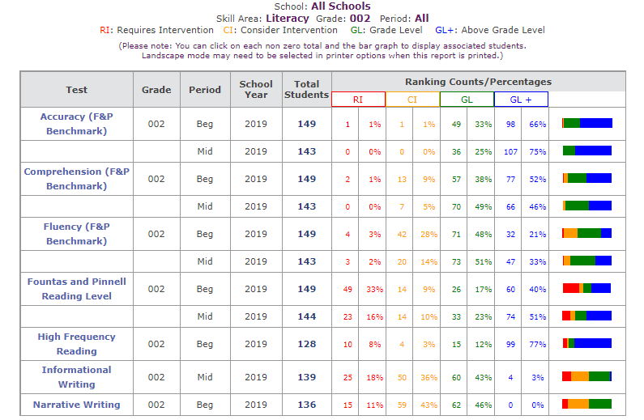

3rd Grade Reading & Writing Data
2019-2020
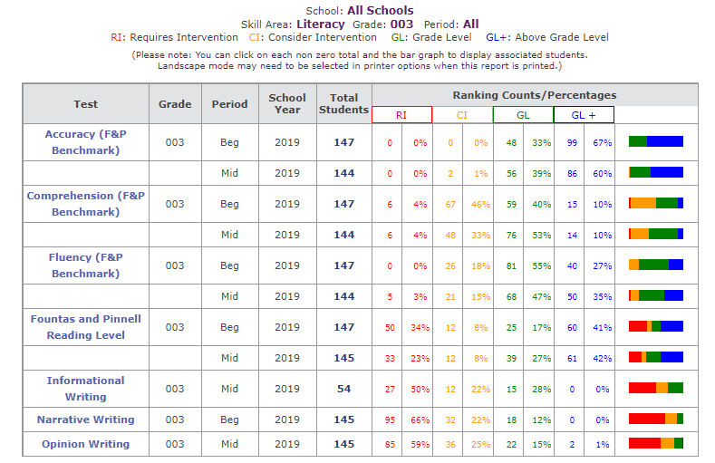

4th Grade Reading & Writing Data
2019-2020

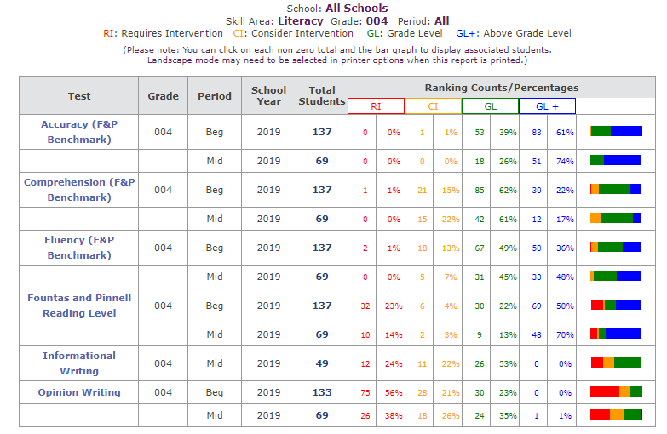

5th Grade Reading & Writing Data
2019-2020

