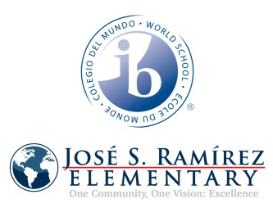 

**Questions:**

**Other**

**PBIS Team**

Brenda Jobes

Lindsey Inmon

Kendall Newman

Janet Powell

**Behavior, ARDS, SST, LPAC**

Nancy Parker-

2nd, 4th, 5th (DL)

Art, Music

Brenda Jobes-

PK, K, 1st, 3rd (SI)

Spanish, Mandarin, PE

**Special Programs**

Yu Kim-Johnson-Special Ed.

Janelle Kinman-Speech

Jatawn Mahan-Diagnostician (Monday, Tuesday a.m.)

**LPAC/ESL/Dyslexia**- Jan Lapilio-Smith

Amber Faske-

IB

(Tuesday, Thursday, Friday every other week)

**Grade-level-**

**Alignment Team**

**Administration**

**N. Parker, B. Jobes**

**Office**

Dolores Hernandez-Attendance, Registrar

Celia Hernandez-

Purchases

Rachel Ramirez-Personal days, substitutes

Nicki Zambrano-PK (Tuesday-Friday)

Emma Arias-Counselor

WATCH Dogs-Russ Miller

**SST**

Amy Magallanes, Counselor (M, Tue and Friday every other week)

Nancy Parker

Brenda Jobes