Kindergarten
SMART Goals | Reading |  | Mathematics |  | ELA
 | By the end of the 2020-2021 academic year, students at Spradling Elementary in Kindergarten will increase the amount of students in Levels 3, 4, and 5 by 5% from 46% to 51% in Reading as demonstrated by Istation assessment data. |  | By the end of the 2020-2021 academic year, students at Spradling Elementary in Kindergarten will increase the amount of students in Levels 3, 4, and 5 by 5% from 66% to 71% in Math as demonstrated by Istation assessment data. |  | N/A
iStation Interim Data
Percent of  Students Proficient | Interim I | Summative | Interim I | Summative | Interim I | Summative
 | 11% | 52% | 40% | 77% | N/A
Summative Unit Data
Percent of  Students Proficient | 59% |  | 49% |  | 63%

1st Grade
SMART Goals | Reading |  | Mathematics |  | ELA
 | By the end of the 2020-2021 academic year, students at Spradling Elementary in 1st grade will increase the amount of students in Levels 3, 4, and 5 by 5% from 52% to 57% in Reading as demonstrated by Istation assessment data. |  | By the end of the 2020-2021 academic year, students at Spradling Elementary in 1st grade will increase the amount of students in Levels 3, 4, and 5 by 10% from 35% to 45% in Math as demonstrated by Istation assessment data. |  | N/A
iStation Interim Data
Percent of  Students Proficient | Interim I | Summative | Interim I | Summative | Interim I | Summative
 | 27% | 41% | 24% | 63% | N/A
Summative Unit Data
Percent of  Students Proficient | 60% |  | 56% |  | 65%

2nd Grade
SMART Goals | Reading |  | Mathematics |  | ELA
 | By the end of the 2020-2021 academic year, students at Spradling Elementary in 2nd grade will increase the amount of students in Levels 3, 4, and 5 by 5% from 67% to 72% in Reading as demonstrated by Istation assessment data. |  | By the end of the 2020-2021 academic year, students at Spradling Elementary in 2nd grade will increase the amount of students in Levels 3, 4, and 5 by 5% from 69% to 74% in Math as demonstrated by Istation assessment data. |  | N/A
iStation Interim Data
Percent of  Students Proficient | Interim I | Summative | Interim I | Summative | Interim I | Summative
 | 36% | 61% | 19% | 52% | N/A
Summative Unit Data
Percent of  Students Proficient | 31% |  | 42% |  | 40%

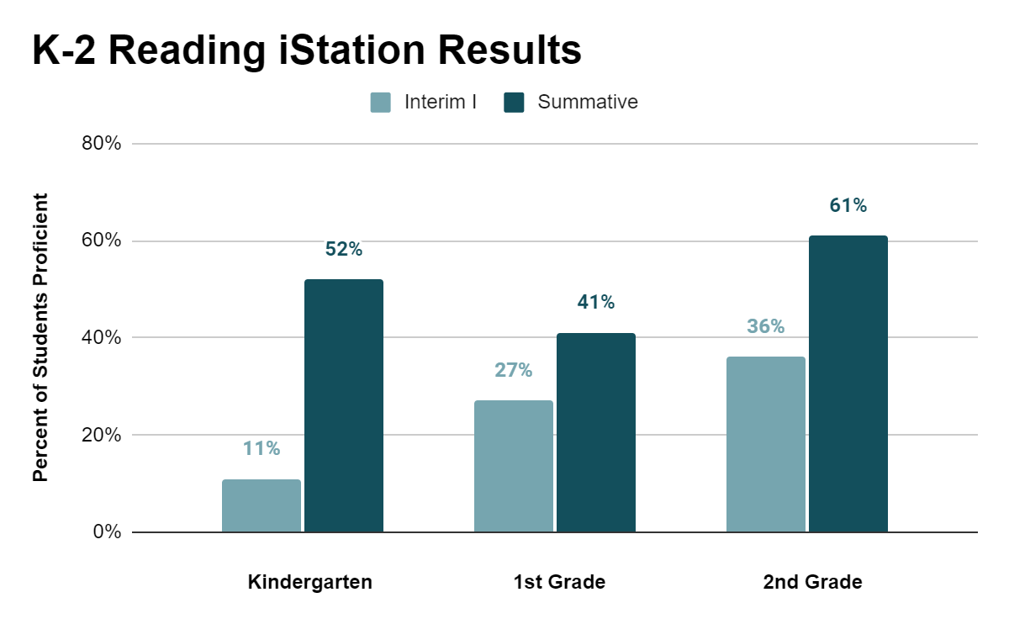
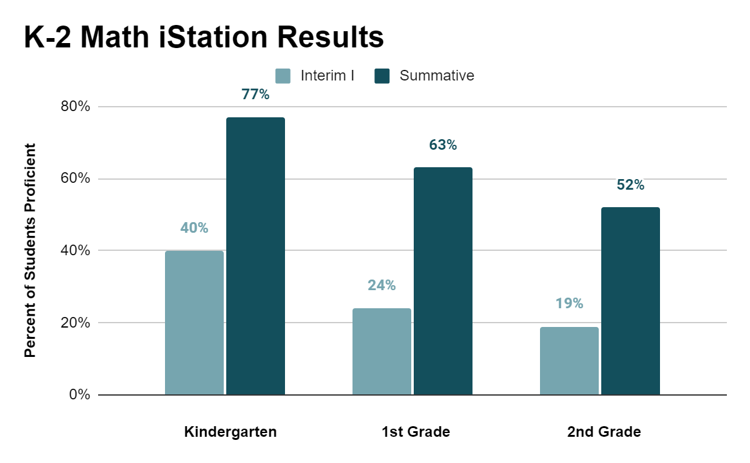

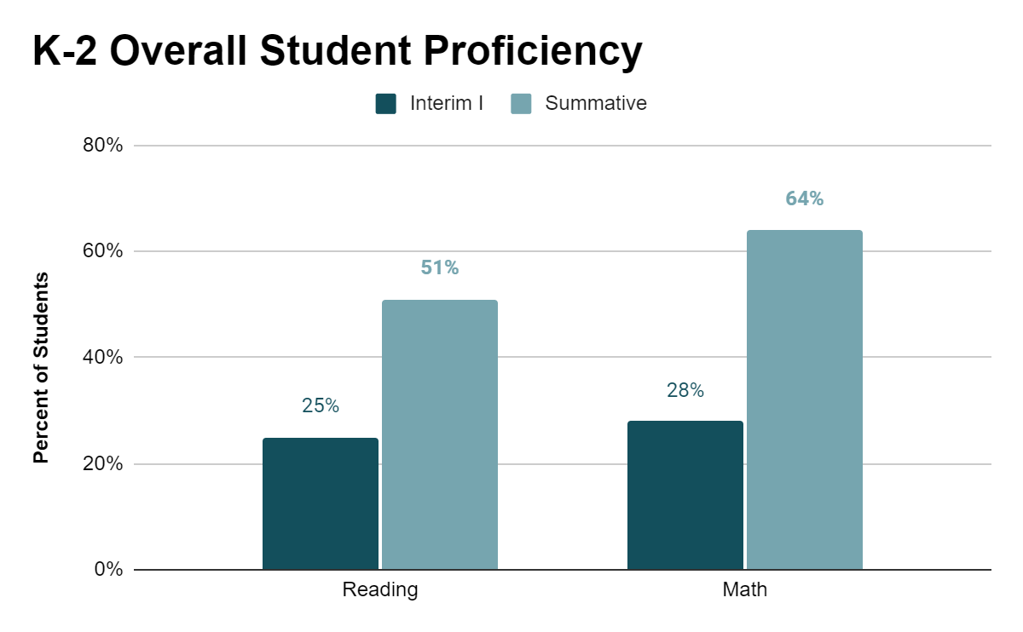

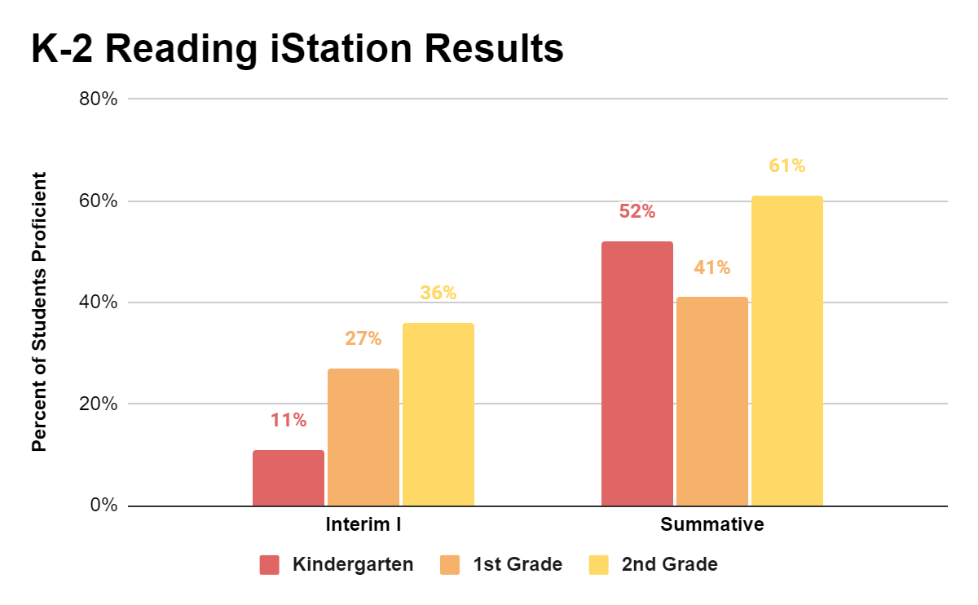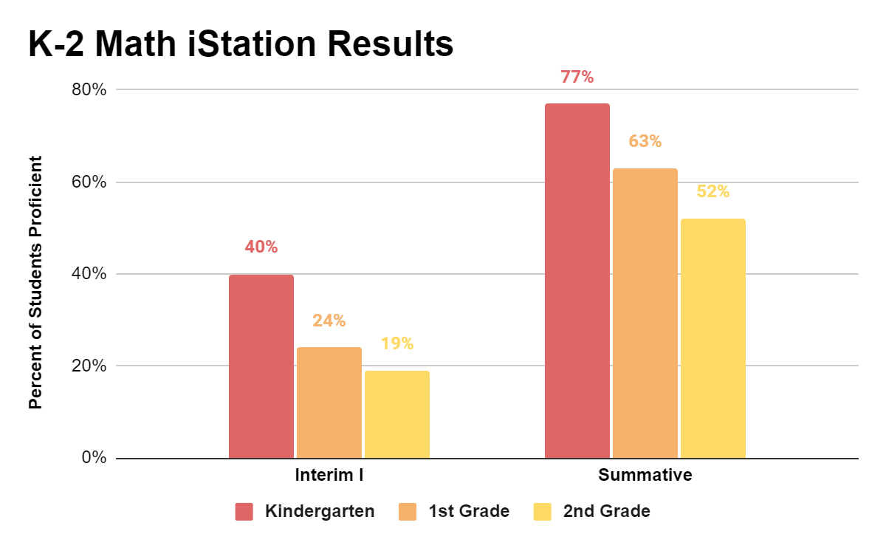
3rd Grade
 | Reading |  | English |  | Mathematics |  | Science
SMART Goals | By the end of 2020-2021 academic year, students at Spradling Elementary in 3rd grade will increase the proficiency pass rate by 6% from 36% to 42% in Reading as demonstrated by ACT Aspire assessment data. |  | By the end of 2020-2021 academic year, students at Spradling Elementary in 3rd grade will increase the proficiency pass rate by 14% from 26% to 40% in ELA as demonstrated by ACT Aspire assessment data. |  | By the end of the 2020-2021 academic year, students at Spradling Elementary in 4th grade will increase the proficiency pass rate by 40% from 20% to 60% in Math as demonstrated by ACT Aspire assessment data. |  | By the end of the 2020-2021 academic year, students at Spradling Elementary in 3rd grade will increase the proficiency pass rate by 7% from 38% to 45% in Science as demonstrated by ACT Aspire assessment data.
ACT Aspire Data
Percent of  Students Proficient | Interim I | Interim II | Interim I | Interim II | Interim I | Interim II | Interim I | Interim II
 | 13% | 20% | 44% | 43% | 18% | 35% | 16% | 27%
 | Summative |  | Summative |  | Summative |  | Summative
 | 28% |  | 67% |  | 50% |  | 26%
 | ELA |  |  |  | STEM
 | 28% |  |  |  | 14%
Summative Unit Data
Percent of  Students Proficient | 61% |  | 60% |  | 56% |  | 59%

4th Grade
SMART Goals | Reading |  | English |  | Mathematics |  | Science
 | By the end of 2020-2021 academic year, students at Spradling Elementary in 4th grade will increase the proficiency pass rate by 13% from 27% to 40% in Reading as demonstrated by ACT Aspire assessment data. |  | By the end of the 2020-2021 academic year, students at Spradling Elementary in 4th grade will increase the proficiency pass rate by 14% from 31% to 45% in English as demonstrated by ACT Aspire assessment data. |  | By the end of the 2020-2021 academic year, students at Spradling Elementary in 4th grade will increase the proficiency pass rate by 40% from 20% to 60% in Math as demonstrated by ACT Aspire assessment data. |  | By the end of the 2020-2021 academic year, students at Spradling Elementary in 4th grade will increase the proficiency pass rate by 10% from 20% to 30% in Science as demonstrated by ACT Aspire assessment data.
ACT Aspire Data
Percent of  Students Proficient | Interim I | Interim II | Interim I | Interim II | Interim I | Interim II | Interim I | Interim II
 | 26% | 40% | 50% | 68% | 18% | 30% | 16% | 31%
 | Summative |  | Summative |  | Summative |  | Summative
 | 44% |  | 60% |  | 42% |  | 34%
 | ELA |  |  |  | STEM
 | 38% |  |  |  | 14%
Summative Unit Data
Percent of  Students Proficient | 59% |  | 58% |  | 64% |  | 65%

5th Grade
SMART Goals | Reading |  | English |  | Mathematics |  | Science
 | By the end of 2020-2021 academic year, students at Spradling Elementary in 5th grade will increase the proficiency pass rate by 5% from 26% to 31% in Reading as demonstrated by ACT Aspire assessment data. |  | By the end of 2020-2021 academic year, students at Spradling Elementary in 5th grade will increase the proficiency pass rate by 13% from 33% to 46% in ELA as demonstrated by ACT Aspire assessment data. |  | By the end of the 2020-2021 academic year, students at Spradling Elementary in 5th grade will increase the proficiency pass rate by 14% from 46% to 60% in Math as demonstrated by ACT Aspire assessment data. |  | By the end of the 2020-2021 academic year, students at Spradling Elementary in 5th grade will increase the proficiency pass rate by 32% from 19% to 51% in Science as demonstrated by ACT Aspire assessment data.
ACT Aspire Interim Data
Percent of  Students Proficient | Interim I | Interim II | Interim I | Interim II | Interim I | Interim II | Interim I | Interim II
 | 10% | 17% | 58% | 64% | 30% | 21% | 12% | 16%
 | Summative |  | Summative |  | Summative |  | Summative
 | 27% |  | 58% |  | 14% |  | 12%
 | ELA |  |  |  | STEM
 | 19% |  |  |  | 4%
Summative Unit Data
Percent of  Students Proficient | 54% |  | 53% |  | 43% |  | 31%

6th Grade
SMART Goals | Reading |  | English |  | Mathematics |  | Science
 | By the end of 2020-2021 academic year, students at Spradling Elementary in 6th grade will increase the proficiency pass rate by 5% from 53% to 58% in Reading as demonstrated by ACT Aspire assessment data. |  | By the end of 2020-2021 academic year, students at Spradling Elementary in 6th grade will increase the proficiency pass rate by 13% from 36% to 49% in ELA as demonstrated by ACT Aspire assessment data. |  | By the end of the 2020-2021 academic year, students at Spradling Elementary in 6th grade will increase the proficiency pass rate by 15% from 45% to 60% in Math as demonstrated by ACT Aspire assessment data. |  | By the end of the 2020-2021 academic year, students at Spradling Elementary in 6th grade will increase the proficiency pass rate by 12% from 48% to 60% in Science as demonstrated by ACT Aspire assessment data.
ACT Aspire Interim Data
Percent of  Students Proficient | Interim I | Interim II | Interim I | Interim II | Interim I | Interim II | Interim I | Interim II
 | 42% | 48% | 76% | 80% | 27% | 30% | 27% | 17%
 | Summative |  | Summative |  | Summative |  | Summative
 | 18% |  | 64% |  | 23% |  | 18%
 | ELA |  |  |  | STEM
 | 23% |  |  |  | 2%
Summative Unit Data
Percent of  Students Proficient | 63% |  | 46% |  | 30% |  | 36%

