Provide high-quality, scientifically based reading instruction that connects listening, speaking, reading, writing, and thinking.

Subject | Time | Resources
Data | 10 min. | CBA Review  Historical Student Data
Tier 1 Priority focus: Workshop Model  - Strategy to utilize during guided reading | 5 min. | PLC Question #3  What do we do if they don’t get it?
Running Records  - Response to data collected  - Model of running record  - Analyze running record  - Lesson example  - How to locate HMH Running Record Resources  - Retelling Rubric  - Adding additional resources (leveled readers) |  | Running Records  Running Records Cheat Sheet  Phonics Terminology  Word Work Resource  HMH Resources  Add addition leveled readers HMH Ed

Assess → | Decide → | Guide
Identify your readers’ strengths and needs. | Decide which word study activities will address their needs. | Plan and teach a word study lesson during guided reading.

*Phonics refers to the instructional strategies used to teach children to decode words.

*Phonics instruction should be limited to one or two types of manipulation at a time to give children a chance to master the concepts presented.

*Children are better able to use their phonics knowledge to improve decoding as well as comprehension when the texts they are reading contain a high percentage of words that followed the patterns introduced by the teacher.
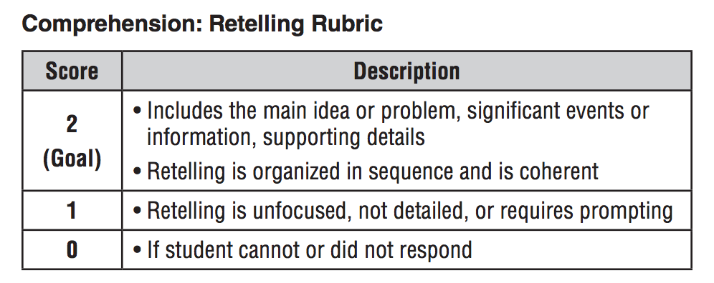

Look for assessments with questions that are based on a specific standard.
Fluent readers who do not comprehend what they are reading. How can we help?

