**NAME:_________________________________________**

**Show What You Know!**



**Quarter 1**

**I can read this many high frequency sight words:**

|  |  |  |  |  |
| --- | --- | --- | --- | --- |
| Number of Words |  |  |  |  |
| 130 |  |  |  |  |
| 120 |  |  |  |  |
| 110 |  |  |  |  |
| 100 |  |  |  |  |
| 90 |  |  |  |  |
| 80 |  |  |  |  |
| 70 |  |  |  |  |
| 60 |  |  |  |  |
| 50 |  |  |  |  |
| 40 |  |  |  |  |
| 30 |  |  |  |  |
| 20 |  |  |  |  |
| 10 |  |  |  |  |
|  | Quarter 1 | Quarter 2 | Quarter 3 | Quarter 4 |

**These are the high frequency sight words I can read:**

|  |  |  |
| --- | --- | --- |
| and | as | his |
| take | by | how |
| use | had | over |
| name | then | some |
| has | him | them |
| after | were | give |
| when | sentence | |

**I am reading at a Rigby Level:**

|  |  |  |  |  |
| --- | --- | --- | --- | --- |
| Rigby Level |  |  |  |  |
| 24 |  |  |  |  |
| 23 |  |  |  |  |
| 22 |  |  |  |  |
| 21 |  |  |  |  |
| 20 |  |  |  |  |
| 19 |  |  |  |  |
| 18 |  |  |  |  |
| 17 |  |  |  |  |
| 16 |  |  |  |  |
| 15 |  |  |  |  |
| 14 |  |  |  |  |
| 13 |  |  |  |  |
| 12 |  |  |  |  |
| 11 |  |  |  |  |
| 10 |  |  |  |  |
| 9 |  |  |  |  |
| 8 |  |  |  |  |
| 7 |  |  |  |  |
| 6 |  |  |  |  |
| 5 |  |  |  |  |
| 4 |  |  |  |  |
| 3 |  |  |  |  |
|  | Quarter 1 | Quarter 2 | Quarter 3 | Quarter 4 |



* **I can decode one syllable words**
* **I can read words with inflectional endings**

**I can comprehend a story or text by retelling…**

* **One detail**
* **Two details in order**
* **Three details in order**



* **I can identify the topic of an informative text.**

**I can identify and use the following text features:**

* **Headings**



* **Table of Contents**
* **Pictures**
* **Maps**

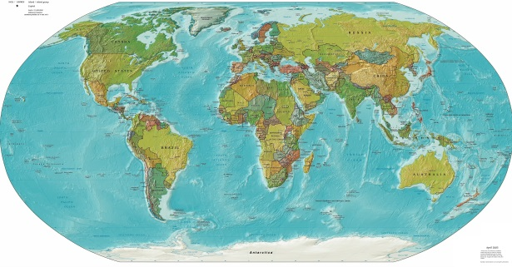

**I can describe the following in a story using details:**

* **Characters**

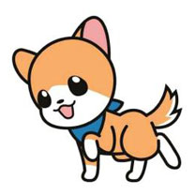



* **Settings**
* **Major events (problem/solution)**

**I can identify the following short vowel sounds:**

**I can read the following words:**

|  |  |
| --- | --- |
| cap | win |
| deck | puck |
| quick | gum |
| sob | lock |
| fed | pack |

**I can read the following words with an inflectional (-s):**

|  |  |
| --- | --- |
| mats | lids |
| pets | tops |

 **I can write a topic sentence with:**

* **A capital letter for the first letter of the first word.**
* **A clear topic.**
* **Punctuation at the end of the sentence.**

**I can count and write the following numbers:**

|  |  |  |  |  |
| --- | --- | --- | --- | --- |
| **1** | **2** | **3** | **4** | **5** |
| **6** | **7** | **8** | **9** | **10** |
| **11** | **12** | **13** | **14** | **15** |
| **16** | **17** | **18** | **19** | **20** |
| **21** | **22** | **23** | **24** | **25** |
| **26** | **27** | **28** | **29** | **30** |
| **31** | **32** | **33** | **34** | **35** |
| **36** | **37** | **38** | **39** | **40** |
| **41** | **42** | **43** | **44** | **45** |
| **46** | **47** | **48** | **49** | **50** |
| **51** | **52** | **53** | **54** | **55** |
| **56** | **57** | **58** | **59** | **60** |
| **60** | **61** | **62** | **63** | **65** |
| **66** | **67** | **68** | **69** | **70** |
| **71** | **72** | **73** | **74** | **75** |
| **76** | **77** | **78** | **79** | **80** |
| **81** | **82** | **83** | **84** | **85** |
| **86** | **87** | **88** | **89** | **90** |
| **91** | **92** | **93** | **94** | **95** |
| **96** | **97** | **98** | **99** | **100** |
| **101** | **102** | **103** | **104** | **105** |
| **106** | **107** | **108** | **109** | **110** |
| **111** | **112** | **113** | **114** | **115** |
| **116** | **117** | **118** | **119** | **120** |