5th Grade Science Planning/PLC
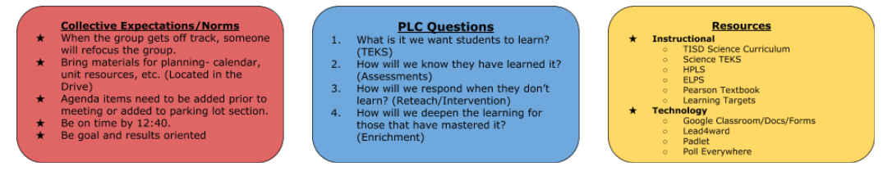
Team SMART goals:
- Increase scores by 10% at all levels
- Begin with the end in mind and review assessments prior to planning the unit.
- Within a week after a common assessment, an action plan will be created and implemented.

Date: 10/24/19 Team Members present: A. McMullen, S. Leach, M. Vazquez, J. Lancaster, A. Eddlemon, C.Karamath
Topic | Desired Outcome | PLC Question | Outcome/Notes
*Designing Learning Plan 5.6D/3.6B force and motion. 5.6A (Mechanical energy) | Everyone participates in the TEKS study and looks at the learning targets for 5.6D, 5.6A, 3.6B | 1 | Led to discussion of content that needs to be covered.
Analyze Unit 5 Test | Analyze Unit 5 Test to ensure alignment and rigor of test to TEKS and instruction | 1, 2, 3 | Begin designing instruction and DLT
Plan for Force and Motion - next 2 weeks - Tuesday, October 29 - November 8  (Total of 8 teaching days and 1 testing day) | Plan 5E lesson to address 5.6A Uses of mechanical energy, 5.6D/3.6B Force and Motion | 2, 3, 4 | See planning calendar  Discuss how to implement interactive word wall
Unit 4 | Work on Unit 4 HW (circuits and uses of sound energy) | 2 | Submit copies for homework

Parking Lot items:

- Keep adding to the materials document as you think of items to be purchased.

- Science word of the week - Call to excellence (Think about how this will look).

- District CBA for 5th grade is 12/4-12/11 (Covers units 1-5: Safety, Matter & Physical Properties,
Thermal & Light Energy, Electrical & Sound Energy, and Force and Motion)

