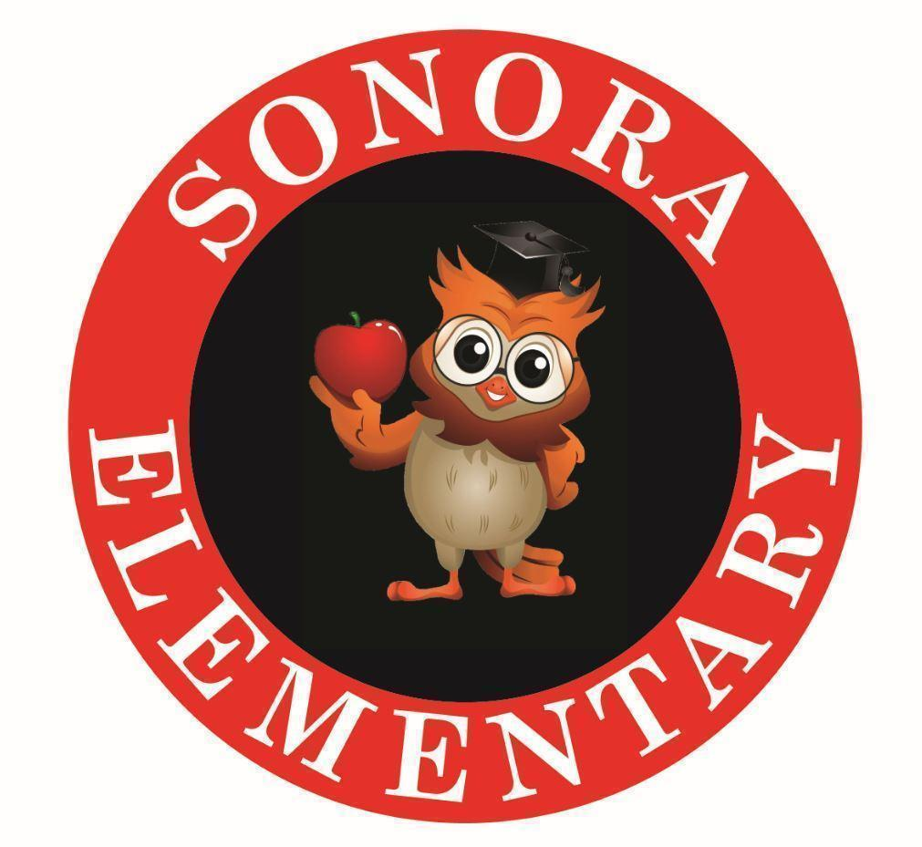
Sonora Guiding Coalition

NORMS
Be present.
Focus on what we can do to support student learning.
Use evidence to make decisions.
Leave each meeting with clear action steps.

Vision, Collective Commitments, Goals, and Administration Collective Commitments
Sonora Strategic Action Plan 22-23

What is a Guiding Coalition? A guiding coalition is the group of teachers who will be committed to the change and help to guide their colleagues through the change.
Purpose: The purpose of the Sonora Guiding Coalition is to promote open communication and provide clarity to meet the needs of ALL Sonora staff and students.
4 Critical Questions for the Guiding Coalition
- What do we expect teams to know and be able to do?
- How will we know if teams have learned it and can do it?
- How will we respond when some teams need additional support?
- How will we stretch teams to continue deepening practices that ensure the learning of every student?
________________________________________________________________________

January 18th, 2023
In attendance:

Meeting Outcomes:
- Set for Day of Learning
- Data Protocol (Math)

- Review Team Norms

II. Ticket in Door - Where are we in the Teaching/Learning Cycle?

- Celebrations … Lens of SAP, vision, mission, & collective commitments
  - Candy has no students in T3 in either reading or math.
  - 4th grade is doing research on extreme weather … students did rough draft yesterday on their subtopics. They are hearing student voice - even though it is non-fiction writing.
  - Moira’s 5th grader wrote a 15 page paper on dinosaurs.
  - A-Team reassessed on EFGo and the students went from 28th to 30th; also, we went from 8 to 19 in the # of students in the least need.
  - 5th grade T3 math used Map to look at the strand that the students received intervention only 4 didn’t make gains in that area. Because of doing data this way, they found kids that would need this intervention that they wouldn’t find before.

III. Summer Work Session … Goals of summer work day: Review of data, Goal setting for 23-24 (Taking Action*)
- Pyramid - read Taking Action; posters posted to continue work.
- Divide up the Taking Action (Pyramid of Intervention) Chapters and have staff help create a Pyramid of Intervention so they can see all the pieces
Type your last name in each cell if you are available on that date:
June 12 Stewman, Hennarichs, Bran, Raines, Worthy, Knight, Reed?, Foltz, Coffman, Whittle
June 13 Stewman, Hennarichs, Bran, Raines, Worthy, Knight, Reed?, Foltz, Coffman, Whittle
June 14 Stewman, Hennarichs, Bran, Raines, Worthy, Knight, Reed?,Foltz, Coffman, Whittle
June 15 Stewman, Bran, Raines, Worthy, Reed?,Spurlock, Whittle
June 16 Stewman, Bran, Raines, Worthy, Reed?, Spurlock, Whittle
June 19 Stewman, Bran, Raines, Worthy, Reed? Spurlock, Whittle
June 20 Stewman, Bran, Raines, Worthy, Reed?,Spurlock, Whittle
June 21 Stewman, Bran, Raines, Worthy, Spurlock, Whittle
June 22 Stewman, Bran, Raines, Worthy, , Whittle
June 23 Stewman, Bran, Worthy, , Whittle
IV. Literacy Data Protocol
Purpose: guiding a group through analysis of data to identify strengths and areas of focus.
- What parts of this data catch your attention? Just the Facts.
  - 2 min individually look through data for things that “stand out”. 6 min share within small group (Ah Ha list 1)
- What does the data tell us? What does the data NOT tell us? Make inferences about the data. Support statements with evidence from data.
  - 3 min making notes, 7 min discussing as a group.
- What good news is there to celebrate? Look for indicators of success in the data.
  - 5 min to ID strengths
- What are the areas of focus suggested by the data? Narrow the focus of the problems of practice.
  - 3 min silently individual ideas for practice, 7 min for group discussion
- What are our key conclusions? What recommendations does the team have for addressing the areas of focus? This is the action phase of the data analysis. The group will design an action plan for next steps to be recorded in the minutes.

V. Nuts & Bolts:

Action Items | Resources Needed | Due Date

Resources:
- CTM Look Fors
- Guidelines from 22-23 (w/Domain !)
- CASEL & SEL Integration Into Academics
- Personality Summary of entire building
- Sonora ES Guiding Coalition Continuums
- Sonora ES Critical Issues for Team Consideration Data Sheet
- adatapictureofourschool
All Things PLC Blog:
- Critical Issues for Guiding Coalitions
- Growing and Utilizing Your Guiding Coalition

