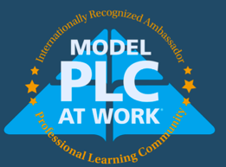
Ambassador Model PLC at Work®
Narrative Essay

Please tell us how your school or district has demonstrated its commitment to the PLC at Work process by continuously improving after achieving model PLC status.

This could include but is not limited to mentoring others as they implement the PLC at Work process, sharing your school or district by setting up site visits, creating video clips of your PLC work in action, and/or venturing outside of the usual education role to ensure advancing student achievement for traditionally underrepresented populations. Share what unique ways you are continuing to ensure that all students are learning at high levels.

Please attach samples of evidence that support your Narrative Essay in the Resources section of your application.

Click or tap here to enter text.

